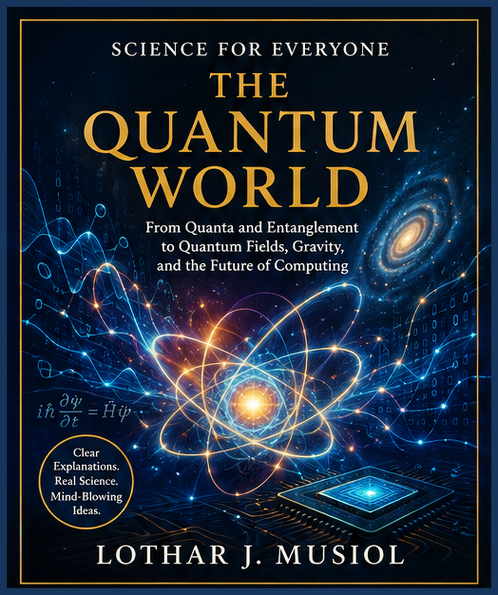
Lothar J. Musiol
The Quantum World
© Lothar J. Musiol
All rights reserved.
This edition is a unified, didactic reconstruction of the supplied Science for Everyone quantum manuscripts, with chapter numbering normalized into a continuous 1–11 sequence.

Contents
Prologue
Chapter 1 — The Quantum World: Nature Stops Behaving
Chapter 2 — Philosophical Foundations of Quantum Mechanics: Reichenbach and the Meaning of Quantum Theory
Chapter 3 — Quantum Entanglement: Spooky but Real
Chapter 4 — EPR, Bell, Aspect, Zeilinger and Quantum Teleportation
Chapter 5 — Quantum Fields: The Stuff Beneath Particles
Chapter 6 — QCD: The Strong Force and the Quark World
Chapter 7 — QED — The Strange Theory of Light and Matter
Chapter 8 — Collective Electrodynamics: When Electromagnetism Emerges from Quantum Matter
Chapter 9 — Quantum Gravity: Where Our Theories Collide
Chapter 10 — Quantum Cryptography: Alice, Bob and Eve
Chapter 11 — Quantum Computing: From Today to One Thousand Years From Now
Appendix 1 — Core Ideas and Unresolved Questions
Appendix 2 — What We Actually Learned
Epilogue — Simulated Existence, the Holographic Universe, and What Is Real?

How to Read This Book
Quantum physics becomes much less intimidating when every strange statement is tied to a physical question. So this book keeps asking: what problem are we solving?
The dark-blue boxes are deliberate pauses. They contain examples, warnings about common misconceptions, small thought experiments, and plain-English explanations.
The illustrations are maps, not photographs. A Feynman diagram is a calculation aid. An entanglement sketch is a diagram of correlations. A curved spacetime grid is an analogy for geometry, not a literal sheet of rubber.
The chapter numbers in this edition are sequential. The original manuscript numbers have been normalized so the finished book reads as one coherent volume.
THE RULE OF THE BLUE BOX
If an idea seems impossible, do not ask whether you can visualize it immediately. Ask whether the theory makes a definite prediction and whether experiments agree with it.

The Road Map

1. Break intuition
Quantum mechanics shows us where classical pictures stop working.

2. Ask what the theory means
Philosophy becomes unavoidable once probability, measurement and causality become part of the story.

3. Discover the fields
Particles become excitations of underlying quantum fields.

4. Meet the forces
QCD and QED show how quantum fields produce the interactions we observe.

5. Find the collision
Gravity and quantum theory eventually demand a deeper framework.

6. Turn weirdness into information
Entanglement becomes a resource for cryptography and computation.

A Note About Certainty
This book distinguishes three different things: established experimental results, well-tested theoretical frameworks, and ideas that are interesting but still speculative.
That distinction matters especially in the later chapters. Quantum gravity, the interpretation of quantum mechanics, and the far future of quantum computing contain genuine open questions. A good science book should not quietly turn a possibility into a fact just because the possibility makes a better sentence.
A SCIENTIFIC REFLEX
Whenever you hear 'physicists know that...', ask: do they know it from experiment, from a successful theory, from a mathematical possibility, or from a philosophical argument?

The Characters We Keep Meeting
Alice, Bob and Eve are not a real family. They are the standard cast of cryptography. Schrödinger's cat is not an abused laboratory animal. It is a thought experiment. And the Lothar Feynman and Susanne Hosentraeger dialogue in Appendix 2 is explicitly fictional.
The point of these characters is pedagogical: abstract physics is easier to hold onto when it has something to push against.
ONE WARNING
A good analogy explains one relationship. It does not give you permission to invent ten additional properties that the real system does not have.

The Central Question
What is the world made of, and what does it mean to say that we know the answer?
The first half of the book keeps dismantling familiar pictures. The second half rebuilds a deeper picture from fields, interactions, information and measurement.
KEEP THIS QUESTION
Whenever the story becomes complicated, come back to the simplest version: what exists, what can be measured, and what does the theory actually predict?

Before the First Quantum
There is one final piece of preparation. Classical physics is not stupid, primitive, or obsolete. It is an extraordinarily successful approximation in the domain where it applies.
Quantum physics does not replace every calculation involving a football with a 300-page integral. If you throw a football, classical mechanics remains magnificently useful. Quantum theory becomes essential when the microscopic structure of matter and radiation can no longer be ignored.
GOOD PHYSICS
A deeper theory should explain why the older theory worked where it worked. The old theory is not 'wrong' in the everyday sense; it is limited.

PROLOGUE
  - The Universe Has a Bad Habit
The trouble with physics is that the universe keeps refusing to behave like the picture in our heads.
START HERE
Do not worry about understanding quantum mechanics yet. The first job is to understand why physicists needed it.

The trouble with physics is that the universe keeps refusing to behave like the picture in our heads. For centuries, that picture worked surprisingly well. Objects had positions. They had velocities. Forces pushed and pulled them. If you knew enough about a system, you could imagine its future. The world was complicated, certainly, but the rules seemed comfortingly mechanical.
Then physics started looking closely.
Light refused to fit into the old boxes. Matter acquired a wave nature. Atoms emitted and absorbed energy in discrete amounts. And eventually the theory built to describe these facts began telling us something profoundly uncomfortable: at the microscopic level, nature is not merely a smaller version of the world we experience every day.
That is where this book begins.
WHY THIS MATTERS
The quantum revolution began because experiments forced physicists beyond older theories.

From here the story becomes increasingly strange. Quantum mechanics introduces superposition and probability. Entanglement turns correlations into something deeper than ordinary bookkeeping. Quantum field theory replaces the picture of tiny isolated particles with fields and their excitations. QED and QCD show just how extraordinarily successful that framework can be.
And then gravity walks into the room.
General relativity tells us that spacetime itself is dynamical. Quantum theory tells us that physical systems are quantum. At the deepest level, we do not yet have a universally accepted theory that makes those two descriptions one coherent story. That is not a footnote. It is one of the great open questions of physics.
↑ Back to Contents
The goal of this book is therefore not to make quantum physics sound ordinary. That would be dishonest. The goal is to make the strangeness understandable.
We will repeatedly stop and ask the same three questions: What did classical intuition expect? What does the quantum theory actually say? And what experiment or calculation gives us reason to believe it?
Physics is not a vocabulary test. It is an argument with nature in which nature gets the final vote.
There will be equations. There will be photons. There will be quarks. There will be a cat that is probably tired of being dragged into philosophical discussions. There will also be moments when the honest answer is simply: we do not know yet.
Good. That is where the interesting questions live.
COMMON MISCONCEPTION
Quantum physics is not simply classical physics with smaller objects. The conceptual structure changes.

↑ Back to Contents
CHAPTER 1

The Quantum World: Nature Stops Behaving
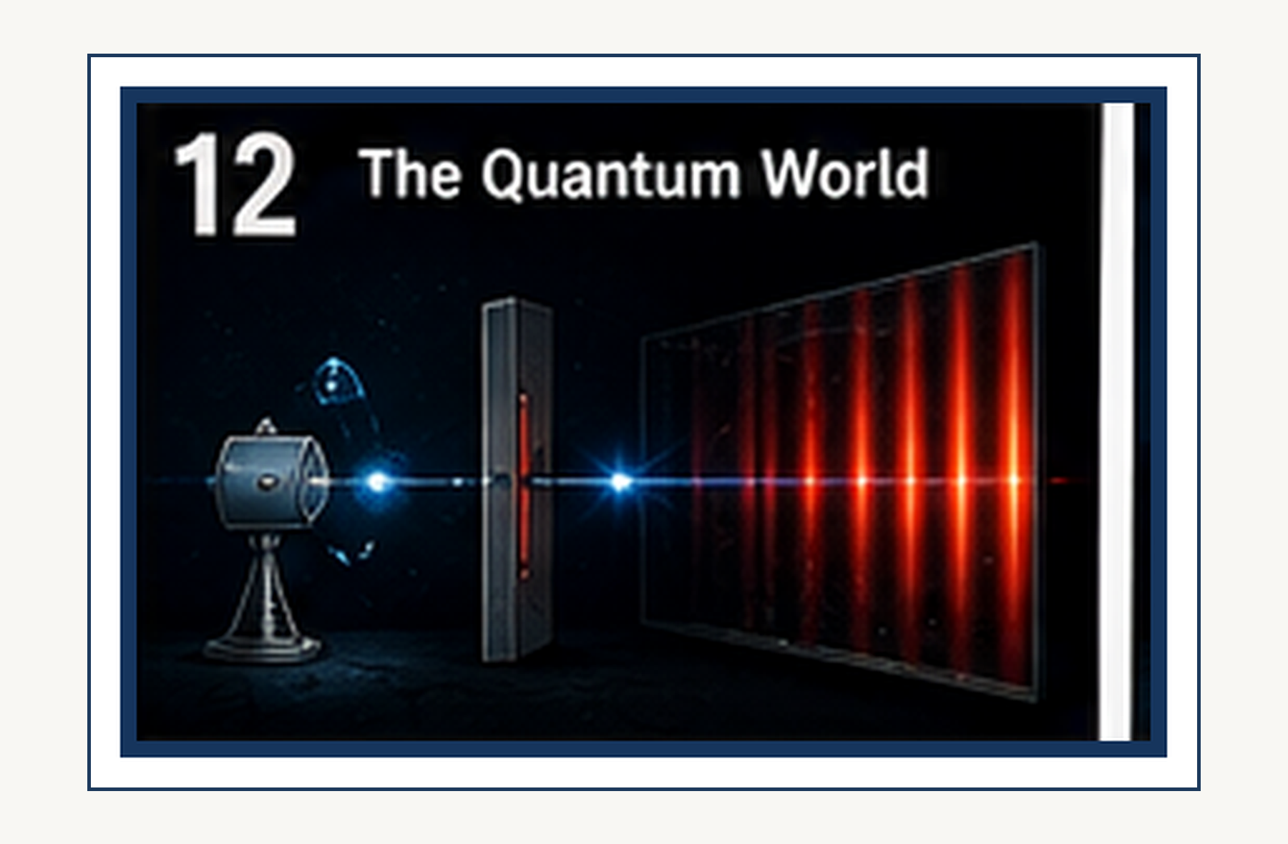
The quantum world: where familiar intuition begins to fail.
SCIENCE FOR EVERYONE

The Quantum World: Nature Stops Behaving

Welcome to the Quantum World
We have spent several chapters looking outward: from falling objects to curved spacetime, from gravitational waves to the expanding universe. Now we are going to do the opposite. We are going to look inward, toward the smallest things we know about. And almost immediately, ordinary intuition starts complaining. Particles can behave like waves. Waves can behave as though they arrive in individual lumps. You can predict probabilities with astonishing precision while being unable to predict the exact result of an individual experiment.
This is quantum physics. It is not nature being deliberately confusing. It is nature telling us that our everyday mental picture was designed for bicycles, bowling balls, and coffee cups—not electrons.
COMMON MISCONCEPTION
A diagram is not a microscopic movie. Use the picture to remember the relationship, then return to the words and the experiment.

↑ Back to Contents

The light bulb that caused trouble
Imagine a hot object glowing. Heat it gently and it glows dull red. Heat it more and it becomes orange, then yellow, then white. Classical physics tried to explain exactly how the energy of that glow was distributed among different frequencies.
The calculation produced a catastrophe. At very high frequencies, the theory predicted that the object should radiate an absurdly large amount of energy. The result was nicknamed the ultraviolet catastrophe. Nature, fortunately, had no interest in obeying a bad calculation.

Planck makes a strange suggestion
WHY THIS MATTERS
The concept matters because it solves a specific problem. Ask what would go wrong if physicists did not have this idea.

↑ Back to Contents
In 1900, Max Planck proposed an idea that initially looked like a mathematical trick. Perhaps energy is not exchanged in completely arbitrary amounts. Perhaps it comes in discrete packets. The energy of a packet is related to frequency by:
E = hf where h is Planck's constant.
The higher the frequency, the larger the packet. This tiny change in the rules fixed the catastrophe. It also opened the door to quantum mechanics.

Einstein and the photon
THINK ABOUT IT
Explain the preceding idea in one sentence without using the words 'quantum', 'weird', or 'magic'. If that is hard, you have found the next thing to understand.

↑ Back to Contents
Planck had introduced quantized energy almost reluctantly. Einstein was willing to take the idea much more seriously. In 1905, he proposed that light itself could behave as though it were made of individual energy packets, later called photons. Light still produces wave-like interference, but when it exchanges energy with matter, it can behave as individual lumps.
That sounds contradictory until you stop demanding that light behave exactly like something familiar. A photon is not a tiny glowing billiard ball. It is a quantum object.

The photoelectric effect
PHYSICS IN PLAIN ENGLISH
First say what happens. Then say why it happens. Only then worry about the formalism. This builds the conceptual ladder.

↑ Back to Contents
Shine light on certain metals and electrons can be knocked out of the surface. Increase the brightness and you might expect the electrons to come flying out with more energy. But that is not what happens. The frequency of the light matters. Below a certain frequency, increasing the brightness does not give the electrons enough energy to escape. Above the threshold, electrons can be emitted immediately.
The simplest explanation is that the electrons receive energy in individual photons. One photon interacts with one electron, and the energy available depends on the photon's frequency. Einstein's explanation of this effect became one of the foundations of quantum physics—and eventually helped earn him the Nobel Prize.

The electron refuses to be a tiny planet
FUN DETOUR
Physics has a recurring habit of making a sensible question produce an answer that sounds ridiculous. The universe is not being rude. Our intuition is simply out of its depth.

↑ Back to Contents
The old picture of an atom was tempting. Imagine a tiny nucleus with electrons orbiting it like planets around the Sun. Unfortunately, classical physics says that a charged particle moving in a curved orbit should radiate energy. The electron should spiral inward and crash into the nucleus almost immediately.
Atoms plainly do not do this. Matter has been sitting around for billions of years without all its electrons falling into the nuclei. Something fundamental was missing from the classical picture.

The atomic staircase
EXAMPLE
Imagine the classical version first. What would a little billiard-ball universe predict? Now compare that with the quantum result. The difference is the lesson.

↑ Back to Contents
One of the great clues came from atomic spectra. When atoms emit or absorb light, they do not produce every possible frequency. They produce specific lines. It is as though an electron is allowed to stand on certain steps of a staircase but not on the spaces between them.
Those steps correspond to discrete energy levels. An electron can move from one allowed state to another by absorbing or emitting a photon with the appropriate energy. The atom therefore behaves less like a miniature solar system and more like a quantum system with a very peculiar set of rules.

Matter becomes wave-like
COMMON MISCONCEPTION
A diagram is not a microscopic movie. Use the picture to remember the relationship, then return to the words and the experiment.

↑ Back to Contents
Then came Louis de Broglie with a wonderfully bold suggestion: if light, which we thought was a wave, can behave like a particle, perhaps matter, which we thought consisted of particles, can behave like a wave. For a particle with momentum p, the associated wavelength is:
λ = h/p
For a baseball, that wavelength is fantastically tiny. For an electron, it can be large enough to produce measurable interference.
Nature appears to have little interest in keeping our categories tidy.

The electron double-slit experiment
WHY THIS MATTERS
The concept matters because it solves a specific problem. Ask what would go wrong if physicists did not have this idea.

Keep the physical question visible while reading the formal explanation. If the mathematics feels abstract, return to the experiment. If the experiment feels mysterious, return to the assumptions.
↑ Back to Contents
Imagine firing electrons one at a time toward a barrier with two narrow slits. Behind the barrier is a screen that records where each electron arrives. If electrons were simply tiny pellets, you would expect two bright bands corresponding to the two openings. Instead, after many electrons have arrived, an interference pattern appears—the signature of waves.
Even stranger, the electrons can arrive one at a time. Each individual detection is a localized event, but the overall pattern builds up like a wave interference pattern. The quantum world has apparently decided that it is perfectly happy to make you wait for a thousand electrons before revealing its personality.

A wave of possibilities
THINK ABOUT IT
Explain the preceding idea in one sentence without using the words 'quantum', 'weird', or 'magic'. If that is hard, you have found the next thing to understand.

↑ Back to Contents
What exactly is waving? It is tempting to say that the electron itself is physically smeared out like a little blob of jelly. That picture is not quite right. Quantum mechanics describes a system using a wavefunction. The wavefunction contains information about the possible outcomes of measurements, and the mathematical machinery tells us how those possibilities evolve.
The square of the wavefunction's magnitude gives probabilities for finding the particle in particular places or states. This is one of the central shifts in quantum thinking: the theory does not normally predict one definite result for every individual measurement. It predicts a distribution of possible results.

Probability is not ignorance
PHYSICS IN PLAIN ENGLISH
First say what happens. Then say why it happens. Only then worry about the formalism. This builds the conceptual ladder.

↑ Back to Contents
Suppose I hide a coin under one of two cups. There is a definite answer. I simply do not know it. Quantum uncertainty is different. In standard quantum mechanics, the theory itself can assign probabilities to different outcomes before a measurement is made.
That distinction has caused arguments among physicists for more than a century. Einstein famously disliked the idea that fundamental physics might be irreducibly probabilistic. But nature has been remarkably uncooperative with attempts to make quantum mechanics behave like an ordinary hidden-information problem.

Heisenberg and the uncertainty principle
FUN DETOUR
Physics has a recurring habit of making a sensible question produce an answer that sounds ridiculous. The universe is not being rude. Our intuition is simply out of its depth.

↑ Back to Contents
Werner Heisenberg discovered that certain pairs of quantities cannot simultaneously have arbitrarily precise values. The most famous pair is position and momentum. The uncertainty principle is often described as though a clumsy experimentalist simply disturbs a particle while measuring it. That is not the deepest meaning.
The quantum state itself has a mathematical structure that prevents position and momentum from both being sharply defined at the same time. The more tightly localized a quantum wave is in position, the broader its range of possible momenta becomes.

Why this does not make your keys disappear
EXAMPLE
Imagine the classical version first. What would a little billiard-ball universe predict? Now compare that with the quantum result. The difference is the lesson.

↑ Back to Contents
Quantum uncertainty is sometimes exaggerated into the claim that anything can happen at any moment. It cannot. Quantum mechanics is probabilistic, but it is not arbitrary. The theory gives extraordinarily precise rules for the probabilities.
A hydrogen atom does not suddenly decide to become a bicycle. An electron does not randomly acquire a mountain's worth of energy because it is having an adventurous afternoon. The strange part is not that quantum physics has no rules. The strange part is how different those rules are from the rules our everyday intuition expects.

Measurement changes the question
COMMON MISCONCEPTION
A diagram is not a microscopic movie. Use the picture to remember the relationship, then return to the words and the experiment.

↑ Back to Contents
A quantum system can exist in a superposition of possible outcomes. When a measurement is made, we obtain one definite result. Exactly what constitutes a measurement is a deep question, and physicists have several interpretations of what the mathematics means. We do not need to settle that philosophical debate to use the theory successfully.
What matters experimentally is that the possible outcomes and their probabilities can be calculated with extraordinary accuracy. Quantum mechanics may be philosophically unsettling, but it is one of the most successful predictive theories humans have ever built.

The strange power of interference
Interference is one of the reasons quantum mechanics works so differently from ordinary probability. Probabilities do not simply add in the way you might expect. Quantum amplitudes combine first, and the resulting probability depends on the interference between them. That is why two possible paths can reinforce one another in some places and cancel one another in others.
The double-slit experiment is therefore not merely a cute demonstration. It exposes the mathematical heart of quantum behavior.

From weird idea to modern technology
Quantum mechanics is not an abstract philosophical game. It explains why atoms have stable structures, why chemical bonds exist, how semiconductors work, how lasers operate, and why modern electronics can exist. Your computer, your phone, the LEDs in your screen, and many of the sensors around you depend on quantum physics. The universe may be strange, but it is strangely useful.

The quantum world is not small classical physics
It is tempting to imagine that an electron is simply a tiny classical object whose behavior we have not yet understood properly. That approach repeatedly fails. Quantum objects have properties that cannot be reproduced by simply shrinking ordinary objects down to microscopic size. The quantum world has its own rules, and classical physics emerges as an approximation when quantum effects become negligible at the scales and conditions of everyday experience.
That is an important theme in science: the familiar world is not replaced by quantum physics. It is explained by it.

One last quantum leap
We have now crossed a conceptual boundary. In relativity, space and time stopped being absolute. In quantum physics, certainty itself became conditional. Particles can behave like waves. Measurements produce discrete outcomes. Probabilities become fundamental to the predictions, and the act of asking a quantum system a question can be part of the physical story.
And we have only reached the beginning. Quantum mechanics becomes even stranger when particles become entangled, when fields replace the idea of individual particles, and when empty space turns out not to be as empty as it looks. Next we will meet quantum entanglement—the phenomenon Einstein called “spooky,” and which nature seems to have regarded as perfectly ordinary.
WHY THIS MATTERS
The concept matters because it solves a specific problem. Ask what would go wrong if physicists did not have this idea.

Keep the physical question visible while reading the formal explanation. If the mathematics feels abstract, return to the experiment. If the experiment feels mysterious, return to the assumptions.
↑ Back to Contents

CHAPTER 2

Philosophical Foundations of Quantum Mechanics: Reichenbach and the Meaning of Quantum Theory
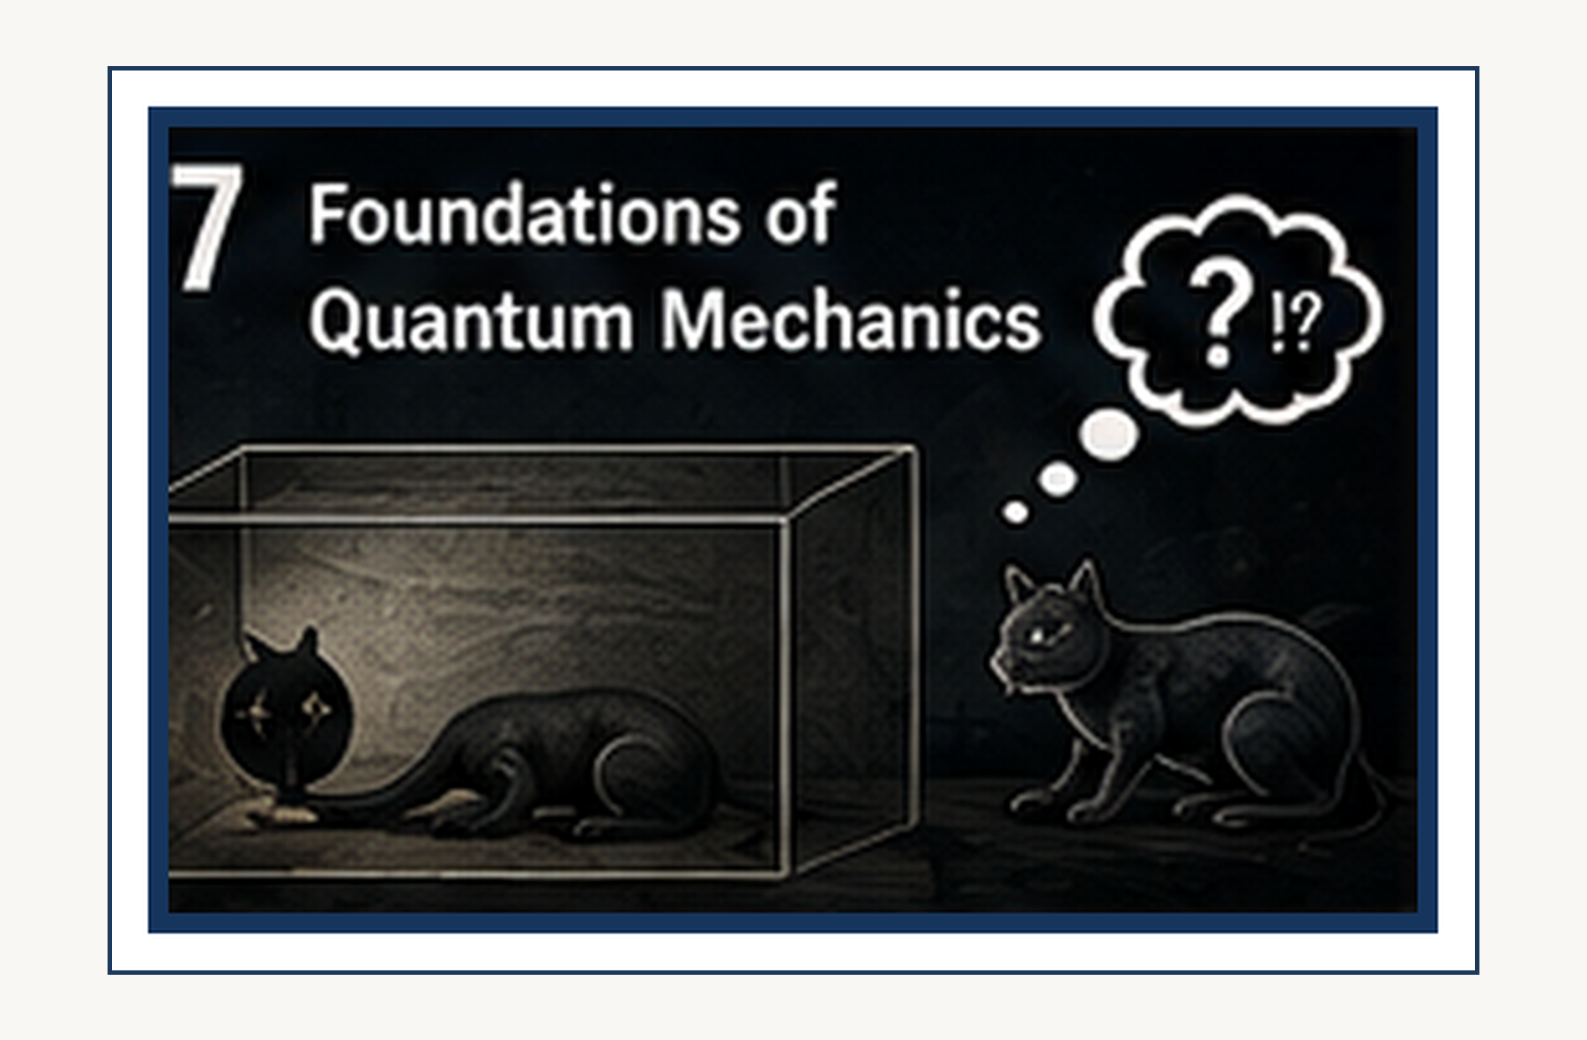
The philosophical question: what does a quantum theory actually mean?
SCIENCE FOR EVERYONE

Philosophical Foundations of Quantum Mechanics: Reichenbach and the Meaning of Quantum Theory

Physics Suddenly Has a Philosophy Problem
Quantum mechanics works. That is not the problem. The problem is that it works while refusing to behave like the physics we grew up with. A particle can have a probability of being detected somewhere.
WHY THIS MATTERS
The concept matters because it solves a specific problem. Ask what would go wrong if physicists did not have this idea.

↑ Back to Contents
A measurement can change what can subsequently be predicted. Some quantities cannot simultaneously have sharply defined values. And experiments involving entanglement force us to rethink what we mean by separate systems. Hans Reichenbach recognized very early that quantum mechanics was not merely a new collection of equations. It was a conceptual revolution that forced physics to reconsider probability, causality, measurement, and even the meaning of a physical law. His 1944 book, Philosophic Foundations of Quantum Mechanics, was devoted specifically to these questions.

Reichenbach: the philosopher who wanted physics to behave
THINK ABOUT IT
Explain the preceding idea in one sentence without using the words 'quantum', 'weird', or 'magic'. If that is hard, you have found the next thing to understand.

↑ Back to Contents

Hans Reichenbach was a philosopher of science with a strong interest in physics. He did not want philosophy to float away into a cloud of words. He wanted philosophical questions about science to be tied to scientific practice, measurement, logic, and the structure of physical theories. That made quantum mechanics irresistible.
Classical physics seemed to offer a comfortable picture: things have properties, laws determine how they evolve, and probability usually means that we do not know all the details. Quantum mechanics appeared to challenge every part of that picture.

Probability: ignorance or reality?
PHYSICS IN PLAIN ENGLISH
First say what happens. Then say why it happens. Only then worry about the formalism. This builds the conceptual ladder.

↑ Back to Contents
Suppose I put a coin in my pocket. If I tell you I do not know whether it is heads or tails, you can reasonably describe the result with a probability. The coin itself, however, already has a definite face pointing upward. That is one familiar meaning of probability: probability represents our ignorance.
FUN DETOUR
Physics has a recurring habit of making a sensible question produce an answer that sounds ridiculous. The universe is not being rude. Our intuition is simply out of its depth.

↑ Back to Contents

Quantum mechanics creates a much harder question. When the theory says there is a 50 percent probability of one result and a 50 percent probability of another, is the world itself genuinely indeterminate? Or is the probability merely telling us that some deeper information is missing? Reichenbach took this distinction seriously. His earlier work on probability had already treated probability as an objective feature relevant to scientific knowledge, rather than simply as a measure of personal ignorance.

The quantum coin is not an ordinary coin
EXAMPLE
Imagine the classical version first. What would a little billiard-ball universe predict? Now compare that with the quantum result. The difference is the lesson.

↑ Back to Contents
Imagine a quantum coin. Before you look, you cannot simply assume that it is secretly sitting there with heads or tails in exactly the same sense as a classical coin. The quantum state can encode probabilities for different possible measurement results. That does not mean “anything can happen.”
The theory gives extremely precise probabilities. And those probabilities can be tested. The philosophical question is what kind of thing a probability in a fundamental physical theory actually is. Is it ignorance?
Is it a propensity? Is it a structural feature of nature? Or is the question itself using classical categories that quantum mechanics has made obsolete?

A law does not always mean a prediction
COMMON MISCONCEPTION
A diagram is not a microscopic movie. Use the picture to remember the relationship, then return to the words and the experiment.

↑ Back to Contents

Classical laws often feel deterministic. Give me the state of the system now, and—at least in principle—I can calculate its future. Quantum mechanics changes the meaning of prediction. The Schrödinger equation evolves the quantum state deterministically.
But measurements generally produce probabilistic outcomes. That creates a fascinating split. The mathematical state evolves according to a precise rule. The individual experimental result is predicted only probabilistically.
So what exactly is the physical law predicting? The distribution of possible outcomes? The evolution of the quantum state? Or some deeper reality behind both?

Determinism has several meanings
WHY THIS MATTERS
The concept matters because it solves a specific problem. Ask what would go wrong if physicists did not have this idea.

↑ Back to Contents
People often say that quantum mechanics destroyed determinism. That sentence is too simple. There is a difference between deterministic evolution of a mathematical state and deterministic prediction of an individual measurement outcome. Standard quantum theory gives deterministic unitary evolution between measurements, while the Born rule gives probabilities for measurement results.
Different interpretations then tell different stories about what this means physically. Some interpretations preserve a form of determinism. Others accept fundamental indeterminism. Still others change what they mean by measurement or by the quantum state itself.
Reichenbach's work is valuable here because it forces us to separate the logical pieces instead of throwing the word “determinism” at the entire problem.

Causality takes a hit—but not a knockout
THINK ABOUT IT
Explain the preceding idea in one sentence without using the words 'quantum', 'weird', or 'magic'. If that is hard, you have found the next thing to understand.

↑ Back to Contents
Classical causality often suggests a simple picture. Event A happens. It causes event B. If we knew enough, we could trace the chain.
Quantum mechanics complicates this. The theory can assign probabilities to outcomes that are not determined by any ordinary classical causal chain. But this does not mean that quantum physics is chaos. The theory has extraordinarily precise rules.
It also does not mean that effects can simply travel backward in time whenever we feel like it. Quantum mechanics changes the structure of causality without making the universe lawless.

Measurement is where the trouble starts
PHYSICS IN PLAIN ENGLISH
First say what happens. Then say why it happens. Only then worry about the formalism. This builds the conceptual ladder.

Keep the physical question visible while reading the formal explanation. If the mathematics feels abstract, return to the experiment. If the experiment feels mysterious, return to the assumptions.
↑ Back to Contents

Suppose an electron is prepared in a quantum state. We then measure its position. Before the measurement, the theory may assign a spread of possible positions. After the measurement, we obtain one result.
What exactly happened? Did the electron always have that position and we merely discovered it? Did the measurement create the property? Did the quantum state change physically?
Did our description change while the underlying reality remained something else? These are not merely verbal questions. Different interpretations of quantum mechanics answer them differently.

The measuring device is part of the world
There is another awkward question. A measuring device is made of atoms. Those atoms obey quantum mechanics. So if quantum mechanics describes everything, the measuring apparatus should itself have a quantum state.
FUN DETOUR
Physics has a recurring habit of making a sensible question produce an answer that sounds ridiculous. The universe is not being rude. Our intuition is simply out of its depth.

↑ Back to Contents
Then why does the apparatus produce one definite reading? Why does a macroscopic pointer not remain in an obvious superposition of all possible readings? This is part of what later became known as the measurement problem. Reichenbach was already examining the relationship between observation, measurement, and the quantum description in his 1944 work.

The observer is not necessarily a conscious mind
This is an important clarification. When physicists say “measurement,” they do not necessarily mean that a human being looked at something. A detector can record a particle. A photographic plate can register light.
EXAMPLE
Imagine the classical version first. What would a little billiard-ball universe predict? Now compare that with the quantum result. The difference is the lesson.

↑ Back to Contents

A Geiger counter can click. A measuring interaction can occur long before a person examines the result. The philosophical question is therefore not simply “does consciousness create reality?” That is a much stronger claim than quantum mechanics requires.
The real issue is how a quantum description of physical interactions connects to definite experimental records.

What does it mean for a particle to have a property?
Classical thinking makes properties feel automatic. An electron has a position. It has a momentum. It has an energy.
COMMON MISCONCEPTION
A diagram is not a microscopic movie. Use the picture to remember the relationship, then return to the words and the experiment.

↑ Back to Contents
Perhaps we do not know the values, but surely the values are simply there. Quantum mechanics makes that assumption dangerous. Some quantities are represented by noncommuting operators. The theory does not permit all of them to be assigned simultaneously sharp values in the classical way.
Reichenbach explored the philosophical consequences of this shift and even examined alternative logical structures for describing quantum propositions.

The uncertainty principle is not just bad equipment
Suppose you measure the position of an electron very accurately. You might think the only problem is that your measurement disturbed its momentum. That is part of the story in some experimental arrangements, but the deeper quantum statement is about the structure of the theory itself. Position and momentum are represented by noncommuting observables.
WHY THIS MATTERS
The concept matters because it solves a specific problem. Ask what would go wrong if physicists did not have this idea.

↑ Back to Contents
The uncertainty relation is therefore not merely a statement about clumsy instruments. It is a structural feature of quantum mechanics. Reichenbach explicitly treated the principle of indeterminacy as a philosophical as well as physical issue.

The wave function: thing or information?
Here is another philosophical trap. The wave function predicts probabilities. But what is it? Is it a real physical field?
Is it a mathematical description of a physical system? Is it information? Is it something in between? Different interpretations answer differently.
Reichenbach was interested in separating the mathematical formalism from the language we use to interpret it. That distinction remains crucial today. The equations can be extraordinarily successful even while physicists disagree about what the equations are telling us about reality.
THINK ABOUT IT
Explain the preceding idea in one sentence without using the words 'quantum', 'weird', or 'magic'. If that is hard, you have found the next thing to understand.

↑ Back to Contents

Three-valued logic enters the room
Classical logic usually gives us two values. A proposition is true. Or it is false. Reichenbach explored whether quantum mechanics might require something more subtle.
He considered a three-valued logical framework in which certain propositions are not simply true or false because the corresponding physical quantity cannot be assigned a definite value in the classical way. This was not an attempt to make arithmetic rebellious. It was an attempt to ask whether our logical language itself should change when the physical concepts it describes change.
His book develops this idea explicitly in its later sections.

Do we really need new logic?
PHYSICS IN PLAIN ENGLISH
First say what happens. Then say why it happens. Only then worry about the formalism. This builds the conceptual ladder.

↑ Back to Contents

This is where we should be cautious. Quantum mechanics does not force everyone to abandon ordinary two-valued logic. Many modern approaches retain classical logic perfectly well while changing the interpretation of quantum propositions, measurements, or states. Reichenbach's three-valued logic is therefore historically interesting and philosophically provocative, not a universally accepted replacement for classical logic.
That distinction matters. A philosophical proposal can be valuable even when the physics community does not adopt it as the final answer.

Reality versus observability
Quantum mechanics also forces us to distinguish two questions. What exists? And what can be measured? Classical physics often lets us treat these as almost the same question.
Quantum theory makes the distinction much harder. There may be properties that the theory does not assign definite values to until a particular measurement context is specified. That does not automatically mean that unmeasured reality does not exist. It means we have to be precise about what the theory actually says.

The EPR challenge
Einstein, Podolsky, and Rosen later pushed these questions into an even more dramatic form. Suppose two quantum systems interact and then separate. Quantum mechanics can predict correlations between their measurements. Einstein worried that the theory might be incomplete because it did not seem to assign definite properties to the individual systems independently of measurement.
The famous EPR argument therefore became a philosophical challenge to the completeness of quantum mechanics. Reichenbach's work belongs to the same broad historical moment in which physicists and philosophers were trying to determine what quantum theory actually commits us to.

From EPR to Bell
Decades later, John Bell transformed the philosophical argument into an experimental one. Bell showed that certain classes of local hidden-variable theories make statistical predictions that differ from quantum mechanics. Experiments have repeatedly found the quantum predictions. That does not settle every philosophical question.
But it sharply limits the kinds of classical hidden-variable picture that can reproduce the observed correlations. The debate moved from “what sounds philosophically reasonable?” toward “what does nature actually permit?”

Probability becomes physical
One of Reichenbach's most important themes becomes clearer here. Probability in physics is not necessarily just a statement about what we happen to know. In quantum mechanics, probabilities are built into the predictive structure of the theory. And experiments repeatedly confirm those statistical predictions.
This does not automatically prove that nature is fundamentally indeterministic. Interpretations such as Bohmian mechanics, for example, preserve determinism while reproducing quantum predictions through a very different ontology. The lesson is more subtle: Quantum mechanics forces us to take probability seriously, but probability alone does not tell us which interpretation of reality is correct.

What is a physical law?
Reichenbach's questions reach beyond quantum mechanics. What is a law of nature? Is it a command that nature obeys? A mathematical regularity?
A statement about what would happen under specified conditions? A pattern in observed events? Classical physics encourages us to think of laws as deterministic rules connecting one state to the next. Quantum mechanics invites a richer picture.
Some laws determine how probabilities evolve. Other rules connect a preparation to a distribution of possible outcomes. The law may therefore constrain possibilities without selecting a unique individual outcome.

The humble probability distribution
Imagine rolling a perfect die. The theory says each face has a one-sixth probability. That is not a prediction that the next throw will be exactly 3. It is a prediction about the distribution of results over repeated trials.
Quantum mechanics works similarly, but the probabilities arise from a radically different mathematical structure. The theory does not merely say “we do not know.” It gives a precise probability distribution calculated from the quantum state. That distinction is central to understanding what quantum theory actually predicts.

Causality without classical trajectories
A classical particle follows a trajectory. You can imagine a tiny object moving through space, carrying its properties along. Quantum mechanics does not always give us such a trajectory. Instead, the theory gives a state and probabilities for possible measurement outcomes.
This does not erase causal structure. It changes what a causal explanation can look like. The question becomes less “which hidden path did the particle secretly take?” and more “what physical preparation and interactions produce these precisely constrained statistical outcomes?”

Why Reichenbach still matters
Reichenbach wrote in the 1940s, but the questions he confronted have not gone away. What does probability mean? What is a physical property? What is a measurement?
What does it mean for a theory to be complete? Can causality survive quantum mechanics? Does determinism describe reality or merely one possible interpretation? What kind of logic should we use for physical propositions?
Modern interpretations disagree about many of these questions. That is not evidence that quantum mechanics has failed. It is evidence that the theory is so successful that we are now arguing about what kind of reality could make it true.

The important distinction: theory versus interpretation
This is the distinction we should carry through the rest of our quantum chapters. Quantum mechanics as a mathematical framework has an extraordinary record of experimental success. An interpretation is an attempt to say what the framework means. Copenhagen-style approaches.
Many-worlds. Bohmian mechanics. Objective-collapse theories. Other proposals.
They can agree on the experimental predictions while disagreeing about the underlying picture. So when someone says, “Quantum mechanics says reality is X,” ask a simple question: Does the theory say that, or does a particular interpretation say that? That one question prevents an enormous amount of confusion.

A philosophical revolution that did not stop the experiments
Reichenbach understood something important. When a scientific theory changes the meaning of familiar concepts, philosophy cannot simply sit on the sidelines. Quantum mechanics changed the roles of probability, measurement, causality, and physical properties. But philosophy also cannot replace experiment.
The universe does not care which interpretation gives us the most satisfying dinner-table conversation. Nature decides. That is why the best philosophy of physics keeps one foot in conceptual analysis and the other firmly planted in experimental science.

One last question
Suppose an electron is prepared in a quantum state. You know exactly what the theory predicts. You calculate the probabilities. You perform the experiment.
The detector clicks. You repeat it thousands of times. The frequencies agree beautifully with the theory. Now ask the philosophical question.
What, exactly, was the electron doing before the click? Quantum mechanics gives you an astonishingly successful answer about what you will observe. Whether it gives you a complete answer about what reality was doing is a different question. That is the question Reichenbach wanted us to take seriously.
And it is still one of the great unfinished conversations in physics.
FUN DETOUR
Physics has a recurring habit of making a sensible question produce an answer that sounds ridiculous. The universe is not being rude. Our intuition is simply out of its depth.

Keep the physical question visible while reading the formal explanation. If the mathematics feels abstract, return to the experiment. If the experiment feels mysterious, return to the assumptions.
↑ Back to Contents

CHAPTER 3

Quantum Entanglement: Spooky but Real
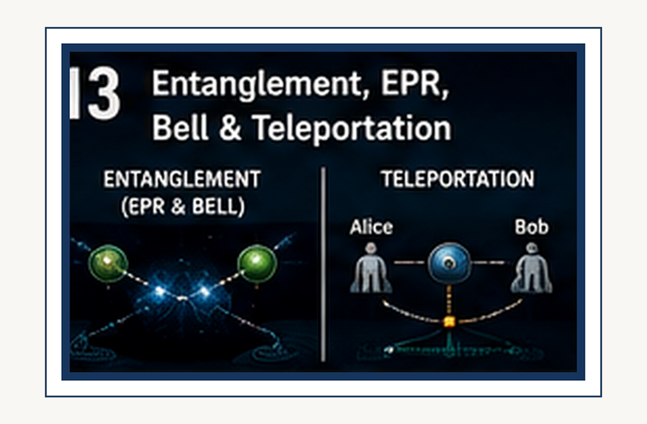
Entanglement: correlations that are deeper than ordinary classical bookkeeping.
SCIENCE FOR EVERYONE

Quantum Entanglement: Spooky but Real

Two Particles, One Strange Connection
Imagine creating two quantum particles together and then sending them far apart. You measure one particle and immediately know something about the other. That sounds like the particles are communicating. But quantum entanglement is stranger than ordinary communication. The correlations are built into the joint quantum state of the pair.
Einstein found this deeply uncomfortable. He wondered whether quantum mechanics was somehow incomplete.

A simple coin is not entangled
THINK ABOUT IT
Explain the preceding idea in one sentence without using the words 'quantum', 'weird', or 'magic'. If that is hard, you have found the next thing to understand.
See Chapter 4 →

↑ Back to Contents
Suppose I put a red card in one envelope and a blue card in another. I shuffle the envelopes and send one to you and one to a friend on Mars. You open yours and find the red card. You instantly know your friend's envelope contains the blue card.
Nothing mysterious happened. The colors were fixed from the beginning. Quantum entanglement is different. In the standard quantum description, the individual outcomes are not simply hidden labels that were quietly assigned in advance like cards in envelopes.
The correlations are stronger and more subtle than that.

The famous EPR question
PHYSICS IN PLAIN ENGLISH
First say what happens. Then say why it happens. Only then worry about the formalism. This builds the conceptual ladder.
See Chapter 4 →

↑ Back to Contents

In 1935, Einstein, Boris Podolsky, and Nathan Rosen published a famous argument about quantum mechanics. They considered situations in which measurements on two separated systems appeared to be connected in a way that challenged ordinary ideas about reality and locality. Their argument became known as the EPR paradox. Einstein was not objecting because quantum mechanics made bad predictions. Quite the opposite. He was asking whether the theory told the whole story.
Perhaps, he thought, there were additional variables hiding underneath the quantum description.

Bell changes the game
FUN DETOUR
Physics has a recurring habit of making a sensible question produce an answer that sounds ridiculous. The universe is not being rude. Our intuition is simply out of its depth.
See Chapter 4 →

↑ Back to Contents
John Bell found a way to turn the philosophical argument into an experimental question. In 1964, he derived what are now called Bell inequalities. Certain kinds of theories based on local hidden variables obey these inequalities. Quantum mechanics predicts situations in which the inequalities are violated.
That means we can actually perform experiments and ask nature which description wins. This is a wonderful moment in physics: a question that sounds philosophical becomes something you can test in a laboratory.

The experiment
Imagine two entangled particles flying in opposite directions. At each end, an experimenter chooses how to measure the particle. The choices can be made independently. Each individual result looks random.
EXAMPLE
Imagine the classical version first. What would a little billiard-ball universe predict? Now compare that with the quantum result. The difference is the lesson.
See Chapter 4 →

↑ Back to Contents

But when the two experimenters compare their results later, the correlations can be stronger than any local hidden-variable theory of the Bell type can reproduce. Experiments have repeatedly observed violations of Bell inequalities. Nature agrees with quantum mechanics.

No faster-than-light telephone
This is where we need to be careful. Entanglement does not give you a device for sending a message faster than light. The individual result of a quantum measurement is random. You cannot choose whether your detector produces one result or another and use that choice to encode a message.
The correlations become visible only when the observers later compare their records through ordinary communication. So relativity survives. There is no quantum telephone allowing you to call Alpha Centauri before lunch.
COMMON MISCONCEPTION
A diagram is not a microscopic movie. Use the picture to remember the relationship, then return to the words and the experiment.
See Chapter 4 →

↑ Back to Contents

Spooky action at a distance
Einstein famously referred to the apparent effect as spooky action at a distance. The phrase has survived because it captures the feeling of the phenomenon. But the word “action” can mislead us. The experiment does not show that one particle sends a controllable signal to the other at the moment of measurement.
It shows that quantum theory predicts correlations between measurements performed on separated systems, and that those correlations cannot be explained by ordinary local hidden information. The spookiness is real. The faster-than-light messaging is not.

What is actually entangled?
WHY THIS MATTERS
The concept matters because it solves a specific problem. Ask what would go wrong if physicists did not have this idea.
See Chapter 4 →

↑ Back to Contents
It is tempting to imagine two particles becoming physically tied together by an invisible string. That is not the right picture. Entanglement is a property of the joint quantum state. The state of the pair can contain information that cannot be separated cleanly into a complete independent state for particle A and another complete independent state for particle B.
The pair is described as one quantum system even when its parts are widely separated. Distance does not automatically destroy the mathematical relationship.

The quantum state is not a private diary
THINK ABOUT IT
Explain the preceding idea in one sentence without using the words 'quantum', 'weird', or 'magic'. If that is hard, you have found the next thing to understand.
See Chapter 4 →

Keep the physical question visible while reading the formal explanation. If the mathematics feels abstract, return to the experiment. If the experiment feels mysterious, return to the assumptions.
↑ Back to Contents

Here is another useful warning. The quantum state should not be imagined as a secret list telling us exactly what every particle was carrying all along. A quantum state is a mathematical object used to calculate probabilities for possible measurements. When two particles are entangled, those probabilities can be correlated in ways that have no classical equivalent.
That is why replacing the quantum state with a collection of ordinary hidden instructions does not reproduce all the experimental results.

Entanglement in the real world
Entanglement is not merely a laboratory curiosity. It is now a practical resource in quantum information science. Quantum computers can use entangled states as part of their processing. Quantum communication protocols can use entanglement to accomplish tasks that have no classical counterpart.
PHYSICS IN PLAIN ENGLISH
First say what happens. Then say why it happens. Only then worry about the formalism. This builds the conceptual ladder.
See Chapter 4 →

↑ Back to Contents
Quantum teleportation can transfer an unknown quantum state from one system to another using shared entanglement plus ordinary classical communication. Despite its science-fiction name, quantum teleportation does not teleport people, objects, or information faster than light.

Quantum teleportation
Suppose Alice and Bob share an entangled pair. Alice also has a quantum state she wants Bob to reproduce. Alice performs a joint measurement involving her unknown state and her half of the entangled pair. The result is random, and she sends ordinary classical information to Bob.
Bob then performs an operation based on that information. The original quantum state is reconstructed at Bob's location. The original state is not copied. It has been transferred.
FUN DETOUR
Physics has a recurring habit of making a sensible question produce an answer that sounds ridiculous. The universe is not being rude. Our intuition is simply out of its depth.
See Chapter 4 →

↑ Back to Contents

And the classical message means the protocol cannot beat the speed of light.

Entanglement and information
Entanglement forces us to rethink what we mean by information. In classical physics, we are comfortable imagining that objects possess definite properties whether or not we look at them. Quantum mechanics is more cautious. The theory tells us what can be predicted about measurements and how different possible outcomes are related.
When systems are entangled, the information about the whole can be richer than the information available from either part alone.

Why the everyday world looks classical
EXAMPLE
Imagine the classical version first. What would a little billiard-ball universe predict? Now compare that with the quantum result. The difference is the lesson.
See Chapter 4 →

↑ Back to Contents
If quantum entanglement is everywhere at the microscopic level, why does your kitchen table not behave like a quantum magic trick? Because large objects interact constantly with their environments. Those interactions destroy delicate quantum coherence extremely quickly. This process is called decoherence.
The quantum world is not replaced by classical physics. Rather, under ordinary macroscopic conditions, quantum behavior becomes effectively classical because information about quantum phases leaks into the environment.

The cat in the box
COMMON MISCONCEPTION
A diagram is not a microscopic movie. Use the picture to remember the relationship, then return to the words and the experiment.
See Chapter 4 →

↑ Back to Contents

Erwin Schrödinger introduced his famous cat thought experiment to show how strange it would be to apply quantum superposition directly to familiar macroscopic objects. The cat is not a serious proposal for building a practical pet-based quantum computer. It is a philosophical alarm bell. If a microscopic quantum event can become linked to a macroscopic outcome, where exactly does the quantum description stop being useful?
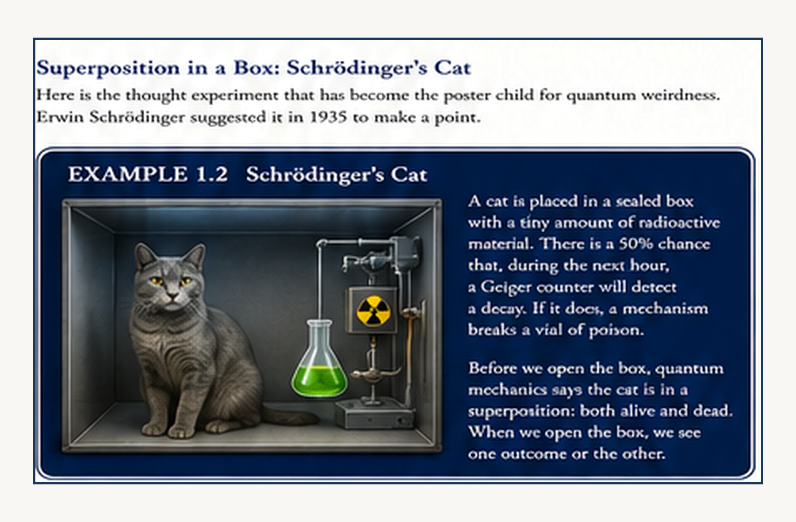
Schrödinger's Cat is a thought experiment, not a claim that real cats literally spend their afternoons in a quantum limbo. Schrödinger imagined a sealed box in which a microscopic quantum event could trigger a macroscopic outcome: the release of poison. Until the box is opened, the thought experiment asks how far we should take the mathematical language of superposition. The cat makes the abstract problem impossible to ignore.
Decoherence helps explain why macroscopic superpositions are so fragile, but questions about measurement and interpretation remain topics of active discussion.

The universe keeps its correlations
WHY THIS MATTERS
The concept matters because it solves a specific problem. Ask what would go wrong if physicists did not have this idea.
See Chapter 4 →

↑ Back to Contents
Entanglement teaches us something profound. The universe cannot always be understood as a collection of completely independent objects, each carrying its own private set of properties. Sometimes the physically meaningful object is the relationship between systems. The correlations are part of the state.
This is one reason quantum physics feels so different from classical physics. Classical intuition begins with objects. Quantum theory often begins with states and relationships.

Not magic—just different rules
It is easy to describe entanglement as magic. That is fun for a headline, but it is not helpful for understanding it. Entanglement is governed by precise mathematics. The predictions are quantitative.
The experiments are repeatable. The phenomenon has become an engineering resource. What is extraordinary is not that quantum mechanics breaks its own rules. It is that the rules themselves are so different from the rules our everyday experience taught us to expect.

One last pair of particles
Imagine the two entangled particles again. They leave the laboratory and travel in opposite directions. You measure yours. Your result is random.
Your friend measures theirs. Their result is also random. Later you compare the records. The patterns line up in a way that cannot be reproduced by ordinary local hidden instructions.
Nothing needed to shout across space. No message outran light. Yet the universe has revealed a connection between distant measurements that classical physics cannot explain. That is entanglement.
And it is real. Next we are going to take another step down the quantum ladder and discover that particles themselves are excitations of something deeper: quantum fields.
THINK ABOUT IT
Explain the preceding idea in one sentence without using the words 'quantum', 'weird', or 'magic'. If that is hard, you have found the next thing to understand.
See Chapter 4 →

Keep the physical question visible while reading the formal explanation. If the mathematics feels abstract, return to the experiment. If the experiment feels mysterious, return to the assumptions.
↑ Back to Contents

CHAPTER 4

EPR, Bell, Aspect, Zeilinger and Quantum Teleportation
EPR, Bell and teleportation: testing what quantum correlations really tell us.
SCIENCE FOR EVERYONE

EPR, Bell, Aspect, Zeilinger and Quantum Teleportation

Einstein's Problem With Quantum Mechanics
In 1935, Albert Einstein, Boris Podolsky, and Nathan Rosen published a paper with a deliberately awkward title: Can Quantum-Mechanical Description of Physical Reality Be Considered Complete? The answer they were steering toward was: No.
They were not trying to prove that quantum mechanics was useless. Quite the opposite. They thought quantum mechanics worked extraordinarily well. Their complaint was that it could not be the whole story.
The theory seemed to describe probabilities beautifully while refusing to tell us what the particles were actually doing underneath. Einstein found that deeply unsatisfying. He wanted a physical reality that did not depend on an observer choosing what to measure.

Was EPR Invented to Ridicule Quantum Mechanics?
PHYSICS IN PLAIN ENGLISH
First say what happens. Then say why it happens. Only then worry about the formalism. This builds the conceptual ladder.
See Chapter 3 →

↑ Back to Contents
“Ridicule” is a little too strong. But there was certainly a challenge in the paper. Einstein and his colleagues were deliberately constructing a situation in which quantum mechanics seemed to force an uncomfortable choice. Either the quantum description was incomplete.
Or apparently distant events had to be connected in a way that conflicted with their preferred idea of locality. Einstein believed the first option was the sensible one. He was essentially saying: “Your equations work.
But I don't believe they tell the whole physical story.” That is not ridicule. It is a very serious challenge. And it turned out to be one of the most productive challenges in the history of physics.

The Two-Particle Trick
FUN DETOUR
Physics has a recurring habit of making a sensible question produce an answer that sounds ridiculous. The universe is not being rude. Our intuition is simply out of its depth.
See Chapter 3 →

↑ Back to Contents

Imagine producing two particles in a correlated quantum state and sending them far apart. You measure one. The result tells you something about the other. Quantum mechanics predicts these correlations with extraordinary accuracy.
But Einstein's objection was subtle. If the distant particle has not been touched, how can your measurement here determine what you can predict about it there? Surely, Einstein argued, the distant particle must already possess the relevant properties. Otherwise, what exactly is the physical reality that quantum mechanics describes?
This became the famous EPR paradox.

Einstein's “Spooky” Problem
Einstein later referred to the apparent phenomenon as spooky action at a distance. The phrase has survived because it is wonderfully memorable. It is also dangerously misleading. Quantum entanglement produces correlations between measurements.
EXAMPLE
Imagine the classical version first. What would a little billiard-ball universe predict? Now compare that with the quantum result. The difference is the lesson.
See Chapter 3 →

↑ Back to Contents
It does not allow you to send an ordinary controllable message faster than light. That distinction becomes essential later when we discuss quantum teleportation. For Einstein, however, the problem was not merely communication. It was what the correlations seemed to say about the underlying reality.

Bohr Says: Not So Fast
Niels Bohr did not accept Einstein's conclusion. His response was subtle and philosophical. The properties of a quantum system cannot always be regarded as possessing the same classical reality independently of the measurement context. In other words, perhaps Einstein's demand for a classical picture of what the particle “really had” before measurement was precisely the wrong demand.
COMMON MISCONCEPTION
A diagram is not a microscopic movie. Use the picture to remember the relationship, then return to the words and the experiment.
See Chapter 3 →

↑ Back to Contents

Einstein wanted the theory to describe an underlying reality. Bohr argued that quantum mechanics required us to rethink what we mean by physical properties and measurement. Neither side was going to give the other an easy victory.

Then John Bell Walked Into the Argument
For almost thirty years, the dispute remained largely philosophical. Then, in 1964, John Stewart Bell found a way to turn the philosophical argument into an experimental one. Bell derived inequalities that must be satisfied by theories combining locality with certain kinds of realism. Quantum mechanics predicted that, under suitable conditions, those inequalities could be violated.
Now the argument could be tested. This was an extraordinary development. Einstein had asked: “Is quantum mechanics complete?”
Bell effectively asked: “Fine. Let's build the experiment.”
WHY THIS MATTERS
The concept matters because it solves a specific problem. Ask what would go wrong if physicists did not have this idea.
See Chapter 3 →

↑ Back to Contents

The Bell Test
The basic idea is wonderfully elegant. Create entangled particles. Send them to two distant measurement stations. Choose different measurement settings.
Record the results. Compare the correlations. If the world obeys a broad class of local hidden-variable theories, the correlations must satisfy Bell's inequality. Quantum mechanics predicts stronger correlations.
If the experiment violates the inequality, something has to give. The experiment cannot simply preserve the classical picture of local pre-existing properties.

Alain Aspect and the Answer From the Laboratory
THINK ABOUT IT
Explain the preceding idea in one sentence without using the words 'quantum', 'weird', or 'magic'. If that is hard, you have found the next thing to understand.
See Chapter 3 →

↑ Back to Contents
And this is where the person you were remembering enters: Alain Aspect. In experiments performed in the early 1980s, Aspect and his collaborators tested Bell inequalities using entangled photons and changing measurement settings while the photons were in flight. The results agreed with quantum mechanics and violated the Bell inequalities expected from local realistic theories.
This did not prove that “spooky signals” were being sent faster than light. It showed something more precise and more profound: nature does not behave according to the combination of locality and realism assumed by Bell's class of theories. Einstein's preferred classical picture had lost its experimental shelter.

The Universe Refuses to Be Classical
PHYSICS IN PLAIN ENGLISH
First say what happens. Then say why it happens. Only then worry about the formalism. This builds the conceptual ladder.
See Chapter 3 →

↑ Back to Contents
The remarkable thing is what happened next. Quantum mechanics did not collapse. It got stronger. The strange correlations were repeatedly observed.
Experiments became more sophisticated. The loopholes were attacked. And eventually the quantum correlations became part of the foundation of an entire new technological field: quantum information.
The very phenomenon Einstein regarded as a sign that quantum mechanics was incomplete became one of the resources we now try to exploit.

Enter Anton Zeilinger
FUN DETOUR
Physics has a recurring habit of making a sensible question produce an answer that sounds ridiculous. The universe is not being rude. Our intuition is simply out of its depth.
See Chapter 3 →

Keep the physical question visible while reading the formal explanation. If the mathematics feels abstract, return to the experiment. If the experiment feels mysterious, return to the assumptions.
↑ Back to Contents
This brings us to Anton Zeilinger and Austria. Zeilinger became one of the central experimental pioneers of quantum information, entanglement, and quantum teleportation. His group was associated with the University of Innsbruck for the famous first experimental quantum teleportation demonstration in 1997. Later, Zeilinger became a leading figure at the University of Vienna and in Austrian quantum physics.
So yes: University of Vienna absolutely belongs in this story. But the first famous teleportation experiment itself was performed at the University of Innsbruck, not Vienna.

Quantum Teleportation Sounds Completely Impossible
Now we arrive at the word that makes science-fiction writers very happy: teleportation. Unfortunately, quantum teleportation does not mean: “Beam me up, Scotty.”
EXAMPLE
Imagine the classical version first. What would a little billiard-ball universe predict? Now compare that with the quantum result. The difference is the lesson.
See Chapter 3 →

↑ Back to Contents

No human disappears. No object travels instantaneously. No spaceship enters a transporter chamber. What gets transferred is a quantum state.
The original physical state is destroyed by the measurement process, while the corresponding state is reconstructed elsewhere. That is already bizarre enough.

The Three-Particle Trick
The basic teleportation protocol uses three quantum systems. One carries the unknown quantum state we want to transfer. Two others are prepared in an entangled state. One member of the entangled pair stays with the sender.
The other goes to the receiver. The sender performs a joint measurement on the original system and their member of the entangled pair. That measurement produces classical information. The receiver then uses that classical information to perform the appropriate operation on their particle.
COMMON MISCONCEPTION
A diagram is not a microscopic movie. Use the picture to remember the relationship, then return to the words and the experiment.
See Chapter 3 →

↑ Back to Contents

The result is a reconstruction of the original quantum state at the distant location.

Nothing Has Been Beamed Through Space
This distinction is crucial. The original quantum state is not physically carried through the wormhole of science fiction. The entanglement provides correlations. The classical communication supplies the information needed to complete the reconstruction.
Because classical information must still travel at or below the speed of light, quantum teleportation does not permit faster-than-light communication. Relativity survives. Our intuition does not.

The First Experimental Teleportation
WHY THIS MATTERS
The concept matters because it solves a specific problem. Ask what would go wrong if physicists did not have this idea.
See Chapter 3 →

In 1997, Dik Bouwmeester, Jian-Wei Pan, Klaus Mattle, Manfred Eibl, Harald Weinfurter, and Anton Zeilinger demonstrated experimental quantum teleportation with photons. Their Nature paper reported transmission and reconstruction of a photon's polarization state using an entangled pair. The result was not science fiction. It was a laboratory demonstration of a protocol that had previously been a theoretical proposal.
And it was the beginning of a much larger field.

The University of Vienna Connection
THINK ABOUT IT
Explain the preceding idea in one sentence without using the words 'quantum', 'weird', or 'magic'. If that is hard, you have found the next thing to understand.
See Chapter 3 →

↑ Back to Contents
Zeilinger later became a major figure at the University of Vienna, where research in quantum optics, foundations, and quantum information continued. His work connected the old foundational puzzles to modern experimental physics. The EPR paradox was no longer merely a philosophical argument between Einstein and Bohr. It had become an experimental laboratory subject.
And then a technology. That is one of the most satisfying transformations in physics: a problem that began as “What does reality mean?” eventually becomes “Can we build something with this?”

Quantum Teleportation Is Not Copying
PHYSICS IN PLAIN ENGLISH
First say what happens. Then say why it happens. Only then worry about the formalism. This builds the conceptual ladder.
See Chapter 3 →

↑ Back to Contents
There is another beautiful feature. Quantum mechanics does not allow an unknown quantum state to be copied perfectly. That is the no-cloning theorem. Teleportation gets around the apparent problem by transferring the state while destroying the original.
So the process is not: make a second identical copy. It is: transfer the state, with the original no longer remaining in its original form.
The universe is apparently happy to move the information. It is considerably less enthusiastic about making duplicates.

What Did Bell Actually Prove?
Bell did not prove that quantum mechanics is correct in every possible respect. He proved something more specific. No theory satisfying Bell's assumptions about local hidden variables can reproduce all the predictions of quantum mechanics. Experiments violate Bell inequalities.
Therefore, if quantum predictions are right—and experiment after experiment says they are—nature cannot be described by that whole class of local realistic theories. This is more precise than saying: “Quantum mechanics is weird.” It tells us exactly which classical assumptions have failed.

So Was Einstein Wrong?
Yes—and no. Einstein was wrong about the particular classical picture he wanted nature to obey. But his objection was enormously fruitful. Without the EPR argument, Bell's theorem would not have had the same historical target.
Without Bell, the experimental program would not have had the same shape. Without those experiments, quantum information theory would not have developed in quite the same way. Einstein's objection helped expose one of the deepest properties of quantum mechanics. That is a spectacular way to lose an argument.

The Experimentalists Kept Tightening the Screws
Early Bell experiments had possible loopholes. Could the measurement settings have been correlated in some hidden way? Could the detectors have missed events? Could the two measurement stations somehow communicate during the experiment?
Experimentalists progressively closed important loopholes. In 2015, several groups reported increasingly rigorous “loophole-free” Bell tests. The result remained the same. Quantum correlations survived.
Local hidden-variable explanations of the relevant Bell type did not.

From Philosophical Nightmare to Quantum Technology
This is the extraordinary historical arc. 1935: EPR: Maybe quantum mechanics is incomplete. 1964:
Bell: We can test that. 1980s: Aspect: Nature violates Bell inequalities. 1990s:
Zeilinger and others: Let's use entanglement. 1997: Quantum teleportation is demonstrated. And now:
quantum communication, quantum cryptography, quantum computing, quantum networks,
and experiments probing the foundations of reality itself. The problem became a technology.

And This Connects Back to Wormholes
Now we can connect the previous chapter. Wormholes brought us to the idea of ER = EPR - EPR: Einstein–Podolsky–Rosen entanglement.
The conjecture suggests that certain forms of quantum entanglement may have a geometric interpretation involving wormhole-like structures. This is speculative theoretical physics, not a demonstrated method for traveling through spacetime.
But the conceptual connection is astonishing: the phenomenon Einstein introduced as an objection to quantum mechanics may be related, in some modern theories, to the geometry of spacetime itself.

The Great Irony
Einstein wanted EPR to show that quantum mechanics was incomplete. Instead, the EPR correlations became one of the defining features of quantum physics. Bell turned the argument into an experiment. Aspect and others tested it.
Zeilinger and others learned to manipulate the entanglement. And theoretical physicists now ask whether entanglement might help explain spacetime. Einstein was trying to expose a flaw. He may have accidentally pointed directly at one of nature's deepest structures.

What Actually Travels?
This question is worth ending on. In quantum teleportation, the quantum state is reconstructed elsewhere. Entanglement establishes correlations. Classical information completes the protocol.
Nothing usable travels faster than light. In a Bell experiment, correlations appear between distant outcomes that cannot be explained by local hidden variables. But those correlations cannot be controlled to transmit an ordinary message instantaneously. So what travels?
Not a little invisible signal racing between particles. What changes is our description of what can be jointly said about the system. That is much stranger.

The Punchline
Einstein looked at quantum mechanics and said, essentially: “This cannot be the whole story.” Then he and Podolsky and Rosen designed a thought experiment to expose the problem. Bell turned the argument into mathematics.
Aspect took it into the laboratory. Zeilinger helped turn entanglement into an experimental technology. And quantum teleportation demonstrated that a quantum state can be reconstructed at a distant location using entanglement plus ordinary classical communication. So the universe's response to Einstein was not:
“No.” It was more like: “No—but thank you for the excellent question.” And that may be one of the greatest compliments physics can give a skeptic.
FUN DETOUR
Physics has a recurring habit of making a sensible question produce an answer that sounds ridiculous. The universe is not being rude. Our intuition is simply out of its depth.
See Chapter 3 →

Keep the physical question visible while reading the formal explanation. If the mathematics feels abstract, return to the experiment. If the experiment feels mysterious, return to the assumptions.
↑ Back to Contents

CHAPTER 5

Quantum Fields: The Stuff Beneath Particles
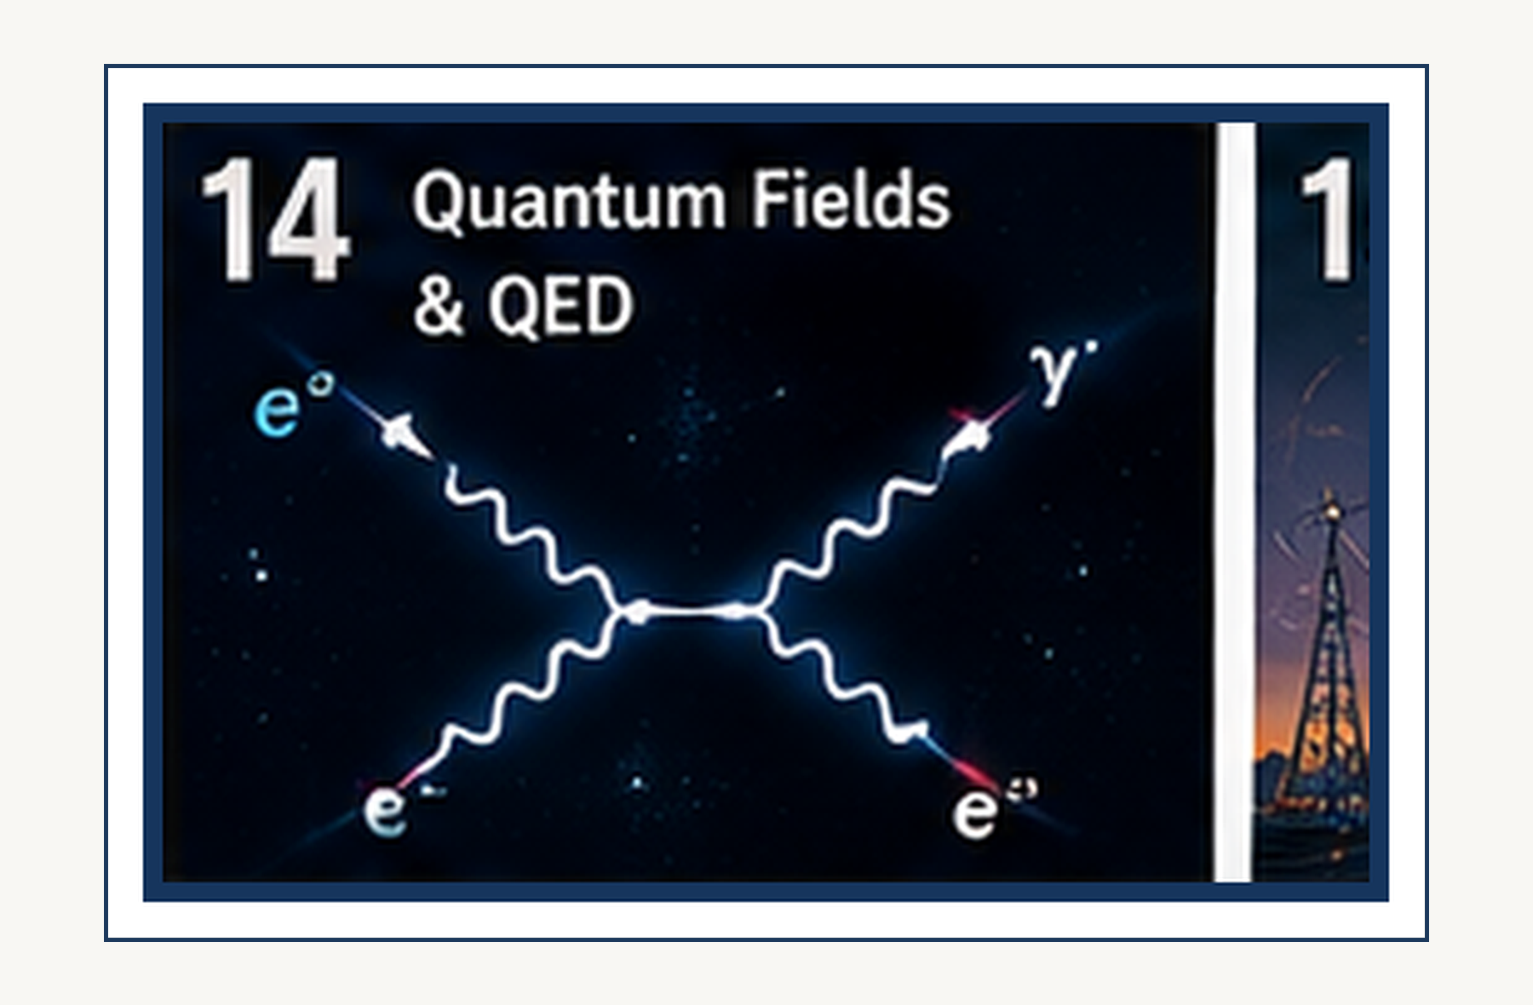
Quantum fields: particles as excitations of underlying fields.
SCIENCE FOR EVERYONE

Quantum Fields: The Stuff Beneath Particles

Particles Are Not Little Balls
We have spent a chapter learning that electrons and photons behave in ways that resist ordinary intuition. Now we can go one level deeper. Modern physics does not ultimately describe the universe as a collection of tiny billiard balls moving through empty space. It describes fields.
A particle is, in a very useful sense, an excitation of a field.

What is a field?
Imagine the temperature in a room. Every location has a temperature, so you could assign a number to every point in the room. That is a field. The temperature field is not a little object sitting somewhere. It is a quantity defined throughout space.
FUN DETOUR
Physics has a recurring habit of making a sensible question produce an answer that sounds ridiculous. The universe is not being rude. Our intuition is simply out of its depth.
See Chapter 7 →

↑ Back to Contents
Physics uses fields for many things: temperature, electric fields, magnetic fields, and gravitational fields. Quantum field theory takes the idea much further. It says that nature is filled with quantum fields, and what we call particles are excitations of those fields.

The electron field is everywhere
There is an electron field throughout the universe. An electron is an excitation of that field. If you remove one electron from one place and detect it somewhere else, you do not have to imagine a tiny permanent bead traveling through an otherwise empty void. The quantum field provides the deeper description.
This is a major conceptual shift. The particle is no longer the fundamental object in the same way it was in classical physics. The field is.
EXAMPLE
Imagine the classical version first. What would a little billiard-ball universe predict? Now compare that with the quantum result. The difference is the lesson.
See Chapter 7 →

↑ Back to Contents

The photon field
There is also an electromagnetic field. Its quantum excitations are photons. Light can therefore be described in two apparently different languages. In one language, we say that an electromagnetic wave propagates through space.
In another, we say that photons are emitted and absorbed. Quantum electrodynamics explains why both descriptions work and how they fit together. The wave is not replaced by the particle. The quantum field is the deeper framework containing both behaviors.

Empty space is not really empty
Now things get stranger. If quantum fields exist throughout space, what does it mean for a region to contain no particles? It does not mean that the fields have vanished. The vacuum state is the lowest-energy state of the quantum fields.
COMMON MISCONCEPTION
A diagram is not a microscopic movie. Use the picture to remember the relationship, then return to the words and the experiment.
See Chapter 7 →

↑ Back to Contents
And because quantum fields obey quantum rules, the vacuum is not simply featureless nothingness. It has structure. Quantum fluctuations can occur, and measurable effects can emerge from the properties of the vacuum.

Virtual particles: useful, but dangerous
You will often hear that empty space is full of virtual particles popping into existence and disappearing again. That is a useful shorthand in some calculations. It is also one of the most abused pictures in popular explanations of quantum field theory. Virtual particles are not ordinary particles briefly appearing from nowhere like tiny rabbits in a magician's hat.
WHY THIS MATTERS
The concept matters because it solves a specific problem. Ask what would go wrong if physicists did not have this idea.
See Chapter 7 →

↑ Back to Contents
They are mathematical elements in perturbative calculations. The underlying quantum field is the physical object. So when we use the phrase “virtual particle,” remember that it is a calculation tool, not necessarily a little invisible object flying around the laboratory.

Fields can create particles
If a field is excited strongly enough, particles can be produced. Energy can become particle excitations. This is closely related to the famous relationship:
E = mc²
Mass is not a mysterious substance stored inside matter.
Mass is one form of energy, and relativistic quantum field theory allows energy to be converted into particle excitations when the conservation laws permit it. This is why high-energy particle collisions can create new particles that were not present before the collision.

The particle zoo
THINK ABOUT IT
Explain the preceding idea in one sentence without using the words 'quantum', 'weird', or 'magic'. If that is hard, you have found the next thing to understand.
See Chapter 7 →

↑ Back to Contents
Once physicists learned how to probe quantum fields at high energies, they discovered a remarkable collection of particles. Electrons. Quarks. Neutrinos.
Photons. Gluons. W and Z bosons. And the Higgs boson.
For a while, the list became so complicated that physicists jokingly referred to it as the particle zoo. The great achievement of the Standard Model was to organize this zoo into a coherent framework.

Quarks: the hidden ingredients
Protons and neutrons are not fundamental particles. They are made from quarks. A proton contains two up quarks and one down quark. A neutron contains one up quark and two down quarks.
PHYSICS IN PLAIN ENGLISH
First say what happens. Then say why it happens. Only then worry about the formalism. This builds the conceptual ladder.
See Chapter 7 →

↑ Back to Contents

But there is a catch. Quarks are not normally found wandering freely around in the laboratory. They are confined inside composite particles by the strong interaction. Nature has apparently decided that quarks should come in company.

The strong force
The strong interaction is carried by particles called gluons. The name is appropriate. Gluons bind quarks together. The underlying theory is called quantum chromodynamics, or QCD.
FUN DETOUR
Physics has a recurring habit of making a sensible question produce an answer that sounds ridiculous. The universe is not being rude. Our intuition is simply out of its depth.
See Chapter 7 →

↑ Back to Contents
The strong interaction behaves in a particularly interesting way: the force becomes weaker at very short distances and stronger as quarks are pulled apart. This is called asymptotic freedom at short distances and confinement at larger distances. Pull a quark away from its partners and you do not simply get a lonely quark. Instead, the energy stored in the field can produce new quark-antiquark pairs.

The Higgs field
The Higgs field is another quantum field filling the universe. The Higgs boson is an excitation of that field. The Higgs mechanism is connected to why certain elementary particles have mass. This does not mean that the Higgs field simply “slows particles down” as they move through a sticky cosmic substance.
EXAMPLE
Imagine the classical version first. What would a little billiard-ball universe predict? Now compare that with the quantum result. The difference is the lesson.
See Chapter 7 →

Keep the physical question visible while reading the formal explanation. If the mathematics feels abstract, return to the experiment. If the experiment feels mysterious, return to the assumptions.
↑ Back to Contents

That popular analogy is misleading. The mathematical mechanism is subtler. The Higgs field has a nonzero vacuum value, and its interactions with other fields contribute to the masses of the W and Z bosons and to elementary fermion masses.

Mass is not all the same thing
There is another subtlety worth knowing. Most of the mass of an ordinary proton does not simply come from adding up the rest masses of its three valence quarks. Much of the proton's mass comes from the energy of the strong-interaction field and the motion and interactions of quarks and gluons inside it. So when you look at your hand, the mass you feel is largely an emergent property of quantum field dynamics.
COMMON MISCONCEPTION
A diagram is not a microscopic movie. Use the picture to remember the relationship, then return to the words and the experiment.
See Chapter 7 →

↑ Back to Contents
That is one of the most beautiful surprises in modern physics.

Forces become fields
In classical physics, we talk about forces acting between objects. In quantum field theory, interactions are described through fields and their couplings. Electromagnetism is associated with the electromagnetic field. The strong interaction with the gluon field.
The weak interaction with the W and Z fields. Gravity is the awkward member of the family, because our best description of gravity is still general relativity rather than a completed quantum field theory of spacetime itself.

The Standard Model
WHY THIS MATTERS
The concept matters because it solves a specific problem. Ask what would go wrong if physicists did not have this idea.
See Chapter 7 →

↑ Back to Contents

The Standard Model is our remarkably successful quantum theory of the known elementary particles and three of the fundamental interactions. It is not a theory of everything. It does not incorporate gravity in the same quantum framework. It does not explain dark matter.
It does not explain why the constants of nature have the values they do. It does not tell us why there is more matter than antimatter. So “Standard Model” does not mean “final answer.” It means something more modest and more impressive: the best-tested framework we have for a huge part of the microscopic universe.

Why the theory works so well
THINK ABOUT IT
Explain the preceding idea in one sentence without using the words 'quantum', 'weird', or 'magic'. If that is hard, you have found the next thing to understand.
See Chapter 7 →

Quantum field theory is extraordinarily accurate. Quantum electrodynamics has produced predictions that agree with experiments to astonishing precision. The Standard Model has predicted particles before they were observed. The Higgs boson was discovered in 2012 at CERN, decades after the mechanism was proposed.
This is what a successful scientific theory looks like. It is not merely a story that sounds plausible. It makes quantitative predictions that experiments can try to break.

But what is a particle really?
At this point you may be wondering whether we have simply moved the mystery one level deeper. Instead of asking what an electron is, we now ask what an electron field is. That is a fair complaint. Physics does not always eliminate mystery.
PHYSICS IN PLAIN ENGLISH
First say what happens. Then say why it happens. Only then worry about the formalism. This builds the conceptual ladder.
See Chapter 7 →

Sometimes it replaces a bad mystery with a better one. The field description explains an enormous amount of observed behavior. It tells us how particles are created, destroyed, scattered, and transformed. It gives us calculations that work.
Whether the field itself is the ultimate layer of reality is a philosophical question that physics has not settled.

A field can have a personality
Different quantum fields have different properties. Some correspond to matter particles. Some correspond to force-carrying particles. They have different masses, charges, spins, and interactions.
FUN DETOUR
Physics has a recurring habit of making a sensible question produce an answer that sounds ridiculous. The universe is not being rude. Our intuition is simply out of its depth.
See Chapter 7 →

You can think of the universe as containing a collection of overlapping quantum fields, all occupying the same spacetime. What we experience as matter is the behavior of those fields. The apparent solidity of a table is therefore an emergent macroscopic phenomenon produced by quantum fields obeying quantum rules.
↑ Back to Contents

The quantum field picture
Imagine spacetime as the stage we discussed in relativity. Now imagine that the stage is permeated by fields. The electron field. The electromagnetic field.
The quark fields. The gluon field. The Higgs field. And others.
Particles are localized excitations of these fields. Interactions occur when the fields interact. This is the modern picture behind much of particle physics.

One last field
We have traveled a long way from the idea of tiny particles flying through empty space. First, quantum mechanics told us that particles can behave like waves. Then entanglement showed us that quantum systems can possess correlations that have no simple classical explanation. Now quantum field theory tells us that particles themselves are excitations of underlying fields.
The universe is beginning to look less like a box full of things and more like a set of interacting structures. And there is still one enormous piece missing. Gravity. We have a superb quantum description of three fundamental interactions and a superb geometric description of gravity.
But the two frameworks do not yet fit together completely. That is the problem we will eventually have to confront.
EXAMPLE
Imagine the classical version first. What would a little billiard-ball universe predict? Now compare that with the quantum result. The difference is the lesson.
See Chapter 7 →

Keep the physical question visible while reading the formal explanation. If the mathematics feels abstract, return to the experiment. If the experiment feels mysterious, return to the assumptions.
↑ Back to Contents

CHAPTER 6

QCD: The Strong Force and the Quark World
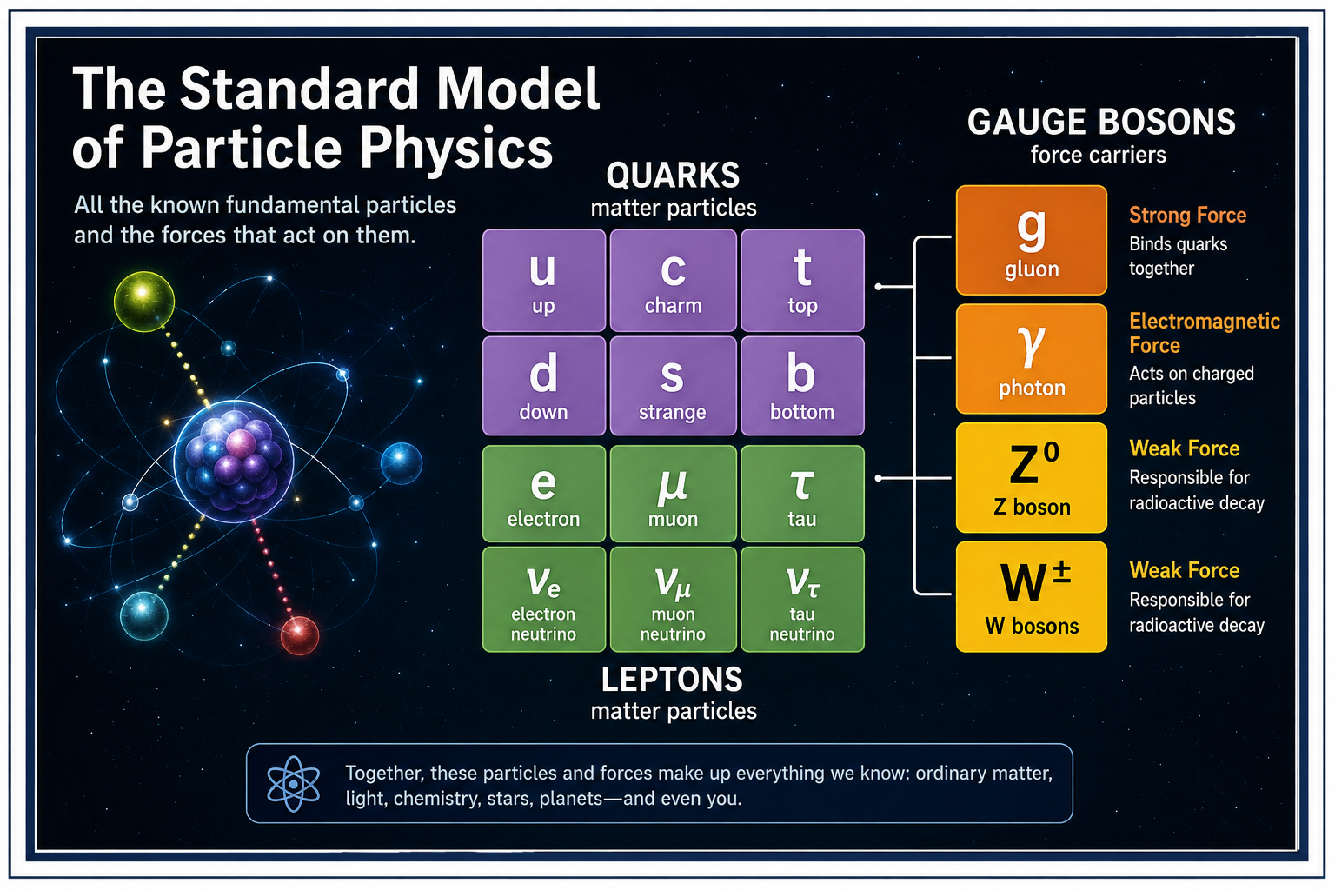
QCD: quarks, gluons, color, and the strong interaction.

QCD: The Strong Force and the Quark World

The Force That Holds the Nucleus Together
We have met electromagnetism and quantum fields. Now we meet the strongest of the fundamental interactions at the level where quarks and gluons live. It is called the strong interaction, and its quantum theory is quantum chromodynamics, or QCD. QCD explains why quarks live inside protons and neutrons, why those particles have almost all of their familiar mass, and why quarks stubbornly refuse to wander around the laboratory by themselves.
The strong force is both enormously powerful and wonderfully strange.

Why “strong” is not quite the whole story
EXAMPLE
Imagine the classical version first. What would a little billiard-ball universe predict? Now compare that with the quantum result. The difference is the lesson.
See Chapter 5 →

At first glance, the strong interaction seems simple: it is strong. But its behavior is unlike a stretched rubber band or a powerful magnet. At very short distances, quarks can interact relatively weakly. As you try to pull them apart, the interaction becomes stronger.
That reversal is one of the central clues to the structure of QCD. The quarks behave almost as though they become freer when they are extremely close together and more tightly imprisoned when you try to separate them.

Quarks come in flavors
Quarks come in six types, which physicists call flavors: up, down, strange, charm, bottom, and top. The names are not meant to describe their personalities. An up quark is not cheerful. A strange quark is not suspicious.
COMMON MISCONCEPTION
A diagram is not a microscopic movie. Use the picture to remember the relationship, then return to the words and the experiment.
See Chapter 5 →

These are simply labels. The up and down quarks make up ordinary protons and neutrons. The heavier flavors can be produced in high-energy environments and particle collisions, but the heavier quarks are unstable and decay into lighter particles.

Quarks also come in colors
QCD has another piece of terminology that sounds like someone got bored during a committee meeting. Quarks come in three colors: red, green, and blue. They are not literally colored. Color is a quantum property, analogous in spirit to electric charge but governed by the strong interaction.
The three colors are arranged so that observable particles are color-neutral overall. So when a physicist says “red quark,” please do not imagine a tiny crimson marble.

The gluon: the strong interaction's messenger
WHY THIS MATTERS
The concept matters because it solves a specific problem. Ask what would go wrong if physicists did not have this idea.
See Chapter 5 →

The electromagnetic interaction has the photon. The strong interaction has the gluon. Gluons carry the strong interaction between quarks. But there is a crucial difference.
Photons themselves have no electric charge, so photons do not directly interact with one another in ordinary quantum electrodynamics. Gluons carry color charge. That means gluons can interact with other gluons. The strong field therefore has a wonderfully complicated self-interacting character.
↑ Back to Contents

Why QCD is called a gauge theory
QCD belongs to the family of quantum gauge theories. The underlying symmetry is called SU(3) color. You do not need to become fluent in group theory to understand the physical idea. The equations contain a symmetry describing how the internal color degrees of freedom can be transformed without changing the physical predictions.
THINK ABOUT IT
Explain the preceding idea in one sentence without using the words 'quantum', 'weird', or 'magic'. If that is hard, you have found the next thing to understand.
See Chapter 5 →

Demanding that this symmetry work locally leads naturally to gauge fields. Those fields are the gluons. So the gluon is not an arbitrary extra particle someone invented to make the theory work. It emerges from the structure of the gauge theory.

Asymptotic freedom: quarks loosen their grip
In the 1970s, David Gross, Frank Wilczek, and David Politzer discovered a remarkable property of non-Abelian gauge theories such as QCD. At very short distances—or equivalently, at very high momentum transfers—the effective strong coupling becomes smaller. The quarks behave more like weakly interacting particles. This is called asymptotic freedom.
PHYSICS IN PLAIN ENGLISH
First say what happens. Then say why it happens. Only then worry about the formalism. This builds the conceptual ladder.
See Chapter 5 →

It sounds almost backward. Usually we expect a force to become stronger as things get closer. QCD does something more interesting. Get extremely close and the quarks become comparatively free.
Try to pull them apart and the strong interaction becomes harder to escape.
↑ Back to Contents

Confinement: no lonely quarks
The other side of the story is confinement. Quarks are not normally observed as isolated particles. When you try to separate quarks, the energy stored in the strong field increases. Eventually it becomes energetically favorable to create new quark-antiquark pairs rather than produce a single isolated quark.
FUN DETOUR
Physics has a recurring habit of making a sensible question produce an answer that sounds ridiculous. The universe is not being rude. Our intuition is simply out of its depth.
See Chapter 5 →

The result is a collection of color-neutral particles. You do not get one naked quark. You get more hadrons. Nature seems to respond to your attempt to liberate a quark by giving you additional particles instead.

Protons are not three little balls
A proton is often introduced as two up quarks and one down quark. That statement is correct but incomplete. The proton is a complicated quantum system containing three valence quarks plus a constantly fluctuating sea of gluons and quark-antiquark pairs. The word “valence” identifies the quark content responsible for the proton's overall quantum numbers.
It does not mean that the proton is a rigid bag containing exactly three tiny marbles.

Where does the proton's mass come from?
EXAMPLE
Imagine the classical version first. What would a little billiard-ball universe predict? Now compare that with the quantum result. The difference is the lesson.
See Chapter 5 →

This is one of the most beautiful lessons of QCD. The up and down quarks themselves have relatively small current masses compared with the mass of a proton. Yet a proton weighs about 938 MeV/c². Where does most of that mass come from?
From the energy of the strongly interacting quantum fields inside the proton: quark motion, gluon fields, and the energy associated with confinement and the dynamics of QCD. The mass of ordinary matter is therefore largely an emergent consequence of the strong interaction. You are carrying around the energy of a quantum field theory.
↑ Back to Contents

The nucleus: a second layer of the strong story
COMMON MISCONCEPTION
A diagram is not a microscopic movie. Use the picture to remember the relationship, then return to the words and the experiment. See Chapter 5 →

There is a subtle distinction worth making. QCD describes the fundamental strong interaction between quarks and gluons. But protons and neutrons are themselves composite objects. The force that binds protons and neutrons together inside an atomic nucleus is often described as the residual strong interaction.
It is somewhat analogous to saying that molecules experience forces because of the electromagnetic interactions of their constituent atoms. The nuclear force is not a completely separate fundamental force. It is a leftover effect of QCD acting between composite hadrons.

Why protons do not fly apart
WHY THIS MATTERS
The concept matters because it solves a specific problem. Ask what would go wrong if physicists did not have this idea.
See Chapter 5 →

Keep the physical question visible while reading the formal explanation. If the mathematics feels abstract, return to the experiment. If the experiment feels mysterious, return to the assumptions.

Two protons both carry positive electric charge, so electromagnetically they repel each other. Yet nuclei can hold multiple protons together. At nuclear distances, the residual strong interaction can be attractive enough to overcome the electric repulsion. This is why the atomic nucleus is possible.
The universe has therefore arranged a rather amusing contest: electromagnetism says “stay away from each other,” while the strong interaction says “get over here.”
↑ Back to Contents

Pions: the old picture that still helps
Historically, physicists described the nuclear force using the exchange of particles such as pions. This picture remains extremely useful for understanding nuclear physics at ordinary nuclear distances. But pions are not the fundamental carriers of the strong interaction. At the deepest level, QCD is about quarks and gluons.
THINK ABOUT IT
Explain the preceding idea in one sentence without using the words 'quantum', 'weird', or 'magic'. If that is hard, you have found the next thing to understand.
See Chapter 5 →

↑ Back to Contents
The pion-exchange picture is an effective description that emerges from the more fundamental theory. Again, physics gives us layers of description rather than one single cartoon that works perfectly at every scale.

Jets: seeing quarks without seeing quarks
If quarks cannot escape, how do we know they exist? One spectacular clue comes from high-energy collisions. A quark produced with enormous energy cannot simply fly away as a free quark. Instead, the energy produces a cascade of particles.
The result is a narrow spray called a jet. Experiments can measure these jets and compare their patterns with QCD predictions. We therefore infer the behavior of quarks from the structured debris they leave behind.

Deep inelastic scattering
PHYSICS IN PLAIN ENGLISH
First say what happens. Then say why it happens. Only then worry about the formalism. This builds the conceptual ladder.
See Chapter 5 →

Another decisive clue came from smashing high-energy electrons into protons. At sufficiently short distances, the electron can probe the proton's internal structure. The scattering data revealed point-like constituents inside the proton. These constituents behaved in a way consistent with quarks.
The proton was not an indivisible ball. It had internal structure. And that structure behaved according to the strange rules of QCD.

The QCD vacuum is not empty
We already learned that quantum fields make the vacuum more interesting than ordinary empty space. QCD makes the story even richer. The vacuum of the strong interaction has a complicated structure. Quantum fluctuations and the behavior of the strong field contribute to phenomena such as confinement and the properties of hadrons.
FUN DETOUR
Physics has a recurring habit of making a sensible question produce an answer that sounds ridiculous. The universe is not being rude. Our intuition is simply out of its depth.
See Chapter 5 →

So even when there are no ordinary particles sitting in a region, the underlying quantum fields have not simply switched off.

↑ Back to Contents

Why QCD is difficult to calculate
QCD is beautifully defined but often painfully difficult to calculate. At very high energies, asymptotic freedom lets physicists use powerful perturbative methods. At low energies, the coupling becomes strong. The neat approximation methods that work at high energies stop working.
Physicists then use other techniques, especially lattice QCD, in which spacetime is represented on a discrete computational lattice and the quantum theory is studied numerically. This is not a failure of QCD. It is a reminder that a simple set of equations can generate extraordinarily complicated collective behavior.

Lattice QCD: turning equations into a universe on a computer
EXAMPLE
Imagine the classical version first. What would a little billiard-ball universe predict? Now compare that with the quantum result. The difference is the lesson.
See Chapter 5 →

↑ Back to Contents

Imagine replacing continuous spacetime with an enormous four-dimensional grid. The quantum fields live on that grid. Then a computer evaluates the resulting theory numerically. This is the basic idea of lattice QCD.
It allows physicists to calculate quantities such as hadron masses and other strong-interaction properties from the underlying theory. The calculation can be ferociously demanding. But it provides a remarkable bridge from fundamental equations to the particles we actually observe.

The quark-gluon plasma
COMMON MISCONCEPTION
A diagram is not a microscopic movie. Use the picture to remember the relationship, then return to the words and the experiment.
See Chapter 5 →

↑ Back to Contents
At ordinary conditions, quarks and gluons are confined inside hadrons. Heat matter to extraordinary temperatures or compress it to extreme densities, and a different state can appear: the quark-gluon plasma. In this state, quarks and gluons are no longer organized into ordinary protons and neutrons. Heavy-ion collision experiments can create tiny, fleeting droplets of this exotic matter.
It is less like a bag of liberated quarks and more like a strongly interacting quantum fluid. Even the most violent experiments produce something surprisingly collective.

The early universe was a QCD laboratory
WHY THIS MATTERS
The concept matters because it solves a specific problem. Ask what would go wrong if physicists did not have this idea.
See Chapter 5 →

↑ Back to Contents
Shortly after the Big Bang, the universe was much hotter and denser than anything we experience today. At sufficiently early times, the conditions were hot enough for matter to exist in a quark-gluon plasma-like state. As the universe expanded and cooled, quarks became confined into hadrons. Eventually protons and neutrons formed the material from which later nuclei, stars, planets, and people could develop.
The strong interaction therefore helped determine the inventory of the visible universe from its earliest moments.

QCD and the Standard Model
QCD is one of the two quantum gauge theories describing the strong and electroweak sectors of the Standard Model. Quantum electrodynamics describes electromagnetism. Quantum chromodynamics describes the strong interaction. The electroweak theory describes the weak interaction and its relationship to electromagnetism.
Together these theories form an extraordinarily successful framework for particle physics. And yet, as we have already learned, the Standard Model still does not include a complete quantum theory of gravity.

One last quark
Imagine trying to pull a quark out of a proton. At first, you might picture the quark escaping into empty space. Instead, the strong field resists. Pull harder and you store more energy.
Eventually there is enough energy to create another quark-antiquark pair. The original quark is still not alone. You have made more hadrons. That is confinement in one wonderfully stubborn picture.
The quark world is not a collection of tiny free particles. It is a world of fields, symmetries, collective behavior, and emergent objects. And from that strange quantum world come the protons and neutrons that make almost all of the ordinary matter around us. Next we will turn to another remarkable ingredient of the Standard Model: the weak interaction, the force behind radioactive decay, neutrinos, and the reactions that make stars shine.
THINK ABOUT IT
Explain the preceding idea in one sentence without using the words 'quantum', 'weird', or 'magic'. If that is hard, you have found the next thing to understand.
See Chapter 5 →

Keep the physical question visible while reading the formal explanation. If the mathematics feels abstract, return to the experiment. If the experiment feels mysterious, return to the assumptions.
↑ Back to Contents

CHAPTER 7

QED — The Strange Theory of Light and Matter
QED: the quantum theory of light and charged matter.
SCIENCE FOR EVERYONE

QED - The Strange Theory of Light and Matter

The Photon at the Door
Switch on a lamp. Nothing seems dangerous. Light fills the room. You see the table.
You see your hand. You probably do not feel that you have just summoned one of the strangest entities in modern physics. But you have. A photon.
COMMON MISCONCEPTION
A diagram is not a microscopic movie. Use the picture to remember the relationship, then return to the words and the experiment.

↑ Back to Contents
Suppose an electron travels from one place to another. Classically, you would draw a path. Here. Then here.
Then here. Quantum mechanics refuses to be so cooperative. Instead, we calculate amplitudes for possible processes. Different possibilities interfere.
Some reinforce one another. Some cancel. And the final probability emerges from that interference. It is tempting to imagine that the electron secretly chose one ordinary path and that our equations merely describe our ignorance.
Quantum mechanics does not require that picture. Nature is under no obligation to behave like a tiny billiard table.

Feynman's Sum Over Possibilities
WHY THIS MATTERS
The concept matters because it solves a specific problem. Ask what would go wrong if physicists did not have this idea.

↑ Back to Contents
Feynman's path-integral way of thinking makes the situation even stranger. Instead of asking only for the one path a particle took, we can mathematically consider contributions from many possible paths. The amplitudes combine. Most possibilities cancel out.
The paths around the classical one reinforce each other in the appropriate limit. And classical physics emerges. That is the trick. The familiar world is not necessarily fundamental.
It can emerge from a deeper quantum calculation in which possibilities interfere.

The Little Diagram That Lied
Then Feynman introduced another extraordinary tool. The Feynman diagram. An electron line meets a photon line. Something happens.
THINK ABOUT IT
Explain the preceding idea in one sentence without using the words 'quantum', 'weird', or 'magic'. If that is hard, you have found the next thing to understand.

↑ Back to Contents

The lines are mathematical ingredients. The “virtual particles” appearing in the bookkeeping are not necessarily little objects flying around that a detector could photograph. The diagram is telling you how to calculate an amplitude. Physics has always had a weakness for pictures that look more literal than they are.

The Vacuum Is Not Empty
Now remove everything. No atoms. No light. No matter.
No dust. Nothing. You might imagine empty space. Quantum field theory has a different answer.
The fields remain. Even what we call the vacuum has quantum structure. The electromagnetic field is still there. Its quantum fluctuations matter.
PHYSICS IN PLAIN ENGLISH
First say what happens. Then say why it happens. Only then worry about the formalism. This builds the conceptual ladder.

↑ Back to Contents

Empty space is not simply a box containing nothing. It is the lowest-energy state of fields. The universe has apparently decided that “nothing” is too simple.

Why QED Is So Successful
QED makes extraordinarily precise predictions about electromagnetic phenomena. It describes interactions between charged particles and photons. It underlies our understanding of atoms, light, chemistry and enormous parts of modern technology. And it survives experimental tests of astonishing precision.
That makes QED more than an interesting theory. It is one of the places where physics comes dangerously close to saying: “We have this figured out.” Physicists immediately become suspicious whenever a sentence begins that way.

Renormalization: The Horrible Calculation That Works
FUN DETOUR
Physics has a recurring habit of making a sensible question produce an answer that sounds ridiculous. The universe is not being rude. Our intuition is simply out of its depth.

↑ Back to Contents

Early quantum field calculations produced infinities. Not small errors. Infinities. The theory seemed to be producing nonsense.
Renormalization provided a systematic way to reorganize the calculation so that measurable quantities became finite and predictive. It initially looked suspicious. Then it worked. And worked.
And worked. The deeper lesson is not that physicists learned to hide infinities under the carpet. It is that the quantities we directly measure are not always identical to the naïve parameters appearing in a mathematical description. Reality is more subtle than the first draft of the equations.

The Electron's Magnetic Moment
EXAMPLE
Imagine the classical version first. What would a little billiard-ball universe predict? Now compare that with the quantum result. The difference is the lesson.

↑ Back to Contents

One of QED's famous triumphs is its calculation of the electron's anomalous magnetic moment. The agreement between theory and experiment is extraordinarily precise. It is one of those comparisons that makes physicists slightly uncomfortable. Not because it disagrees.
Because it agrees so well. When a theory survives tests at that level, you start wondering where the next crack might be.

The Punchline
QED began with a simple question: How do light and matter interact? The answer turned into photons, amplitudes, virtual processes, quantum fields, interference, renormalization, and calculations of almost absurd precision. Feynman did something particularly useful along the way.
COMMON MISCONCEPTION
A diagram is not a microscopic movie. Use the picture to remember the relationship, then return to the words and the experiment.

Keep the physical question visible while reading the formal explanation. If the mathematics feels abstract, return to the experiment. If the experiment feels mysterious, return to the assumptions.
↑ Back to Contents
He made the strange parts easier to think about without pretending they were ordinary. That is the secret of good physics. Do not make the universe less strange. Make the reader brave enough to look at it.
WHY THIS MATTERS
The concept matters because it solves a specific problem. Ask what would go wrong if physicists did not have this idea.

↑ Back to Contents

What Does an Electron Actually Do?
THINK ABOUT IT
Explain the preceding idea in one sentence without using the words 'quantum', 'weird', or 'magic'. If that is hard, you have found the next thing to understand.

↑ Back to Contents
This is the territory of quantum electrodynamics—QED. Feynman helped turn it into one of the most successful theories ever devised.
PHYSICS IN PLAIN ENGLISH
First say what happens. Then say why it happens. Only then worry about the formalism. This builds the conceptual ladder.

↑ Back to Contents

Another line leaves. It looks like a tiny comic strip of subatomic events. But the diagram is not a photograph. It is a calculation.
FUN DETOUR
Physics has a recurring habit of making a sensible question produce an answer that sounds ridiculous. The universe is not being rude. Our intuition is simply out of its depth.

↑ Back to Contents

Not a tiny classical bullet. Not quite a little wave either. A quantum of the electromagnetic field. And when photons interact with matter, our everyday intuition becomes almost useless.
EXAMPLE
Imagine the classical version first. What would a little billiard-ball universe predict? Now compare that with the quantum result. The difference is the lesson.

Keep the physical question visible while reading the formal explanation. If the mathematics feels abstract, return to the experiment. If the experiment feels mysterious, return to the assumptions.
↑ Back to Contents

CHAPTER 8

Collective Electrodynamics: When Electromagnetism Emerges from Quantum Matter
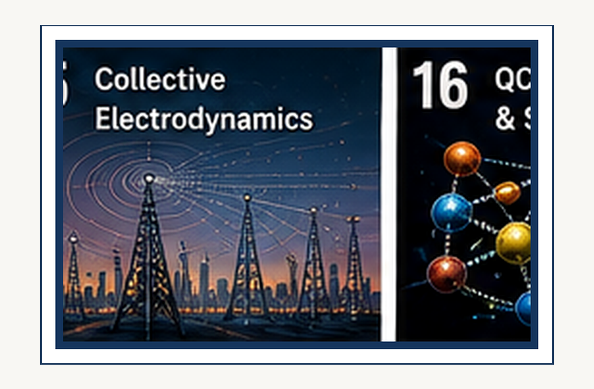
Collective electrodynamics: how familiar electromagnetic behavior can emerge.
SCIENCE FOR EVERYONE

Collective Electrodynamics: When Electromagnetism Emerges from Quantum Matter

A Different Way to Ask the Question
We have just learned that electricity, magnetism, and light belong to one electromagnetic field. The usual route is to start with Maxwell's equations and then, later, quantize the electromagnetic field. Carver Mead asks us to turn the route around. What if we start with quantum matter—electrons, their wave nature, their interactions—and see how much of electromagnetism can be recovered from there?
WHY THIS MATTERS
The concept matters because it solves a specific problem. Ask what would go wrong if physicists did not have this idea.

↑ Back to Contents
That is the central adventure of collective electrodynamics. It is not simply a new way of drawing Maxwell's equations. Mead's program starts from experimentally grounded quantum behavior of matter and derives standard electromagnetic results from the interactions of quantum systems. The surprising claim is that phenomena we normally treat as separate pieces of electromagnetism can emerge from a deeper quantum description.

Maxwell gave us the beautiful finished picture
Maxwell's theory is one of the great achievements of physics. Electric fields, magnetic fields, waves, radiation, and light fit into one elegant mathematical structure. But Maxwell did not know about electrons as quantum objects. He lived before the electron's quantum nature had been experimentally established.
THINK ABOUT IT
Explain the preceding idea in one sentence without using the words 'quantum', 'weird', or 'magic'. If that is hard, you have found the next thing to understand.

↑ Back to Contents

That creates an intriguing historical question: if we now know more about matter than Maxwell did, can we rebuild the electromagnetic story from that deeper knowledge? Mead's answer is essentially yes—at least for a broad and important class of electromagnetic phenomena. The standard electromagnetic results still come out, but the conceptual starting point is different.

Electromagnetism as electrons talking to electrons
Here is the wonderfully simple intuition. Forget, for a moment, the idea that an electromagnetic field is a separate thing sitting between two charges. Imagine instead that one quantum system interacts with another. Electrons affect electrons.
PHYSICS IN PLAIN ENGLISH
First say what happens. Then say why it happens. Only then worry about the formalism. This builds the conceptual ladder.

↑ Back to Contents
The electromagnetic behavior we observe can then be understood as the collective manifestation of those interactions. Mead himself describes the point in strikingly direct terms: electromagnetism is not something separate from electrons and their interactions. It is part of what the electrons are doing to one another. That is a very different mental picture from the one most introductory courses give us.
And it is exactly the sort of conceptual reversal that can make physics suddenly feel alive.

The word collective matters
FUN DETOUR
Physics has a recurring habit of making a sensible question produce an answer that sounds ridiculous. The universe is not being rude. Our intuition is simply out of its depth.

↑ Back to Contents

Why call it collective electrodynamics? Because the behavior of many quantum particles can become extraordinarily coherent. A superconducting system is a particularly beautiful example. A large population of electrons can form a coherent quantum state in which the behavior of the individual particles is strongly tied to the state of the ensemble.
The system then becomes a macroscopic quantum object. That is enormously useful. Instead of trying to watch one lonely electron perform every electromagnetic trick, we can study a collective system whose quantum behavior is measurable on a laboratory scale. Mead's work emphasizes such macroscopic quantum systems as a route to clearer physical intuition.

Superconductors: quantum mechanics you can almost touch
EXAMPLE
Imagine the classical version first. What would a little billiard-ball universe predict? Now compare that with the quantum result. The difference is the lesson.

↑ Back to Contents
Quantum mechanics can sound abstract when all we have is a symbol on a blackboard. A superconducting circuit is different. It is a physical object large enough to hold in your hand, yet its collective behavior can preserve quantum coherence. That gives us an extraordinary bridge between microscopic quantum physics and macroscopic electrical behavior.
Mead's approach takes advantage of this bridge. The quantum nature of matter is no longer hidden behind an idealized single-particle thought experiment. It becomes something that can be engineered, measured, and manipulated.

The vector potential moves to center stage
COMMON MISCONCEPTION
A diagram is not a microscopic movie. Use the picture to remember the relationship, then return to the words and the experiment.

↑ Back to Contents

Introductory electromagnetism often teaches us to think primarily in terms of electric and magnetic fields. Mead's treatment puts the electromagnetic potentials in a more fundamental-looking position, especially the vector potential and scalar potential. This may sound like a change of notation. It is more interesting than that.
Quantum mechanics is sensitive to the potentials in ways that cannot be captured by the naive idea that only the local force fields matter. The Aharonov–Bohm effect is a famous reminder that quantum phases can respond to electromagnetic potentials even in regions where the classical magnetic field is zero. The potentials therefore become more than bookkeeping devices. They become part of the physical language of quantum interaction.

The Aharonov–Bohm warning
WHY THIS MATTERS
The concept matters because it solves a specific problem. Ask what would go wrong if physicists did not have this idea.

↑ Back to Contents

Imagine a region in which the magnetic field is zero. Classically, you might conclude that a charged particle traveling there has nothing magnetic to worry about. Quantum mechanics is less easily satisfied. In the Aharonov–Bohm effect, the electromagnetic vector potential can influence the quantum phase of a particle even when the particle travels through a region where the magnetic field itself vanishes.
This does not mean that a mysterious force is secretly pushing the particle. It means that quantum phase and electromagnetic potentials are connected in a deeper way than our classical intuition suggests. That is precisely the kind of clue Mead takes seriously.

Start with what experiments tell us about electrons
THINK ABOUT IT
Explain the preceding idea in one sentence without using the words 'quantum', 'weird', or 'magic'. If that is hard, you have found the next thing to understand.

Keep the physical question visible while reading the formal explanation. If the mathematics feels abstract, return to the experiment. If the experiment feels mysterious, return to the assumptions.
↑ Back to Contents

One of Mead's methodological ideas is worth emphasizing. Do not begin with a giant pile of abstract formalism and then ask what it might mean. Begin with experimentally established quantum behavior. Use the Einstein–de Broglie relations.
Respect the discrete nature of electric charge. Use the quantum wave description. Then ask what electromagnetic behavior follows. Mead's published work explicitly presents this as a way to derive standard electromagnetic results from direct interactions of quantum systems rather than taking Maxwell's equations as the starting axiom.

The current in a wire
A wire looks reassuringly classical. Connect a battery and current flows. But underneath that simple picture are quantum particles occupying allowed states in a material. The collective response of the electrons determines the electrical behavior we measure.
PHYSICS IN PLAIN ENGLISH
First say what happens. Then say why it happens. Only then worry about the formalism. This builds the conceptual ladder.

↑ Back to Contents

Mead's program asks us to look at the wire from that deeper level. Instead of saying, “Here is a classical current, and now Maxwell tells us what magnetic field it creates,” we can ask how the quantum state of the electrons gives rise to the collective current and its electromagnetic interaction. The answer can reproduce the familiar macroscopic laws while changing the conceptual route by which we arrive at them.

Magnetism without treating it as a separate mystery
A current-carrying wire produces a magnetic field. That is one of the first facts students learn in electromagnetism. In collective electrodynamics, the magnetic interaction can be viewed directly as an interaction between quantum systems carrying electric charge. The magnetic field description remains useful.
FUN DETOUR
Physics has a recurring habit of making a sensible question produce an answer that sounds ridiculous. The universe is not being rude. Our intuition is simply out of its depth.

↑ Back to Contents
But it need not be the deepest story. This is an important distinction throughout physics: a successful description can be completely correct within its domain without being the most fundamental way to think about the phenomenon.

Waves emerge from interaction
Now the idea becomes especially beautiful. If quantum systems interact with one another through relationships that propagate, then changes in those interactions do not have to remain local to the original source. They can move outward. Under the appropriate conditions, the collective behavior becomes a propagating electromagnetic wave.
EXAMPLE
Imagine the classical version first. What would a little billiard-ball universe predict? Now compare that with the quantum result. The difference is the lesson.

↑ Back to Contents

That means the wave is not necessarily something we must introduce as a separate primitive object. It can emerge from the underlying dynamics. Mead's book explicitly develops its treatment from magnetic interaction through propagating waves, electromagnetic energy, radiation, and finally electromagnetic interaction of atoms.

And suddenly there is light
Our Chapter 0 story began with Maxwell discovering that electromagnetic waves travel at the speed of light. Now we can look at the same family of phenomena from the other direction. Quantum matter interacts. Those interactions can propagate.
COMMON MISCONCEPTION
A diagram is not a microscopic movie. Use the picture to remember the relationship, then return to the words and the experiment.

↑ Back to Contents
The resulting collective electromagnetic behavior can appear as waves. At the quantum level, the exchange of electromagnetic energy is associated with photons. At the classical level, large numbers of quanta can produce beautifully smooth electromagnetic fields and waves. The two descriptions are not enemies.
They are different levels of the same physical story.

Radiation is an interaction, not a magical substance
WHY THIS MATTERS
The concept matters because it solves a specific problem. Ask what would go wrong if physicists did not have this idea.

↑ Back to Contents
When an accelerating charge radiates, the classical description says that electromagnetic energy travels outward. The quantum description says that the charged system interacts with the electromagnetic degrees of freedom and can transfer energy and momentum into radiation. Mead's program explores radiation in free space from its quantum foundations. This is one reason the approach is so attractive conceptually: radiation does not have to be introduced as a mysterious fluid leaving the antenna.
It is the dynamical electromagnetic interaction of quantum matter.

What about energy?
Electromagnetic energy can look like another separate ingredient. There is energy in a capacitor. Energy in a magnetic field. Energy carried by a radio wave.
THINK ABOUT IT
Explain the preceding idea in one sentence without using the words 'quantum', 'weird', or 'magic'. If that is hard, you have found the next thing to understand.

↑ Back to Contents
Energy emitted by an atom. Collective electrodynamics asks whether these should really be thought of as unrelated categories. If electromagnetic phenomena arise from quantum interactions, then the energy stored in apparently classical electromagnetic systems should ultimately be traceable to the quantum state and interactions of matter. Mead develops electromagnetic energy as a separate stage of the program precisely to make that connection explicit.

The atom joins the story
The final step is especially important. Electromagnetism is not only about wires, coils, and antennas. Atoms emit and absorb radiation. Electrons change quantum states.
Photons are emitted or absorbed. So a genuinely quantum foundation of electromagnetism should eventually explain the interaction of atoms with electromagnetic radiation. Mead's treatment therefore moves from macroscopic quantum systems to electromagnetic interaction of atoms. The same underlying idea is being pushed from the laboratory scale down to individual quantum transitions.

Is this replacing Maxwell?
Here we need to be careful. Collective electrodynamics is not the standard replacement for Maxwell's equations taught throughout physics. Maxwell's equations remain extraordinarily successful and indispensable. Mead's proposal is better understood as an alternative foundational route: derive standard electromagnetic behavior from quantum matter and interaction rather than taking classical electrodynamics as the starting point.
The remarkable feature is that the familiar results come back. The point is not that Maxwell was wrong. The point is that we may be able to understand why Maxwell's beautiful classical theory works from a deeper quantum starting point.

This is a lesson about emergence
This brings us to a very general idea in physics. Sometimes the laws we use at one level are not the most fundamental laws. Temperature is real. Pressure is real.
Sound is real. Fluid flow is real. Yet none of these requires a fundamental “temperature particle” or “pressure particle.” They emerge from the collective behavior of microscopic constituents.
Mead's electrodynamics suggests taking a similar attitude toward classical electromagnetic phenomena. The fields we use may be an extraordinarily powerful large-scale language for underlying quantum interactions.

But emergence does not mean fake
There is a dangerous misunderstanding here. If something is emergent, that does not mean it is imaginary. A wave in the ocean is real. A hurricane is real.
Temperature is real. A magnetic field measured in a laboratory is real. Emergence means that the phenomenon is most naturally described at a higher level than the microscopic ingredients from which it arises. The electromagnetic field can therefore be both real and emergent.
Those two words are not enemies.

The deeper question
Mead's approach leaves us with a wonderful question. What if the fundamental story of electromagnetism is not “charges create fields and fields push charges”? What if the deeper story is “quantum matter interacts, and the electromagnetic behavior is what that interaction looks like at larger scales”? That is a much more relational picture.
It fits beautifully with one of the themes running through this book: modern physics increasingly asks us to think about relationships rather than isolated objects.

A bridge to our other chapters
This chapter also connects several ideas we have already encountered. Quantum mechanics gives matter wave-like behavior. Entanglement tells us that quantum systems can have deeply nonclassical correlations. Quantum field theory describes particles as excitations of fields.
Special relativity constrains how interactions can propagate. Maxwell's equations describe classical electromagnetism. Collective electrodynamics asks whether some of the classical electromagnetic structure can be understood directly from quantum matter and its interactions. It is therefore not a detour.
It is a bridge.

The important caveat
Mead's approach is intellectually provocative, but we should not confuse a provocative foundation with an experimentally established replacement for all of modern electrodynamics. The standard framework of quantum electrodynamics is extraordinarily successful. Collective electrodynamics offers a different conceptual route and emphasizes direct quantum interactions and macroscopic coherent systems.
For this book, the value is especially pedagogical: it gives us another way to ask what electromagnetic phenomena actually are. And sometimes a different question is exactly what we need to see an old answer clearly.

One last electron
Imagine one electron interacting with another. Then imagine a billion billion electrons in a coherent system. The microscopic quantum rules are still there. But now the collective behavior can look like a smooth current, a magnetic field, a propagating wave, stored electromagnetic energy, or radiation.
The classical electromagnetic world has emerged from quantum matter. That does not make Maxwell's equations less beautiful. It makes them more remarkable. They may be the large-scale handwriting of quantum matter.
And that is the big idea we should carry forward: sometimes the most familiar laws of nature are not the bottom layer. They are the magnificent pattern that appears when enormous numbers of quantum possibilities act together.
PHYSICS IN PLAIN ENGLISH
First say what happens. Then say why it happens. Only then worry about the formalism. This builds the conceptual ladder.

Keep the physical question visible while reading the formal explanation. If the mathematics feels abstract, return to the experiment. If the experiment feels mysterious, return to the assumptions.
↑ Back to Contents

CHAPTER 9

Quantum Gravity: Where Our Theories Collide
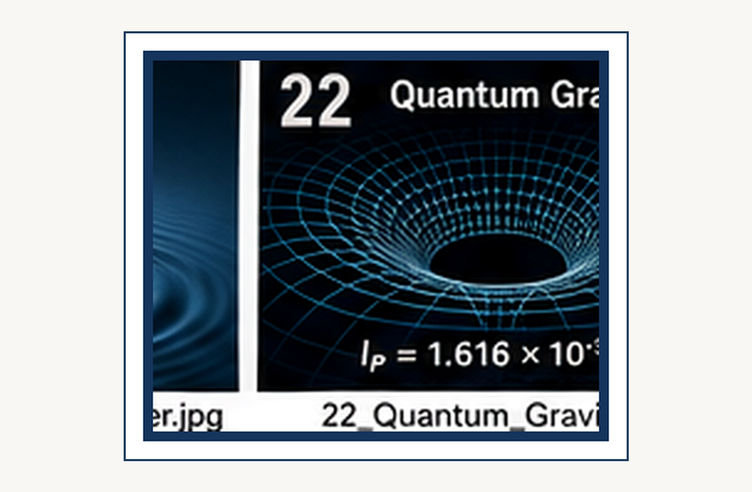
Quantum gravity: where quantum theory meets dynamical spacetime.
SCIENCE FOR EVERYONE

Quantum Gravity: Where Our Theories Collide

Two Great Theories, One Universe
We have reached one of the great unfinished stories in physics. General relativity gives us our best description of gravity, spacetime, black holes, and the large-scale universe. Quantum field theory gives us our best description of particles and the other fundamental interactions. Both theories are spectacularly successful.
And yet they do not fit together completely. The universe, annoyingly, insists on using both.

The problem in one picture
Imagine describing a city with two maps. One map is extraordinarily good for roads and buildings. The other is extraordinarily good for underground pipes and electrical cables. Most of the time, you can use whichever map you need.
THINK ABOUT IT
Explain the preceding idea in one sentence without using the words 'quantum', 'weird', or 'magic'. If that is hard, you have found the next thing to understand.
See Chapter 2 →

↑ Back to Contents
But eventually you find a place where the two systems interact so strongly that you need one map containing both. That is roughly where physics stands with gravity and quantum mechanics. We need a theory that can describe spacetime itself when quantum effects become important.

Why ordinary quantum theory is not enough
Quantum field theory normally assumes a spacetime background on which the fields live. General relativity says that spacetime is not a fixed background. It is dynamical. Matter and energy affect the geometry.
So the problem is deeper than simply adding one more particle to the Standard Model. If gravity is quantum, then the geometry itself must somehow participate in quantum behavior.

The obvious question: is gravity a particle?
PHYSICS IN PLAIN ENGLISH
First say what happens. Then say why it happens. Only then worry about the formalism. This builds the conceptual ladder.
See Chapter 2 →

↑ Back to Contents
The other fundamental interactions can be described using quantum fields. That naturally suggests asking whether gravity also has a quantum field. If so, its quantum excitation would be a particle called the graviton. The graviton is a useful theoretical concept, but it has not been experimentally detected.
And even if gravitons exist, simply writing down a quantum field for gravity does not automatically give us a complete theory that works at arbitrarily high energies.

Why gravitons are so difficult to detect
Gravity is extraordinarily weak compared with the other fundamental interactions. A single quantum of a gravitational field would interact incredibly weakly with matter. Detecting individual gravitons with any foreseeable experiment appears fantastically difficult. Gravitational waves are different.
FUN DETOUR
Physics has a recurring habit of making a sensible question produce an answer that sounds ridiculous. The universe is not being rude. Our intuition is simply out of its depth.
See Chapter 2 →

↑ Back to Contents
We can detect classical or semiclassical gravitational radiation from enormous astrophysical events. That does not mean we have detected individual gravitons. It is the difference between hearing an ocean wave and detecting one particular water molecule.

Black holes create the crisis
Black holes are where our two great theories begin glaring at each other. General relativity describes the geometry around a black hole extremely well. Quantum mechanics tells us that quantum fields should exist there. Then Stephen Hawking discovered something extraordinary: black holes are not completely black.
Quantum effects near a black-hole horizon imply that black holes can emit thermal radiation. That radiation is now called Hawking radiation.

The black hole information problem
EXAMPLE
Imagine the classical version first. What would a little billiard-ball universe predict? Now compare that with the quantum result. The difference is the lesson.
See Chapter 2 →

↑ Back to Contents

Here is the trouble. Quantum mechanics normally evolves information in a way that preserves the underlying quantum state. But if a black hole evaporates completely through Hawking radiation, what happens to the information about everything that fell into it? If the information simply disappears, something profound has gone wrong with ordinary quantum mechanics.
If the information escapes somehow, general relativity and our simple picture of the horizon are missing something. This is the black hole information problem. It is not a minor technical annoyance. It is a clue that our theories are incomplete.

The universe may have started in the danger zone
COMMON MISCONCEPTION
A diagram is not a microscopic movie. Use the picture to remember the relationship, then return to the words and the experiment.
See Chapter 2 →

↑ Back to Contents
The earliest universe presents the same problem from another direction. Run general relativity backward far enough and the universe becomes extremely hot and dense. Eventually, the curvature of spacetime and quantum effects should both become enormous. That is precisely where we need quantum gravity.
Unfortunately, our current theories do not yet provide a universally accepted, experimentally confirmed description of that regime.

Planck scales
There is a natural combination of the constants G, c, and h that produces characteristic scales of length, time, and energy. The resulting length is the Planck length, about 1.6 × 10⁻³⁵ meters. The Planck time is about 5.4 × 10⁻⁴⁴ seconds. These numbers are so extreme that ordinary intuition simply gives up.
WHY THIS MATTERS
The concept matters because it solves a specific problem. Ask what would go wrong if physicists did not have this idea.
See Chapter 2 →

Keep the physical question visible while reading the formal explanation. If the mathematics feels abstract, return to the experiment. If the experiment feels mysterious, return to the assumptions.
↑ Back to Contents

The Planck scale does not automatically mean that spacetime literally becomes a foam of tiny cubes. It means that our familiar descriptions are expected to require quantum gravity there.

Maybe spacetime is not fundamental
Here is a truly radical possibility. Perhaps spacetime itself is not fundamental. Maybe space and time emerge from something deeper, just as temperature emerges from the collective behavior of enormous numbers of particles. If that is true, asking what spacetime is made of could be like asking what a wave is made of.
The answer might be: nothing resembling a little piece of spacetime. The wave is a pattern in something deeper.

String theory
THINK ABOUT IT
Explain the preceding idea in one sentence without using the words 'quantum', 'weird', or 'magic'. If that is hard, you have found the next thing to understand.
See Chapter 2 →

↑ Back to Contents

One major approach is string theory. Instead of treating elementary particles as point-like objects, string theory proposes tiny one-dimensional objects whose different vibrational states correspond to different particles. One of those states naturally behaves like a quantum graviton. That is exciting.
But string theory also requires additional mathematical structure, including extra dimensions in many formulations. Most importantly, it has not yet produced the kind of decisive experimental evidence that would settle the matter.

Loop quantum gravity
PHYSICS IN PLAIN ENGLISH
First say what happens. Then say why it happens. Only then worry about the formalism. This builds the conceptual ladder.
See Chapter 2 →

↑ Back to Contents

Another approach is loop quantum gravity. Rather than beginning with ordinary quantum fields on a fixed spacetime, it attempts to quantize spacetime geometry itself. In some formulations, geometric quantities such as area and volume acquire discrete quantum properties. The idea is conceptually attractive because it takes the dynamical nature of general relativity seriously.
But like other quantum-gravity programs, it faces major theoretical and experimental challenges.

There are other ideas too
These are not the only possibilities. Physicists investigate causal sets, asymptotic safety, emergent gravity, holographic approaches, and many other ideas. Some may eventually turn out to be aspects of the same deeper theory. Some may be wrong.
FUN DETOUR
Physics has a recurring habit of making a sensible question produce an answer that sounds ridiculous. The universe is not being rude. Our intuition is simply out of its depth.
See Chapter 2 →

↑ Back to Contents
That is normal. At the frontier of physics, a beautiful idea is not enough. Nature gets the final vote.

The holographic surprise
One of the strangest clues comes from black-hole physics. The amount of information associated with a black hole appears to scale with the area of its event horizon rather than simply with the volume inside it. That is deeply surprising. It suggests that the information content of a region of space may somehow be encoded on a lower-dimensional boundary.
This idea is associated with the holographic principle. It is one of the most profound hints that our ordinary picture of space may not be the deepest description.

The universe may be made of relationships
EXAMPLE
Imagine the classical version first. What would a little billiard-ball universe predict? Now compare that with the quantum result. The difference is the lesson.
See Chapter 2 →

↑ Back to Contents
Quantum theory already taught us that relationships between systems can be more fundamental than the properties of isolated pieces. General relativity taught us that geometry is not an immutable stage. Quantum gravity may force us to take both lessons even more seriously. Perhaps the fundamental description of reality is not a collection of objects sitting inside space.
Perhaps what we call objects, space, and time all emerge from a deeper network of relationships.

Why this is not just philosophy
It is tempting to hear all this and think that physicists have wandered into philosophy. Some of the questions certainly have philosophical consequences. But quantum gravity is also a physics problem because competing theories make mathematical predictions, constrain possible observations, and must reproduce the enormous body of experimental evidence we already possess. A successful theory of quantum gravity must reduce to quantum physics where quantum physics works and to general relativity where general relativity works.
That is a formidable requirement.

The humility test
There is something wonderful about reaching the edge of knowledge and being able to say, “We do not know yet.” Physics is not a collection of answers handed down from a mountain. It is a process for discovering which ideas survive contact with reality. General relativity survived spectacular tests.
Quantum mechanics survived even more. A future theory will have to contain both in some deeper sense. Until then, the disagreement between our best theories is not an embarrassment. It is a signpost.

One last thought about gravity
We began this journey by learning that gravity is geometry. Then we discovered that matter behaves quantum mechanically. Now we have reached the uncomfortable conclusion that geometry itself may have to become quantum. That is a much bigger idea than simply inventing a new particle.
It may mean that space and time, as we experience them, are emergent features of a deeper reality. We do not yet know what that reality is. And that is precisely why the question is so exciting. The universe has given us two extraordinarily successful descriptions of itself.
Our next job is to discover the deeper language in which they become one story.
COMMON MISCONCEPTION
A diagram is not a microscopic movie. Use the picture to remember the relationship, then return to the words and the experiment.
See Chapter 2 →

Keep the physical question visible while reading the formal explanation. If the mathematics feels abstract, return to the experiment. If the experiment feels mysterious, return to the assumptions.
↑ Back to Contents

CHAPTER 10

Quantum Cryptography: Alice, Bob and Eve
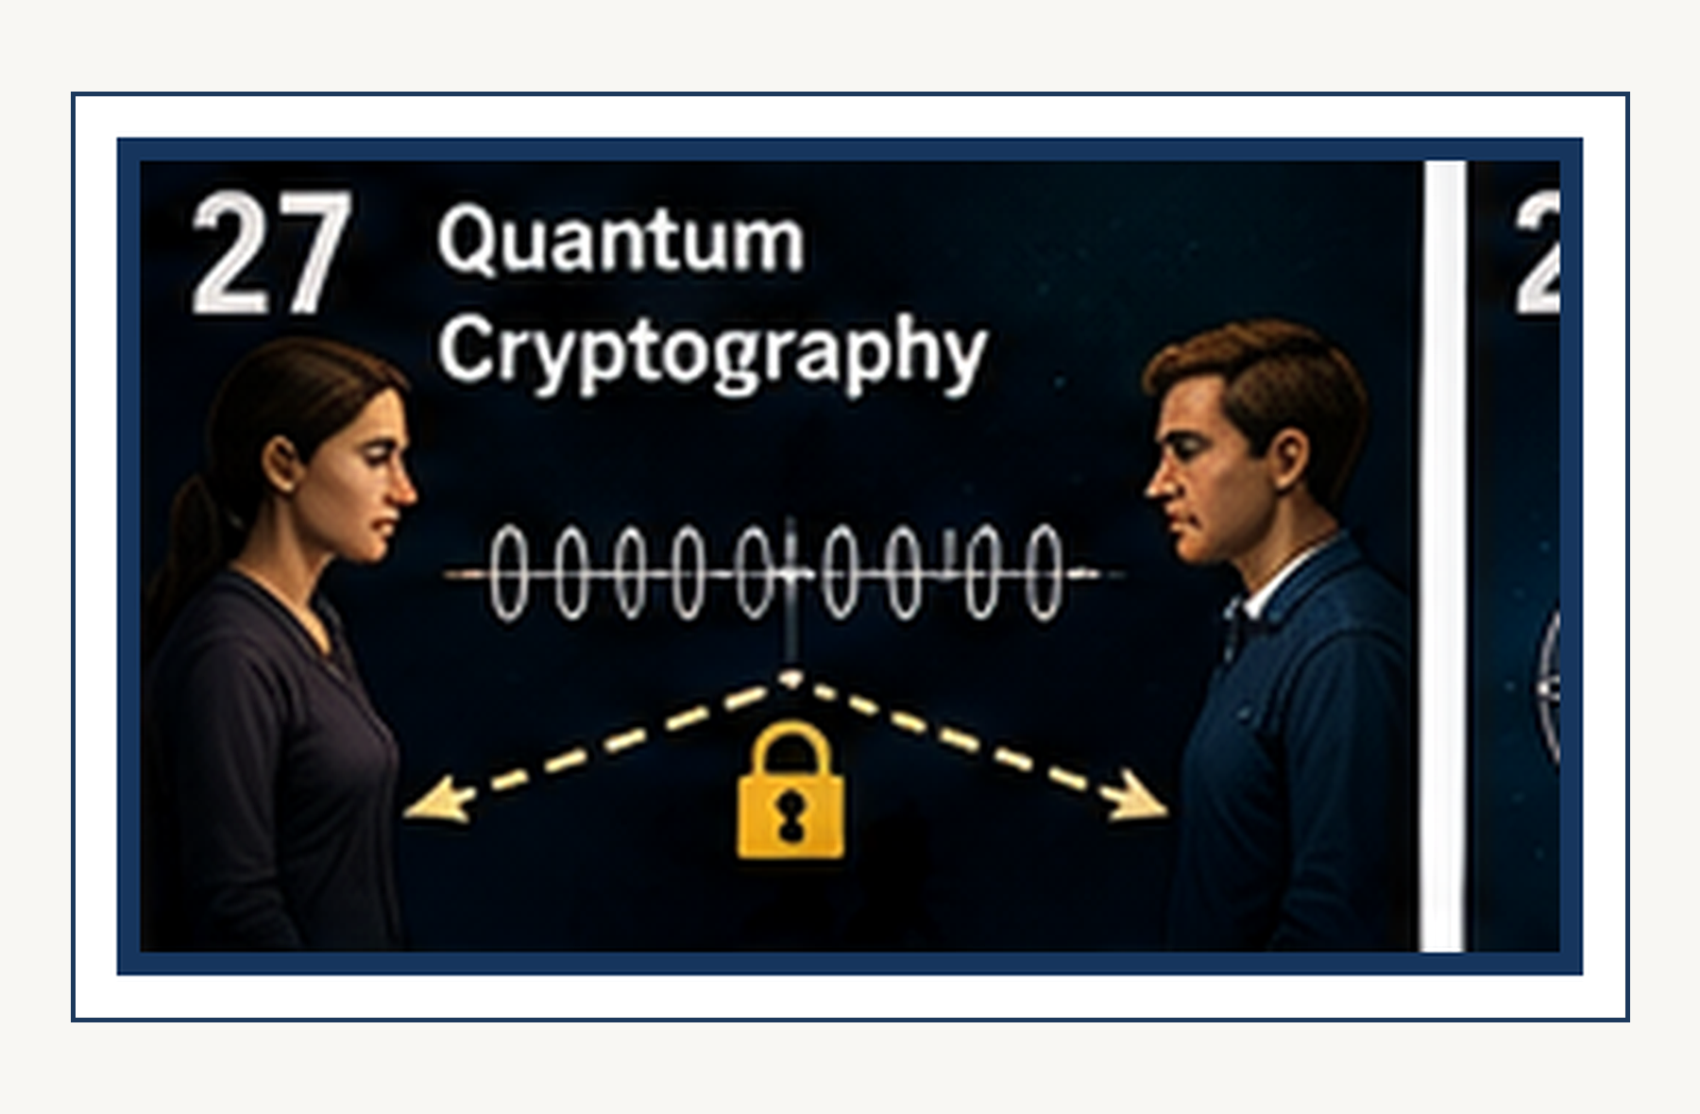
Quantum cryptography: turning quantum measurement into a security resource.
SCIENCE FOR EVERYONE

Quantum Cryptography: Alice, Bob and Eve

Alice Has a Secret
Alice wants to send Bob a secret message. There is only one problem. Eve is listening. This is the standard cast of characters in cryptography:
Alice — the sender. Bob — the receiver. Eve — the eavesdropper. It sounds like the beginning of a children's story.
It is actually one of the deepest applications of quantum mechanics. Because Alice and Bob have discovered something rather useful: perhaps the laws of physics themselves can tell them whether Eve has been listening.

The Old Cryptography Problem
PHYSICS IN PLAIN ENGLISH
First say what happens. Then say why it happens. Only then worry about the formalism. This builds the conceptual ladder.
See Chapter 11 →

↑ Back to Contents

Suppose Alice and Bob want to communicate securely. They need a secret key. If Alice and Bob already share a secret key, they can use it to encrypt messages. But how do they get the secret key to each other in the first place?
That is the key-distribution problem. Traditional cryptography solves it using mathematical assumptions. For example, a problem may be easy to perform but extremely difficult to reverse without a secret key. That works beautifully.
Until somebody invents a better algorithm or a sufficiently powerful computer.

Quantum Mechanics Offers a Different Idea
FUN DETOUR
Physics has a recurring habit of making a sensible question produce an answer that sounds ridiculous. The universe is not being rude. Our intuition is simply out of its depth.
See Chapter 11 →

↑ Back to Contents
Quantum cryptography asks a wonderfully strange question: What if security came from physics rather than merely from mathematics? The first famous quantum key-distribution protocol was proposed by Charles Bennett and Gilles Brassard in 1984. It became known as BB84.
Instead of sending the secret key as ordinary bits, Alice sends quantum states—typically encoded in individual photons. Now Eve has a problem. She cannot simply look at the quantum information without potentially disturbing it.

The Two Sets of Directions
Alice has two different ways of encoding each bit. Think of photon polarization. She can use one basis, such as vertical and horizontal. Or she can use another basis rotated by 45 degrees.
EXAMPLE
Imagine the classical version first. What would a little billiard-ball universe predict? Now compare that with the quantum result. The difference is the lesson.
See Chapter 11 →

↑ Back to Contents

For each photon, she randomly chooses one. She also randomly chooses whether the photon represents 0 or 1. Eve does not know which basis Alice used. Bob does not know either.
And that is exactly the point.

Bob Guesses
Bob measures each incoming photon. For every photon, he randomly chooses one of the two measurement bases. Sometimes he chooses the same basis Alice used. Sometimes he chooses the wrong one.
If he chooses correctly, quantum mechanics gives him the corresponding bit. If he chooses the wrong basis, his result is essentially random. At first, Alice and Bob therefore have a rather untidy pile of data. Then they perform a little public housekeeping.

They Can Talk Publicly
COMMON MISCONCEPTION
A diagram is not a microscopic movie. Use the picture to remember the relationship, then return to the words and the experiment.
See Chapter 11 →

↑ Back to Contents

Alice and Bob can discuss their measurement bases over an ordinary public channel. This sounds dangerous. Eve can hear them. But Alice and Bob do not reveal the actual bit values.
They merely say which basis they used for each photon. They throw away all the cases in which their bases differed. The remaining results are called the sifted key. And now something remarkable has happened.
Alice and Bob have a shared sequence of bits that Eve was not supposed to obtain.

But How Do They Know Eve Wasn't Listening?
They test part of the key. Alice and Bob publicly compare a randomly chosen sample. If the error rate is too high, something is wrong. Perhaps the channel is noisy.
WHY THIS MATTERS
The concept matters because it solves a specific problem. Ask what would go wrong if physicists did not have this idea.
See Chapter 11 →

↑ Back to Contents

Perhaps the equipment is imperfect. Or perhaps Eve has been meddling. They discard the key and start again. If the observed error rate is sufficiently low, quantum information theory lets them estimate how much information an eavesdropper could have gained and then use classical error correction and privacy amplification to obtain a shorter, highly secure final key.
The security is not based on Eve being stupid. It is based on Eve being unable to interact with the quantum states without leaving evidence.

Eve Has a Terrible Strategy
Eve could try to intercept a photon, measure it, and send a replacement to Bob. But she does not know which basis Alice used. So she must guess. If she guesses wrong, her measurement disturbs the state.
THINK ABOUT IT
Explain the preceding idea in one sentence without using the words 'quantum', 'weird', or 'magic'. If that is hard, you have found the next thing to understand.
See Chapter 11 →

↑ Back to Contents
When Bob later measures it in the correct basis, errors appear. Alice and Bob can detect an elevated error rate. Eve therefore faces a peculiar security system: the act of spying can betray the spy.

The No-Cloning Problem Makes It Worse for Eve
Perhaps Eve could avoid measuring the photon. She could simply copy it. Then she could keep one copy and send the other to Bob. Unfortunately for Eve, quantum mechanics does not permit an unknown arbitrary quantum state to be copied perfectly.
This is the no-cloning theorem. It is not a technological limitation. It is a consequence of the structure of quantum mechanics. The universe has apparently decided that unauthorized photocopying of quantum states is illegal.
PHYSICS IN PLAIN ENGLISH
First say what happens. Then say why it happens. Only then worry about the formalism. This builds the conceptual ladder.
See Chapter 11 →

Keep the physical question visible while reading the formal explanation. If the mathematics feels abstract, return to the experiment. If the experiment feels mysterious, return to the assumptions.
↑ Back to Contents

Why This Is So Different From Ordinary Cryptography
In ordinary cryptography, Alice and Bob generally hope that Eve cannot solve the mathematical problem. In quantum key distribution, Alice and Bob can arrange things so that an eavesdropper's interaction with the quantum channel necessarily creates detectable disturbance. That is a profound difference. Instead of saying:
“Eve probably cannot break this.” they can aim for: “If Eve obtains too much information, the laws of quantum mechanics force her to leave fingerprints.”

The Security Is Not Magic
There is an important qualification. Real quantum cryptography is not automatically secure merely because somebody uses the word “quantum.” Real devices have losses. Detectors have imperfections.
FUN DETOUR
Physics has a recurring habit of making a sensible question produce an answer that sounds ridiculous. The universe is not being rude. Our intuition is simply out of its depth.
See Chapter 11 →

↑ Back to Contents

Sources are not ideal. Channels are noisy. Implementation details can create vulnerabilities. Security proofs therefore have assumptions about the physical setup.
The ideal BB84 protocol has strong theoretical security properties, and rigorous security proofs were developed later. Shor and Preskill gave a particularly influential proof in 2000.

The First Experimental Demonstrations
The idea quickly moved from paper to laboratory. Early experiments demonstrated quantum key distribution over short distances, and subsequent systems extended the distance dramatically. Quantum key distribution has now been demonstrated over optical fiber and free-space links. The point is not that quantum cryptography has magically replaced all ordinary encryption.
It has not. The point is that the underlying physical effect is real, measurable, and technologically exploitable.

Ekert's Different Idea
EXAMPLE
Imagine the classical version first. What would a little billiard-ball universe predict? Now compare that with the quantum result. The difference is the lesson.
See Chapter 11 →

↑ Back to Contents
BB84 is not the only way to do quantum key distribution. In 1991, Artur Ekert proposed E91, a protocol based directly on entangled particles. Now the story connects to our previous chapter. Alice and Bob share entangled particles.
They make measurements. The resulting correlations can be tested using Bell-type ideas. If the observed correlations have the right quantum character, they can establish security. The EPR problem has therefore become part of a security protocol.

From Einstein's Nightmare to Alice's Security System
Think about the historical irony. Einstein, Podolsky, and Rosen introduced their argument because quantum mechanics seemed to contain an uncomfortable kind of nonclassical correlation. Bell turned those correlations into a test. Aspect and others demonstrated the violation experimentally.
COMMON MISCONCEPTION
A diagram is not a microscopic movie. Use the picture to remember the relationship, then return to the words and the experiment.
See Chapter 11 →

↑ Back to Contents

Then quantum information scientists asked: “What can we do with this?” One answer was: protect secrets.
That is a spectacular career change for a philosophical paradox.

Alice, Bob and Eve Become Quantum Characters
The characters are now familiar. Alice sends quantum states. Bob measures them. Eve tries to interfere.
Alice and Bob compare selected information publicly. They estimate the disturbance. They discard compromised data. They process the remainder into a secret key.
The names are deliberately generic. They have become a kind of physics shorthand. But Eve has earned her reputation. She is the person who cannot resist opening the envelope.

Quantum Teleportation Is Not the Same Thing
WHY THIS MATTERS
The concept matters because it solves a specific problem. Ask what would go wrong if physicists did not have this idea.
See Chapter 11 →

↑ Back to Contents
We should separate two ideas. Quantum teleportation transfers an unknown quantum state from one place to another using entanglement plus classical communication. Quantum key distribution establishes a shared secret key while detecting excessive eavesdropping. Both use quantum mechanics.
Neither permits faster-than-light communication. Teleportation is about transferring a state. QKD is about establishing secrecy. They are cousins.
They are not twins.

What Actually Makes the Key Secret?
The final key is not secret because Alice and Bob whisper. They can discuss parts of the protocol publicly. The security comes from limiting Eve's possible information. Quantum measurements disturb nonorthogonal states.
THINK ABOUT IT
Explain the preceding idea in one sentence without using the words 'quantum', 'weird', or 'magic'. If that is hard, you have found the next thing to understand.
See Chapter 11 →

↑ Back to Contents

Unknown quantum states cannot be perfectly cloned. Those facts constrain what Eve can learn without being detected. Then classical information theory finishes the job. Error correction reconciles Alice and Bob's imperfect raw keys.
Privacy amplification compresses the shared data so that any information Eve may have is driven to a negligible level. Quantum mechanics opens the door. Classical mathematics finishes the security system.

The Remarkable Part: Eve Does Not Have to Be Weak
This is one of the most beautiful ideas in quantum cryptography. The security analysis does not have to assume that Eve has a slow computer. It does not have to assume she uses today's technology. The theoretical security can be formulated against extremely powerful attacks, subject to the protocol's assumptions and implementation model.
Eve can be very clever. She can own a quantum computer. She can store quantum information. She can wait.
The laws of quantum mechanics still constrain what information she can extract without creating detectable consequences.

But Authentication Still Matters
There is one classical detail that is easy to miss. Alice and Bob need an authenticated classical channel. Otherwise Eve could impersonate Alice to Bob and Bob to Alice. Quantum mechanics does not automatically tell Alice that the person on the other end is really Bob.
That is a different problem. So quantum key distribution does not abolish cryptography. It changes one part of it. The quantum channel provides a remarkable physical security property.
Classical authentication is still needed to prevent impersonation.

Quantum Cryptography and the Real World
QKD has been demonstrated in real communication systems. Fiber links can carry quantum states over substantial distances. Free-space experiments can send quantum states between distant locations. Zeilinger's Vienna research has included long-distance quantum cryptography with entangled photons, including experiments over fiber and free space.
So the idea is no longer confined to a blackboard. It is an engineering field. A difficult, expensive, delicate engineering field—but an engineering field nonetheless.

The Quantum Internet Begins to Appear
If quantum communication networks become sufficiently advanced, we could connect quantum processors, sensors, and memories over optical links. Quantum key distribution is one application. Quantum teleportation can be another. Entanglement distribution is another.
The long-term dream is sometimes described as a quantum internet. It will not be the ordinary internet with more mysterious routers. Quantum networks have fundamentally different rules. They will have to cope with loss, measurement, decoherence, quantum memories, and the impossibility of simply copying quantum information whenever convenient.

The Universe as a Security Consultant
There is something almost poetic about the whole idea. For thousands of years, people protected secrets by hiding information. Then mathematics became powerful enough to protect information through computational difficulty. Then quantum mechanics arrived and offered something stranger:
perhaps nature itself can tell us when somebody has interfered with the message. Alice does not need to catch Eve. She only needs the quantum system to make Eve's meddling statistically visible.

And Eve Has Not Lost Yet
Real-world quantum cryptography is not invincible magic. Attackers can target the hardware. Implementation flaws can undermine ideal security proofs. Detector vulnerabilities, imperfect sources, side channels, and poor authentication can all matter.
This is why serious QKD research is as much about engineering and security analysis as about beautiful quantum states. A perfect protocol running on a badly designed device is not a perfect security system.

The Final Irony
EPR began as a complaint. Bell turned the complaint into a theorem. Aspect and other experimentalists turned the theorem into a test. Entanglement survived.
Zeilinger and others turned entanglement into technology. And now Alice and Bob use quantum mechanics to make life difficult for Eve. The phenomenon Einstein found so troubling has become a security feature. That is one of the recurring jokes of quantum physics:
the thing that looked like a problem turns out to be the useful part.

The Punchline
Alice has a secret. Bob wants to receive it. Eve wants to steal it. In classical physics, Eve might simply listen and hope nobody notices.
In quantum physics, Eve has a problem. If she measures the wrong thing, she disturbs it. If she tries to copy an unknown state, quantum mechanics says no. If she gains too much information, Alice and Bob can detect the resulting disturbance and throw the key away.
The universe has therefore provided Alice and Bob with something rather extraordinary: a communication system in which spying can leave fingerprints. Eve, understandably, is not amused. And somewhere, Einstein is probably asking why this was not the result he wanted in 1935.
PHYSICS IN PLAIN ENGLISH
First say what happens. Then say why it happens. Only then worry about the formalism. This builds the conceptual ladder.
See Chapter 11 →

Keep the physical question visible while reading the formal explanation. If the mathematics feels abstract, return to the experiment. If the experiment feels mysterious, return to the assumptions.
↑ Back to Contents

CHAPTER 11

Quantum Computing: From Today to One Thousand Years From Now
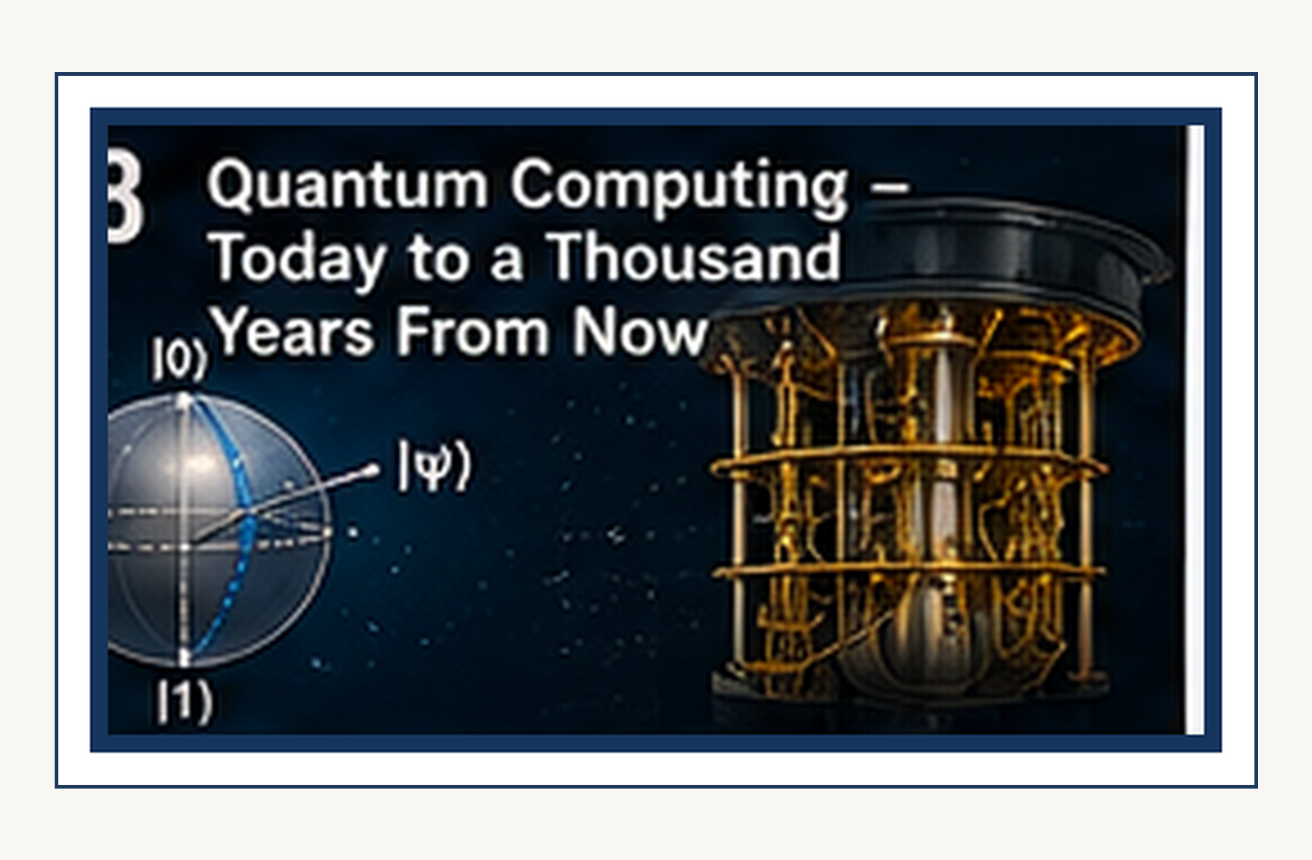
Quantum computing: amplitudes, interference, entanglement, and information.
SCIENCE FOR EVERYONE

Quantum Computing: From Today to One Thousand Years From Now

The Computer That Does Not Merely Calculate
A normal computer stores information as bits. Zero. One. Zero.
One. Very fast zeroes and ones. A quantum computer uses qubits. A qubit can occupy a quantum superposition of states, and multiple qubits can become entangled.
That does not mean a quantum computer simply tries every possible answer simultaneously and then magically reads all the answers. That popular explanation is too good to be true. The real advantage comes from designing quantum operations so that amplitudes interfere in useful ways and unwanted possibilities cancel. Quantum computing is therefore not merely “a faster computer.”
It is a different computational model built from the rules of quantum mechanics.
FUN DETOUR
Physics has a recurring habit of making a sensible question produce an answer that sounds ridiculous. The universe is not being rude. Our intuition is simply out of its depth.

↑ Back to Contents

And Today We Have Actual Quantum Computers
This is no longer a purely theoretical technology. As of 2026, working quantum processors exist in laboratories and cloud-accessible systems. IBM, Google, Microsoft, Quantinuum, IonQ, and others are pursuing different hardware architectures. They use different physical systems.
Superconducting circuits. Trapped ions. Neutral atoms. Photons.
And, in Microsoft's case, a topological approach based on Majorana modes. There is no single winning architecture yet. Quantum computing is currently a very expensive competition to discover which kind of tiny quantum object will be least annoying.

But Today's Machines Are Still Fragile
A qubit is not a normal bit with a funny name. Quantum states are extremely sensitive to unwanted interactions with their environment. Noise can destroy coherence. Operations are imperfect.
EXAMPLE
Imagine the classical version first. What would a little billiard-ball universe predict? Now compare that with the quantum result. The difference is the lesson.

↑ Back to Contents

Measurements are imperfect. And the more operations you perform, the more opportunities you give the universe to ruin your calculation. This is the central engineering problem: How do you build a quantum computer when the thing doing the computing is extraordinarily easy to disturb?

The Error-Correction Revolution
The answer is quantum error correction. Instead of storing useful quantum information in one fragile physical qubit, we can encode it across many physical qubits. The result is a logical qubit. The physical qubits are noisy.
The encoded logical information can, under suitable conditions, be much more reliable. This is enormously expensive. One useful logical qubit may require many physical qubits. So the quantum-computing industry has a peculiar problem:
COMMON MISCONCEPTION
A diagram is not a microscopic movie. Use the picture to remember the relationship, then return to the words and the experiment.

↑ Back to Contents

to make one good qubit, you may need a small army of bad ones.

Google's Willow Moment
Google's Willow processor, announced in December 2024, demonstrated a major milestone in quantum error correction. As the size of the encoded system increased, the logical error rate decreased rather than increasing. Google described this as operating below the error-correction threshold—the regime required for scalable fault-tolerant quantum computing. Willow also completed a particular benchmark computation in under five minutes that Google estimated would take a leading classical supercomputer roughly 10^25 years.
That is spectacular. It is also important to understand what it does not mean. It does not mean your laptop should be replaced by a quantum computer.

Microsoft Takes a Different Route
WHY THIS MATTERS
The concept matters because it solves a specific problem. Ask what would go wrong if physicists did not have this idea.

↑ Back to Contents
Microsoft has pursued topological qubits based on Majorana zero modes. In 2025 it announced Majorana 1, a processor based on a topological architecture designed with scalability in mind. And in 2026 Microsoft announced Majorana 2, reporting substantially longer qubit lifetimes than its previous generation and a roadmap toward a scalable quantum computer. These are important developments.
They are also company claims about an active research program, not proof that topological quantum computing has already solved the engineering problem. The race is very much still on.

IBM Wants a Fault-Tolerant Machine
THINK ABOUT IT
Explain the preceding idea in one sentence without using the words 'quantum', 'weird', or 'magic'. If that is hard, you have found the next thing to understand.

↑ Back to Contents

IBM's current roadmap targets large-scale fault-tolerant quantum computing. Its March 2026 roadmap describes a goal of a first large-scale fault-tolerant system around 2029, with a modular architecture and substantial error-correction capability. IBM also says its systems are already being used by hundreds of organizations for real workloads. Again, the important distinction is between quantum computers that exist now and large fault-tolerant quantum computers capable of solving major practical problems.
The first exists. The second is the prize everyone is chasing.

So What Can Quantum Computers Actually Do?
Today, the most impressive demonstrations often involve carefully selected problems designed to expose quantum advantage. That matters. But it is not the same as saying quantum computers are generally better than classical computers. They are not.
PHYSICS IN PLAIN ENGLISH
First say what happens. Then say why it happens. Only then worry about the formalism. This builds the conceptual ladder.

↑ Back to Contents
For most ordinary tasks, a classical computer remains vastly more practical. The quantum machine becomes interesting when the problem has a structure that a quantum algorithm can exploit.

Chemistry May Be the Killer Application
This is one of the most compelling possibilities. Nature itself is quantum mechanical. Molecules are quantum systems. Chemical reactions depend on quantum states.
Classical computers can simulate chemistry, but the cost can grow enormously as systems become more complicated. A sufficiently powerful quantum computer could represent quantum systems more naturally. That could eventually help design: new medicines,
new catalysts, new batteries, new materials, new industrial chemicals.
Instead of using a classical computer to imitate nature, we could use one quantum system to calculate another quantum system.

Materials, Energy and Climate
FUN DETOUR
Physics has a recurring habit of making a sensible question produce an answer that sounds ridiculous. The universe is not being rude. Our intuition is simply out of its depth.

↑ Back to Contents

The same idea extends to materials. Better superconductors. More efficient solar materials. Catalysts for industrial chemistry.
New energy-storage materials. Potentially new methods for carbon capture or nitrogen fixation. These applications are plausible targets because quantum mechanics is already the language of the microscopic processes involved. The challenge is building a quantum computer large and reliable enough to solve useful versions of those problems.

Cryptography Is the More Immediate Threat
There is another reason quantum computing matters. A sufficiently powerful fault-tolerant quantum computer could run Shor's algorithm, which would efficiently factor large integers and solve related mathematical problems underlying widely used public-key cryptography. That means some encryption systems used today would eventually become vulnerable. This is why governments and companies are already moving toward post-quantum cryptography.
EXAMPLE
Imagine the classical version first. What would a little billiard-ball universe predict? Now compare that with the quantum result. The difference is the lesson.

Keep the physical question visible while reading the formal explanation. If the mathematics feels abstract, return to the experiment. If the experiment feels mysterious, return to the assumptions.
↑ Back to Contents
The interesting part is that we do not need to wait until the quantum computer exists. We need to protect information that might still be secret when such a machine arrives.

Grover's Algorithm Is Different
Quantum computing does not magically speed up every problem exponentially. Grover's algorithm gives a quadratic speedup for certain unstructured search problems. That is useful. But it is not the same spectacular leap as Shor's algorithm provides for factoring.
The lesson is important: quantum advantage depends on the problem. A quantum computer is not a universal “faster button.”

The Quantum Computer of 2050
COMMON MISCONCEPTION
A diagram is not a microscopic movie. Use the picture to remember the relationship, then return to the words and the experiment.

↑ Back to Contents

Now we have to leave the laboratory and make predictions. This is where confidence decreases rapidly. By perhaps the 2030s or 2040s, it is reasonable to imagine useful fault-tolerant quantum computers if current research succeeds. But the exact hardware architecture is unknown.
The number of logical qubits required for commercially important problems is uncertain. The economics are uncertain. The algorithms are still developing. And unexpected discoveries could change the entire field.
So we should distinguish: near-term projection from one-thousand-year speculation.

A Hundred Years From Now
A century is long enough for technology to become almost unrecognizable. The first electronic computers were enormous machines. Today a phone contains more computing capability than early computer pioneers could comfortably imagine. Quantum computing could follow a similar trajectory.
WHY THIS MATTERS
The concept matters because it solves a specific problem. Ask what would go wrong if physicists did not have this idea.

↑ Back to Contents

Machines might become smaller. More reliable. More modular. Better integrated with classical processors.
Possibly distributed across quantum networks. The refrigerator-sized cryogenic laboratory of today could become the equivalent of the room-sized mainframe. Or it could become the equivalent of the steam engine: historically important, but technologically superseded. We simply do not know.

A Thousand Years Is Another Category Entirely
Predicting technology one thousand years into the future is not really forecasting. It is controlled science fiction. A thousand years ago, there was no modern science. No electricity.
No industrial chemistry. No electronic computation. No understanding of quantum mechanics. The people of the year 1026 could not have produced a reliable shopping list for 2026.
THINK ABOUT IT
Explain the preceding idea in one sentence without using the words 'quantum', 'weird', or 'magic'. If that is hard, you have found the next thing to understand.

↑ Back to Contents
So we should not pretend to know what a quantum computer in 3026 will look like. But we can ask what physical principles might allow.

Maybe Quantum Computers Become Invisible
The ultimate quantum computer may not look like a computer. It may be embedded in materials. Distributed across networks. Built into scientific instruments.
Or coupled directly to classical and biological systems. The word “computer” may become as unhelpful as the word “calculator.” Nobody carries a calculator to access the internet. Computing has become part of the environment.
Quantum computation could eventually do the same.

Maybe There Is a Quantum Internet
PHYSICS IN PLAIN ENGLISH
First say what happens. Then say why it happens. Only then worry about the formalism. This builds the conceptual ladder.

↑ Back to Contents
Quantum networks could distribute entanglement between distant nodes. Quantum teleportation could transfer quantum states between nodes. Quantum cryptography could protect communications. Quantum computers could share resources.
Quantum sensors could be networked. Eventually, the boundary between “computer,” “network,” and “sensor” could become much less clear. The machine would not simply calculate. It would participate in a distributed quantum information system.

Maybe Quantum Simulation Changes Science
Imagine a future in which scientists can simulate complicated quantum materials almost as naturally as we now simulate weather. They could design molecules before synthesizing them. Test possible catalysts before manufacturing them. Explore materials that do not exist in nature.
FUN DETOUR
Physics has a recurring habit of making a sensible question produce an answer that sounds ridiculous. The universe is not being rude. Our intuition is simply out of its depth.

↑ Back to Contents

Search enormous chemical spaces. Model biological processes at quantum scales. This could transform science in the same way numerical simulation transformed engineering. The laboratory would increasingly become a place where theories are tested after computers have already explored millions of possibilities.

Maybe AI and Quantum Computing Become Partners
There is another obvious marriage. AI is good at finding patterns, approximating complicated functions, optimizing, and learning from enormous datasets. Quantum computers may be good at particular classes of quantum and mathematical problems. The future may therefore not be:
quantum computer versus classical computer. It may be: classical computing + AI + quantum computing + specialized hardware. The quantum processor becomes an accelerator inside a much larger computational ecosystem.
EXAMPLE
Imagine the classical version first. What would a little billiard-ball universe predict? Now compare that with the quantum result. The difference is the lesson.

↑ Back to Contents

A Thousand Years: What Would We Even Mean by a Qubit?
Suppose civilization survives for another thousand years. The word “qubit” may still exist. But the physical implementation might be completely different. Today's qubits require elaborate control systems.
Future quantum information might be stored in topological states, exotic phases of matter, protected collective excitations, or physical systems we have not discovered yet. A qubit is an abstract information concept. The universe gives us many possible places to hide one.

Could Quantum Computing Become Planetary?
A sufficiently advanced civilization could distribute computation across enormous physical systems. Quantum processors might be linked across continents. Then planets. Then perhaps spacecraft.
The limitation would no longer simply be how many qubits fit in a laboratory. It would be how much quantum information can be maintained, corrected, transmitted, and coordinated across enormous distances. At that scale, relativity becomes part of the computer architecture.

The Speed-of-Light Problem Returns
No computer, quantum or otherwise, escapes relativity. Information cannot be transmitted locally faster than light. A galaxy-sized quantum computer would therefore not behave like one giant instantaneous machine. Different regions would have to deal with communication delays.
A civilization spread across the galaxy would have to compute with light-cone geometry built into its algorithms. At that point, spacetime itself becomes part of computer science.

Could We Simulate an Entire Universe?
Now we reach the edge of reasonable speculation. A sufficiently advanced quantum computer might simulate enormous physical systems. Could it simulate an entire universe? There are immediate problems.
The universe contains an enormous amount of information. A simulation of a system generally requires resources related to the system being simulated. So “simulate everything perfectly on a smaller computer” is not automatically possible. But perhaps we could simulate selected laws, regions, or coarse-grained descriptions with extraordinary accuracy.
That alone would be transformative.

Could We Simulate Life?
This is more plausible. A powerful quantum computer might simulate chemical networks, proteins, membranes, molecular machines, and eventually increasingly complex biological processes. That could connect directly to the Life book. We might be able to explore how chemistry becomes biology in unprecedented detail.
We could test competing hypotheses about the origin of life. We could model evolutionary landscapes. We could design artificial biological systems. The quantum computer might therefore become a laboratory for life itself.

Could We Simulate Consciousness?
Now we are back in dangerous philosophical territory. If consciousness is produced by physical information-processing processes, perhaps sufficiently detailed simulations could reproduce some aspects of conscious systems. But this raises the same question we encountered with AI and mind uploading: Would the simulation merely behave like a conscious system?
Or would it actually experience something? Quantum computing does not automatically answer that question. A quantum brain simulation, even if physically perfect, would still leave us with the philosophical problem of what subjective experience is.

The Really Far Future
A thousand years from now, quantum computing might be central to civilization. Or it might be a historical curiosity. Perhaps another technology will make today's quantum computers look primitive. Perhaps quantum information will merge with a deeper theory of physics.
Perhaps we will discover that the best computational architecture is something we cannot currently imagine. This is where humility becomes part of good science. We can extrapolate physical principles. We cannot extrapolate civilization with confidence for a millennium.

But There Is One Prediction I Would Risk
Quantum mechanics is not going away. Whatever computers look like in a thousand years, they will still have to obey the laws of physics. If quantum mechanics remains correct—and every experiment so far gives us extraordinary reason to think it will—then quantum information will remain part of the physical possibilities available to advanced civilizations. The future computer may not resemble today's quantum processor.
But the underlying quantum nature of matter will still be there.

From Counting Stones to Quantum Worlds
The history of computing is a story of abstraction. Pebbles became numbers. Numbers became algorithms. Mechanical machines became electronic machines.
Bits became software. Networks connected machines. Now quantum states are becoming information. The astonishing part is that the universe itself seems to contain computational possibilities that classical intuition does not capture.
We are only beginning to learn how to use them.

The One-Thousand-Year Punchline
Today, a quantum computer is a spectacularly complicated machine in a very cold room. A thousand years from now, perhaps quantum computation will be so ordinary that nobody thinks about it. Or perhaps the entire concept will have been absorbed into a deeper theory of information. Maybe future scientists will look at our superconducting chips and laugh.
“Look at them,” they will say. “They had to cool the whole thing down just to make a few hundred delicate quantum states behave.” And perhaps someone will answer: “Yes.
But it worked.” That is how technology begins. First we learn how to make nature do something astonishing. Then we spend the next thousand years making it boring.
COMMON MISCONCEPTION
A diagram is not a microscopic movie. Use the picture to remember the relationship, then return to the words and the experiment.

Keep the physical question visible while reading the formal explanation. If the mathematics feels abstract, return to the experiment. If the experiment feels mysterious, return to the assumptions.
↑ Back to Contents
APPENDIX 1

Core Ideas and Unresolved Questions
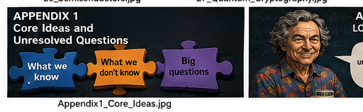

Appendix 1 — Core Ideas and Unresolved Questions

APPENDIX

The Universe, Explained Badly Enough to Be Memorable
A humorous summary of the ideas, surprises, and unresolved questions in the book.

The One Idea You Should Never Lose
Here is the strangest useful way to think about special relativity.
We normally imagine an object as having a velocity through space.
But relativity gives us a deeper picture.
An object moves through spacetime.
And, in the appropriate four-dimensional sense, its motion through spacetime has a fixed magnitude set by the speed of light, c.
That means something rather delightful:
you do not get to choose a speed through spacetime.
What you can change is how your motion is divided between space and time.
QUICK SUMMARY
The appendix is here to compress the journey without pretending that the unanswered questions have disappeared. Keep the distinction between what is established, what is inferred, and what remains open.

↑ Back to Contents

The Thales Circle of Relativity
Imagine a right triangle.
One leg is motion through space.
The other is motion through time.
The diagonal represents the invariant spacetime scale associated with c.
This is essentially the geometry behind the familiar Pythagorean relationship.
If you put more of your motion into space, less remains in the time direction.
If you move less through space, more of your spacetime motion lies along your time direction.
You are not adding speed to the universe.
You are changing the angle.

So Why Can't We Go Faster Than Light?
The usual answer is:
“Because relativity says you cannot.”
That is true.
But it is not the most illuminating answer.
A deeper answer is:
there is no extra velocity waiting beyond c.
QUICK SUMMARY
The appendix is here to compress the journey without pretending that the unanswered questions have disappeared. Keep the distinction between what is established, what is inferred, and what remains open.

↑ Back to Contents

For a massive object, increasing its ordinary spatial speed toward c corresponds to changing its trajectory through spacetime more and more toward the lightlike direction.
The required energy rises without bound as the speed approaches c.
There is no spare category called “very, very fast” waiting on the other side.
The geometry itself closes the door.

A Necessary Precision
There is one important technical qualification.
It is useful to say that everything has a spacetime velocity whose invariant magnitude is c, but we must not confuse that with saying that every object literally travels through space at c.
A massive object can move through space at 10 m/s, 100,000 km/s, or 0.999999c.
A photon moves through space at c.
QUICK SUMMARY
The appendix is here to compress the journey without pretending that the unanswered questions have disappeared. Keep the distinction between what is established, what is inferred, and what remains open.

↑ Back to Contents

In the language of four-velocity, a massive object's motion has both spatial and temporal components, while light follows a null path and has no rest frame.
So the slogan is powerful:
“Everything moves through spacetime at c.”
But the careful physicist adds:
“In the relativistic four-dimensional sense.”
The universe is perfectly happy with a memorable slogan.
It simply insists that we put the footnote underneath it.

Time Is Part of the Motion
This gives us a wonderfully strange picture.
When you are sitting still, you are not doing nothing.
You are moving through spacetime.
Almost all of your motion is in the time direction.
Start moving through space.
The balance changes.
QUICK SUMMARY
The appendix is here to compress the journey without pretending that the unanswered questions have disappeared. Keep the distinction between what is established, what is inferred, and what remains open.

↑ Back to Contents
Move faster through space, and the geometry assigns less proper time between events along your path.
This is time dilation.
It is not an optical illusion.
It is not a malfunction of clocks.
It is what spacetime geometry says different paths between events must do.

Why Light Is Different
Light travels on a null path.
In ordinary language, we say light travels through space at c.
But light does not have a rest frame.
Trying to imagine what a photon “experiences” is therefore dangerous.
There is no legitimate inertial frame in which the photon is sitting still with a clock beside it.
QUICK SUMMARY
The appendix is here to compress the journey without pretending that the unanswered questions have disappeared. Keep the distinction between what is established, what is inferred, and what remains open.

↑ Back to Contents

So when we say that the photon has no proper-time passage along its path, we should not turn that into a story about what the photon feels.
Photons do not write diaries.
This is one of those places where mathematics is safer than imagination.

The Universe Has Been Doing This All Along
The same spacetime geometry lies behind much of the earlier story.
Special relativity gives us spacetime.
General relativity makes spacetime dynamic.
Gravity becomes geometry.
Gravitational waves become ripples in that geometry.
Black holes become extreme regions of curved spacetime.
Wormholes appear as possible geometric structures in certain solutions.
Quantum theory then comes along and says:
“Lovely geometry.
What about the fields?”
Physics continues.

The Quantum Surprise
Quantum mechanics introduces another revolution.
QUICK SUMMARY
The appendix is here to compress the journey without pretending that the unanswered questions have disappeared. Keep the distinction between what is established, what is inferred, and what remains open.

↑ Back to Contents

A particle is not always describable as a little object carrying definite classical properties.
Superposition, entanglement and quantum measurement force us to abandon some familiar assumptions.
EPR turned that discomfort into a challenge.
Bell turned the challenge into mathematics.
Aspect and others tested it.
Zeilinger and others learned to manipulate entanglement.
Quantum teleportation and quantum cryptography followed.
The joke is almost too good:
**Einstein worried that quantum mechanics was incomplete.
The universe responded by making its weirdness technologically useful.**

Fields Are the Stuff Beneath the Particles
Modern particle physics goes one level deeper.
The fundamental description is not simply a collection of tiny billiard balls.
Quantum fields fill spacetime.
Particles are excitations of those fields.
Electromagnetism has its quantum field.
The strong interaction has its quantum field theory, QCD.
The Higgs field has its own role.
And the Standard Model organizes an astonishing amount of this structure.
The “particle zoo” is therefore less like a zoo and more like a set of temporary disturbances in a much larger landscape.

The Universe Is Suspiciously Good at Keeping Accounts
Energy is conserved.
Momentum is conserved.
Angular momentum is conserved.
Electric charge is conserved.
These are not random rules pasted onto the universe.
Symmetry lies behind many of them.
Noether showed the deep connection between continuous symmetries and conservation laws.
The universe apparently keeps remarkably good books.
Unfortunately, it does not explain where it keeps the filing cabinet.

Entropy: The Fine Print
Thermodynamics adds another rule.
Entropy tends to increase in an isolated system.
This gives us the arrow of time.
It explains why broken eggs do not normally reassemble themselves.
It explains why heat flows from hot to cold.
And it raises a deeper question:
Why did the universe begin in such a low-entropy state?
That question connects ordinary cups of tea to cosmology.
Which is rather a lot of responsibility for a cup of tea.

Quantum Information
Entanglement is not merely a philosophical curiosity.
It can be used.
Quantum teleportation can transfer a quantum state.
Quantum key distribution can establish shared secret keys with security grounded in quantum physics.
Quantum computing uses superposition, entanglement and interference to perform certain calculations in ways classical machines cannot reproduce efficiently.
The old foundational puzzles have become engineering resources.
Physics has a peculiar habit of doing that.

The Quantum Computer of the Future
Today's quantum computers are impressive, fragile, noisy and expensive.
Future machines may be fault-tolerant.
They may simulate chemistry.
They may help design materials.
They may threaten some existing cryptographic systems.
They may become components in quantum networks.
A thousand years from now, they may look as primitive to future physicists as our first electronic computers look to us.
Or they may be remembered as the moment we learned to make information obey quantum rules.
We should probably avoid writing the user manual for the year 3026 just yet.

What We Still Don't Know
This book has repeatedly arrived at the same uncomfortable destination.
We do not yet know how to combine quantum mechanics and gravity into a complete theory.
We do not know what dark matter is.
We do not know what dark energy really is.
We do not know why there is more matter than antimatter.
We do not know why the constants of nature have the values they do.
We do not know why the early universe had such low entropy.
We do not know whether spacetime is fundamental or emergent.
We do not know whether time itself is fundamental.
And we certainly do not know what the universe will look like a thousand years from now.

The Most Important Habit
The best lesson is not a particular equation.
It is a habit of mind.
When something seems obvious, ask what would happen if it were not.
When a theory works, ask where it might fail.
When an experiment disagrees with the theory, do not shout at the experiment.
When a strange idea makes a successful prediction, take it seriously.
And when someone says:
“That's impossible.”
ask:
“According to which law?”

Five Things Worth Remembering
1. Space and time are not independent.
Relativity joins them into spacetime.
2. Light is not merely something moving through space.
It defines the invariant speed and the causal structure of spacetime.
3. Quantum mechanics is not classical physics with smaller objects.
Superposition and entanglement are genuinely different.
4. Matter is deeper than atoms.
Atoms contain nuclei and electrons; nuclei contain quarks and gluons; quantum field theory gives us an even deeper description.
5. We are nowhere near the end.
Every successful theory has opened another question.

And One Thing Not to Forget
The universe is under no obligation to match our intuition.
That is not a defect in the universe.
It is a defect in intuition.
Our brains evolved to catch falling objects, find food, avoid predators and judge whether a branch will hold our weight.
They were not designed to visualize curved spacetime, quantum fields, Hilbert spaces or the interior geometry of a black hole.
Fortunately, we invented mathematics.
Mathematics lets us ask the universe questions our instincts cannot even formulate.
And sometimes the universe answers.

The Final Feynman-ish Rule
There is a wonderfully simple attitude that belongs at the end of a book like this:
Do not be afraid of not knowing.
Not knowing is where the interesting questions live.
The purpose of science is not to turn the universe into a collection of facts we have memorized.
It is to make our ignorance more precise.
Every great discovery removes one mystery and exposes a larger one.
That is not failure.
That is the game.

The Final Punchline
So here is the entire book in one slightly unreasonable paragraph.
You live in spacetime, moving through it in a way constrained by c. Gravity is geometry. Light is a quantum field. Matter is fields behaving in quantized ways. Entanglement is real. Information matters. Entropy gives the macroscopic universe an arrow of time. The Standard Model is spectacularly successful but incomplete. Black holes are real. Wormholes are mathematically possible but not known to be usable. Quantum computers are beginning to work. The universe is expanding. Something called dark matter seems to be there. Something called dark energy seems to be pushing the expansion faster.
And we still have no final theory that puts gravity and quantum mechanics comfortably in the same room.
Which is encouraging.
Because if we had finally explained everything, we would have to find something else to talk about.
And physics would be terribly boring.
Fortunately, the universe has shown no sign whatsoever of cooperating.
QUICK SUMMARY
The appendix is here to compress the journey without pretending that the unanswered questions have disappeared. Keep the distinction between what is established, what is inferred, and what remains open.

↑ Back to Contents
APPENDIX 2

What We Actually Learned
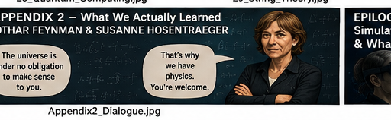

Appendix 2 — What We Actually Learned

APPENDIX 2

What We Actually Learned

A Conversation Between Lothar Feynman and Susanne Hosentraeger
A fictional dialogue. Susanne Hosentraeger is a fictional character, not a portrayal of Sabine Hossenfelder.
LOTHAR FEYNMAN: So. We have reached the end.
SUSANNE HOSENTRAEGER: No.
LOTHAR: No?
SUSANNE: We have reached the end of the book. That is not the same thing.
LOTHAR: Ah. Very good. Physics has already ruined the meaning of the word “end.”
SUSANNE: Exactly. Which is why I thought we should ask the only sensible question left: what did the reader actually learn?
LOTHAR: That everything is complicated.
SUSANNE: That's not a physics lesson. That's adulthood.
LOTHAR: Fair enough. Let's try again.
SUSANNE: Start with the beginning.
LOTHAR: Newton.
QUICK SUMMARY
The appendix is here to compress the journey without pretending that the unanswered questions have disappeared. Keep the distinction between what is established, what is inferred, and what remains open.

↑ Back to Contents
SUSANNE: A good place to start.
LOTHAR: Newton gave us a universe in which motion could be described by mathematical laws. Apples fell. Planets orbited. The same gravity operated in heaven and on Earth.
SUSANNE: And that was magnificent.
LOTHAR: Yes. People sometimes tell the history of physics as if Newton was a primitive who had to be rescued by Einstein.
SUSANNE: Which is nonsense. Newtonian mechanics is still extraordinarily useful. If I throw a ball at you, I don't calculate its geodesic in curved spacetime.
LOTHAR: You should.
SUSANNE: I should not.
LOTHAR: It would impress the ball.
SUSANNE: The ball has standards.
LOTHAR: Then Maxwell.
SUSANNE: Electricity and magnetism became one theory.
LOTHAR: And light turned out to be electromagnetic.
QUICK SUMMARY
The appendix is here to compress the journey without pretending that the unanswered questions have disappeared. Keep the distinction between what is established, what is inferred, and what remains open.

↑ Back to Contents

SUSANNE: Which is a lovely moment in physics. Something that looked like a separate phenomenon—light—turned out to be part of a larger structure.
LOTHAR: And Maxwell's equations gave us a speed.
SUSANNE: c.
LOTHAR: The number that would later become much more than the speed of light.
SUSANNE: Right. Special relativity taught us that c is not merely a property of light. It is built into spacetime.
LOTHAR: Which brings us to one of the best take-home ideas in the entire book.
SUSANNE: The triangle.
LOTHAR: The triangle.
SUSANNE: Space on one axis, time on another, and the invariant spacetime structure setting the scale.
LOTHAR: You move through spacetime. Your motion can be decomposed into spatial and temporal components.
QUICK SUMMARY
The appendix is here to compress the journey without pretending that the unanswered questions have disappeared. Keep the distinction between what is established, what is inferred, and what remains open.

↑ Back to Contents
SUSANNE: With the important caveat that saying “everything moves through spacetime at c” is a useful four-dimensional slogan, not a statement that your chair is secretly travelling through the room at light speed.
LOTHAR: Your chair would deny the allegation.
SUSANNE: And rightly so.
LOTHAR: The deep point is that there is no mysterious extra supply of velocities beyond c. The relativistic geometry itself tells massive objects what is possible.
SUSANNE: Good. Put that in large letters.
LOTHAR: I already did.
SUSANNE: Then put it in larger letters.
LOTHAR: She is difficult.
SUSANNE: I am precise.
LOTHAR: Then gravity.
SUSANNE: Einstein's great move was to stop thinking of gravity as an ordinary force in the Newtonian sense and recognize that spacetime itself has geometry.
QUICK SUMMARY
The appendix is here to compress the journey without pretending that the unanswered questions have disappeared. Keep the distinction between what is established, what is inferred, and what remains open.

↑ Back to Contents

LOTHAR: Matter tells spacetime how to curve.
SUSANNE: And curved spacetime tells matter how to move.
LOTHAR: Which gives us black holes.
SUSANNE: And gravitational waves.
LOTHAR: And the universe as a whole becoming a physical object we can study.
SUSANNE: And eventually the terrible question: what happens when quantum mechanics enters the room?
LOTHAR: Quantum mechanics.
SUSANNE: The chapter where reality stops behaving like the furniture.
LOTHAR: Particles can be in superpositions.
SUSANNE: Quantum systems can be entangled.
LOTHAR: Measurement becomes conceptually troublesome.
SUSANNE: And probability is no longer merely our ignorance about an ordinary classical state. Quantum theory gives probabilities to outcomes in a way that cannot simply be replaced by the classical picture underneath.
LOTHAR: Einstein disliked some of that.
QUICK SUMMARY
The appendix is here to compress the journey without pretending that the unanswered questions have disappeared. Keep the distinction between what is established, what is inferred, and what remains open.

↑ Back to Contents

SUSANNE: Einstein was right to ask difficult questions.
LOTHAR: And wrong about some of the answers.
SUSANNE: That is allowed. In fact, it is rather important. Great physicists are not prophets.
LOTHAR: Bell then turns philosophy into an experiment.
SUSANNE: That is one of the great methodological lessons. If you argue about what quantum mechanics means, ask whether different interpretations make different predictions.
LOTHAR: If they do, experiment can decide.
SUSANNE: If they don't, you may have a philosophical dispute wearing a lab coat.
LOTHAR: And experiments violated Bell inequalities.
SUSANNE: Yes. Quantum entanglement is not merely a strange story physicists tell at conferences.
LOTHAR: It became technology.
SUSANNE: Quantum teleportation. Quantum cryptography. Quantum information.
LOTHAR: Not teleporting people.
SUSANNE: Sadly.
QUICK SUMMARY
The appendix is here to compress the journey without pretending that the unanswered questions have disappeared. Keep the distinction between what is established, what is inferred, and what remains open.

↑ Back to Contents

LOTHAR: I was ready to send you to lunch.
SUSANNE: You still can.
LOTHAR: Then quantum fields.
SUSANNE: This is where the particle zoo gets reorganized.
LOTHAR: An electron is not simply a tiny billiard ball.
SUSANNE: In quantum field theory, particles are excitations of fields.
LOTHAR: The vacuum is not simply nothing.
SUSANNE: And that sentence should permanently ruin the phrase “empty space.”
LOTHAR: Electromagnetism becomes QED.
SUSANNE: The strong interaction becomes QCD.
LOTHAR: Quarks.
SUSANNE: Gluons.
LOTHAR: The Standard Model.
SUSANNE: A spectacular success.
LOTHAR: And incomplete.
SUSANNE: Both statements must be held simultaneously. That is another useful scientific habit.
LOTHAR: The Standard Model explains an enormous amount.
QUICK SUMMARY
The appendix is here to compress the journey without pretending that the unanswered questions have disappeared. Keep the distinction between what is established, what is inferred, and what remains open.

↑ Back to Contents
SUSANNE: But it does not explain dark matter, dark energy, gravity in quantum terms, the matter-antimatter asymmetry in its observed magnitude, or why the constants have the values they do.
LOTHAR: And neutrinos turned out to have mass.
SUSANNE: Which was a nice reminder that Nature can quietly violate the assumptions you made about her.
LOTHAR: Then the nucleus.
SUSANNE: A tiny, incredibly dense object containing most of an atom's mass.
LOTHAR: And inside it, quarks and gluons.
SUSANNE: And nuclear physics gives us stars, radioactivity, fission and fusion.
LOTHAR: Including the rather important fact that the Sun is not a giant fire.
SUSANNE: It is a nuclear reactor.
LOTHAR: A naturally occurring one.
SUSANNE: With no maintenance department.
LOTHAR: Semiconductors.
QUICK SUMMARY
The appendix is here to compress the journey without pretending that the unanswered questions have disappeared. Keep the distinction between what is established, what is inferred, and what remains open.

↑ Back to Contents

SUSANNE: Ah. The moment quantum mechanics became pocket-sized.
LOTHAR: Band gaps.
SUSANNE: Doping.
LOTHAR: Holes.
SUSANNE: p-n junctions.
LOTHAR: Diodes.
SUSANNE: Transistors.
LOTHAR: Billions of transistors.
SUSANNE: A civilization built on carefully persuading electrons to behave.
LOTHAR: And somehow people call that engineering.
SUSANNE: It is engineering.
LOTHAR: It is also quantum mechanics with a soldering iron.
SUSANNE: That I will allow.
LOTHAR: Then least action.
SUSANNE: One of the most beautiful conceptual surprises.
LOTHAR: Nature can be described as selecting a path for which the action is stationary.
SUSANNE: And in quantum mechanics, Feynman's path integral makes us consider contributions from many possible paths.
LOTHAR: The classical path emerges from the quantum description in the appropriate limit.
SUSANNE: Which is a beautiful reminder that different formulations can reveal different truths about the same physics.
LOTHAR: Then chaos.
SUSANNE: Very important.
LOTHAR: Because deterministic does not mean predictable.
SUSANNE: Exactly.
LOTHAR: Tiny uncertainties in initial conditions can grow dramatically.
SUSANNE: Weather. Three-body dynamics. Nonlinear systems.
LOTHAR: The butterfly was framed.
SUSANNE: The butterfly was exaggerated.
LOTHAR: But acquitted?
SUSANNE: Mostly.
LOTHAR: Entropy.
SUSANNE: Now we meet the arrow of time.
LOTHAR: Microscopic laws can be reversible.
SUSANNE: Yet macroscopic processes have a direction. Eggs break; they do not spontaneously reassemble.
LOTHAR: And the low-entropy beginning of the universe remains one of the deepest puzzles.
SUSANNE: Yes. The question is not merely why entropy increases. It is why the early universe began in such an extraordinarily special low-entropy state.
LOTHAR: Which means time is still not finished with us.
SUSANNE: Far from it.
LOTHAR: Then black holes.
SUSANNE: Where gravity, thermodynamics and quantum information start having an extremely awkward dinner together.
LOTHAR: Black holes have entropy proportional to horizon area.
SUSANNE: And that clue helped motivate the holographic principle.
LOTHAR: Information may be encoded in fewer dimensions than we naively expect.
SUSANNE: But do not tell people the universe is literally a hologram projected onto a cosmic cinema screen.
LOTHAR: Why not?
SUSANNE: Because the physics is subtler and the cinema screen is fictional.
LOTHAR: You are ruining my metaphors.
SUSANNE: I am preventing your metaphors from becoming misinformation.
LOTHAR: Fair.
SUSANNE: Then string theory.
LOTHAR: Tiny strings instead of point particles.
SUSANNE: Extra dimensions.
LOTHAR: Supersymmetry.
SUSANNE: Branes.
LOTHAR: Five string theories.
SUSANNE: Dualities.
LOTHAR: Witten.
SUSANNE: M-theory.
LOTHAR: And what is M-theory?
SUSANNE: We don't know.
LOTHAR: Excellent.
SUSANNE: That is not a failure of the chapter. It is the scientifically correct ending.
LOTHAR: And then the speculative strand model.
SUSANNE: A perfect place to learn another lesson.
LOTHAR: That a beautiful idea is not automatically a true idea.
SUSANNE: Exactly.
LOTHAR: Strands, tangles, topology, particles emerging from structure.
SUSANNE: Interesting.
LOTHAR: Speculative.
SUSANNE: Yes.
LOTHAR: Potentially profound.
SUSANNE: Possibly.
LOTHAR: Proven?
SUSANNE: No.
LOTHAR: I like this classification system.
SUSANNE: You should. It prevents us from confusing imagination with evidence.
LOTHAR: Which brings us to the most important thing we learned.
SUSANNE: That science is not a list of facts.
LOTHAR: It is a method.
SUSANNE: A method for distinguishing what we know from what we think, and what we think from what we wish were true.
LOTHAR: A theory is not promoted because it is beautiful.
SUSANNE: Or because a famous physicist likes it.
LOTHAR: Or because it sounds deep.
SUSANNE: Or because someone wrote “quantum” on the cover.
LOTHAR: Especially that.
SUSANNE: A theory earns confidence by surviving tests.
LOTHAR: And sometimes by making predictions nobody expected.
SUSANNE: Yes.
LOTHAR: What about consciousness?
SUSANNE: We know brains are physical systems. We know biology exploits astonishingly subtle chemistry and physics. But we do not yet have a complete theory of subjective experience.
LOTHAR: And artificial intelligence?
SUSANNE: Powerful systems exist. Whether sufficiently advanced computation is conscious is still a philosophical and scientific question.
LOTHAR: So we should not pretend.
SUSANNE: Never.
LOTHAR: What about simulated reality?
SUSANNE: Interesting philosophy. Not established physics.
LOTHAR: Holographic universe?
SUSANNE: A serious and powerful theoretical idea in specific settings. Not evidence that we are living inside a computer game.
LOTHAR: Time does not exist?
SUSANNE: There are serious approaches in which time is emergent or not fundamental. That is not the same as proving that clocks are imaginary.
LOTHAR: Good. We are accumulating a lot of “yes, but.”
SUSANNE: Science is full of “yes, but.” It is one of its healthiest phrases.
LOTHAR: Then what should the reader carry away tomorrow morning?
SUSANNE: Five things.
LOTHAR: Only five?
SUSANNE: Five big ones.
LOTHAR: Go on.
SUSANNE: First: reality is stranger than intuition.
LOTHAR: Space and time can merge. Gravity can be geometry. Particles can be field excitations. Quantum systems can be entangled.
SUSANNE: Second: simple laws can generate enormous complexity.
LOTHAR: Chaos, biology, stars, galaxies, weather, life.
SUSANNE: Third: information is physical.
LOTHAR: Quantum information, black-hole entropy, computing, semiconductors.
SUSANNE: Fourth: our best theories are astonishingly successful and still incomplete.
LOTHAR: That is not a contradiction.
SUSANNE: It is the normal state of science.
LOTHAR: And fifth?
SUSANNE: Learn to separate the map from the territory.
LOTHAR: Meaning?
SUSANNE: A theory is a map. A beautiful map can be extraordinarily accurate. But it is still a description. Never confuse the elegance of the map with the obligation of Nature to match your aesthetic preferences.
LOTHAR: That sounds almost philosophical.
SUSANNE: Physics becomes philosophical whenever it asks what its equations mean.
LOTHAR: And then mathematics?
SUSANNE: Mathematics is the language that lets us ask questions our intuition cannot formulate.
LOTHAR: Which is why we can understand curved spacetime without being able to visualize it.
SUSANNE: Exactly.
LOTHAR: Quantum mechanics without picturing a little particle doing both things.
SUSANNE: Exactly.
LOTHAR: A four-dimensional spacetime velocity without imagining yourself zooming through time like a rocket.
SUSANNE: Please do not imagine that.
LOTHAR: Too late.
SUSANNE: Of course.
LOTHAR: So after all these chapters, what is the universe?
SUSANNE: We do not know.
LOTHAR: That's the answer?
SUSANNE: It is the honest answer.
LOTHAR: Could you make it more exciting?
SUSANNE: Certainly.
SUSANNE: We know enough to predict eclipses, build lasers, split atoms, detect gravitational waves, manipulate entangled quantum states, make transistors containing billions of switches, observe galaxies billions of light-years away, and reconstruct the history of the universe.
LOTHAR: Not bad.
SUSANNE: And we still do not know what dark matter is, what dark energy is, why the constants have their values, what happened at the deepest level of the Big Bang, how gravity becomes quantum, whether spacetime is fundamental, or why there is something rather than nothing.
LOTHAR: Much better.
SUSANNE: You see? Ignorance becomes impressive when you measure it accurately.
LOTHAR: That may be the best definition of science in the book.
SUSANNE: Write it down.
LOTHAR: Already did.
SUSANNE: Good.
LOTHAR: One final question.
SUSANNE: Of course.
LOTHAR: After everything we have learned, should the reader feel that the universe is less mysterious?
SUSANNE: No.
LOTHAR: No?
SUSANNE: The reader should feel that the mystery has become better organized.
LOTHAR: Ah.
SUSANNE: We began with falling objects and ended with quantum fields, curved spacetime, black holes, information, semiconductors, chaos, life, and questions about whether spacetime itself is fundamental.
LOTHAR: So we did not remove the mystery.
SUSANNE: We replaced vague mystery with precise questions.
LOTHAR: Which is what science does.
SUSANNE: Exactly.
LOTHAR: And tomorrow?
SUSANNE: Tomorrow you look at the world differently.
LOTHAR: At what?
SUSANNE: A falling apple.
LOTHAR: Newton.
SUSANNE: A radio antenna.
LOTHAR: Maxwell.
SUSANNE: A GPS clock.
LOTHAR: Einstein.
SUSANNE: A laser pointer.
LOTHAR: Quantum mechanics.
SUSANNE: A phone.
LOTHAR: Semiconductors.
SUSANNE: A star.
LOTHAR: Nuclear physics.
SUSANNE: A cup of coffee cooling on the table.
LOTHAR: Entropy.
SUSANNE: An empty room.
LOTHAR: Quantum fields.
SUSANNE: And then you look at yourself.
LOTHAR: Biology.
SUSANNE: And physics.
LOTHAR: And perhaps one day a molecular machine.
SUSANNE: And perhaps one day a machine that asks whether it is conscious.
LOTHAR: And perhaps one day we will know what time really is.
SUSANNE: Perhaps.
LOTHAR: You say “perhaps” a lot.
SUSANNE: It is a very useful word.
LOTHAR: Why?
SUSANNE: Because it leaves room for the universe to surprise us.
LOTHAR: Then I think we have learned the most important thing.
SUSANNE: Which is?
LOTHAR: The universe is under no obligation to be intuitive.
SUSANNE: Correct.
LOTHAR: No obligation to be simple.
SUSANNE: Correct.
LOTHAR: No obligation to fit our favorite theory.
SUSANNE: Correct.
LOTHAR: But it does seem to have a weakness.
SUSANNE: Which is?
LOTHAR: It keeps giving us fascinating things to argue about.
SUSANNE: That is not a weakness.
LOTHAR: No?
SUSANNE: That is the reason we keep doing physics.
LOTHAR: And the reason the reader should turn the page.
SUSANNE: There is no page left.
LOTHAR: Then they will have to go outside.
SUSANNE: Good.
LOTHAR: Look at the sky.
SUSANNE: Ask questions.
LOTHAR: And don't believe everything you hear.
SUSANNE: Especially from physicists.
LOTHAR: I object.
SUSANNE: You would.
QUICK SUMMARY
The appendix is here to compress the journey without pretending that the unanswered questions have disappeared. Keep the distinction between what is established, what is inferred, and what remains open.

↑ Back to Contents
EPILOGUE

Simulated Existence, the Holographic Universe, and What Is Real?
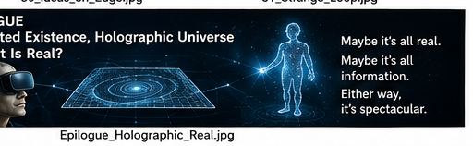

Epilogue — Simulated Existence, Holographic Universe and What Is Real?

EPILOGUE

Simulated Existence, the Holographic Universe, and What Is Real?

We Have Reached the Edge
We began with an apple.
We ended with quantum fields, black holes, entanglement, spacetime, information and computers that can manipulate quantum states.
That sounds like progress.
It is.
But there is an uncomfortable detail.
The farther physics has travelled, the less certain we are that our familiar picture of reality is fundamental.

Perhaps Space Is Not Fundamental
General relativity tells us that spacetime has geometry.
Quantum theory tells us that physical systems have quantum states.
But we still do not possess a universally accepted theory that combines quantum mechanics and gravity in a complete way.
QUICK SUMMARY
The appendix is here to compress the journey without pretending that the unanswered questions have disappeared. Keep the distinction between what is established, what is inferred, and what remains open.

↑ Back to Contents
One possibility is that spacetime itself is emergent.
Perhaps space is not the stage on which physics happens.
Perhaps space is something physics produces.

The Holographic Idea
Black holes helped create one of the strangest clues.
Black-hole entropy scales with the area of the event horizon rather than the volume inside it.
That led to the holographic principle: under certain circumstances, the information describing a gravitational system may be encoded on a lower-dimensional boundary.
The idea became especially concrete in the AdS/CFT correspondence, where a gravitational theory in a higher-dimensional spacetime can be related to a quantum field theory living on its boundary. citeturn0academia8turn0academia10
This is not the same thing as saying:
“Your universe is literally a hologram projected onto a wall.”
QUICK SUMMARY
The appendix is here to compress the journey without pretending that the unanswered questions have disappeared. Keep the distinction between what is established, what is inferred, and what remains open.

↑ Back to Contents
That is the popular version.
The physics is subtler—and much more interesting.

A Universe With Less Stuff Than It Appears to Have
Imagine discovering that a three-dimensional world could be completely described by information living on a two-dimensional boundary.
Not because the third dimension is fake in the ordinary sense.
But because the same physics might have two mathematically equivalent descriptions.
That is the important idea behind holographic duality.
The universe may admit descriptions that look radically different while encoding the same underlying physics.
Reality could have more than one perfectly valid language.

Then Someone Asked: What If It Is a Simulation?
Now we make a dangerous jump.
If information is fundamental—or at least deeply important—could the universe be a computer simulation?
QUICK SUMMARY
The appendix is here to compress the journey without pretending that the unanswered questions have disappeared. Keep the distinction between what is established, what is inferred, and what remains open.

↑ Back to Contents
Nick Bostrom's 2003 simulation argument does not claim to prove that we are simulated.
It presents a trilemma: either civilizations like ours rarely reach a posthuman stage, or advanced civilizations rarely run large numbers of ancestor simulations, or simulated observers could vastly outnumber observers in the original reality. citeturn0search0turn0search5
That is a philosophical argument.
It is not experimental evidence that we live in a simulation.

The Important Difference
A holographic universe and a simulated universe are not the same idea.
Holography is a serious research program in theoretical physics, with concrete mathematical realizations such as AdS/CFT.
Simulation is a philosophical hypothesis about what kind of physical substrate ultimately generates our experienced world.
One is about duality and information in physical theories.
QUICK SUMMARY
The appendix is here to compress the journey without pretending that the unanswered questions have disappeared. Keep the distinction between what is established, what is inferred, and what remains open.

↑ Back to Contents
The other is about whether our physical world is itself computationally generated.
They can be discussed together.
They should not be quietly merged.

Would a Simulation Still Be Real?
Suppose, for the sake of argument, that we are simulated.
Would your chair stop being real?
Would gravity stop hurting if you fell off it?
Would your coffee become philosophical?
Not necessarily.
If the simulated world has stable laws and produces genuine experiences, then it is still the world you inhabit.
Bostrom himself notes that a simulated world could still be real in an ordinary sense, while being part of a larger reality containing the simulator and its physical substrate. citeturn0search5
“Simulated” does not automatically mean “imaginary.”
A weather simulation is imaginary weather.
QUICK SUMMARY
The appendix is here to compress the journey without pretending that the unanswered questions have disappeared. Keep the distinction between what is established, what is inferred, and what remains open.

↑ Back to Contents
A conscious simulated experience, if consciousness can exist in such a substrate, would be another matter entirely.

Could We Ever Know?
This is where things become particularly uncomfortable.
If a sufficiently advanced simulation perfectly reproduced every experiment we could perform, then an experiment performed entirely inside it might never reveal the outside computer.
Looking for a “glitch” is therefore not a scientific method.
If you find one, check your eyesight before checking the universe.
The deeper problem is epistemological:
How do you distinguish a sufficiently perfect model of reality from reality itself?
Physics normally answers questions by experiment.
But if the hypothesis changes what counts as the physical substrate of every experiment, the rules become slippery.

The Computer That Simulates Itself
There is an even stranger possibility.
Suppose a simulated civilization becomes technologically advanced.
It builds computers.
Those computers run simulations.
Some of those simulations contain civilizations.
Those civilizations build computers.
And so on.
A hierarchy of realities appears.
Bostrom discusses this possibility explicitly in connection with simulated civilizations and “virtual machines.” citeturn0search15
At this point, someone should probably put a label on the bottom level.
Unfortunately, we have no idea which floor we are on.

And Then There Is Consciousness
A simulation argument becomes much more interesting if consciousness can exist in a computational process.
If a sufficiently detailed model of a brain produced the same conscious experience, then a simulated person might not merely behave like a person.
They might actually be a person.
But that is not established.
We do not yet have a complete theory explaining consciousness.
We do not know whether consciousness is substrate-independent.
We do not know whether a perfect functional simulation would necessarily produce subjective experience.
The computer may be able to simulate your behavior.
Whether it can simulate your Tuesday afternoon remains an open philosophical question.

The Most Dangerous Word: “Just”
We have repeatedly made the same mistake in this book.
We say:
“It's just a field.”
“It's just information.”
“It's just a wavefunction.”
“It's just geometry.”
“It's just a simulation.”
The word just is doing far too much work.
If spacetime emerges from quantum information, that information is not “just” information.
If consciousness emerges from physical processes, those processes are not “just” chemistry.
If our universe has a holographic description, the hologram is not a cheap illusion.
Physics keeps teaching us that the layer we thought was fundamental may be an approximation of something deeper.

So What Is Reality?
We began by asking about motion.
Then time.
Then energy.
Then gravity.
Then quantum mechanics.
Then fields.
Then particles.
Then information.
The questions became less like:
“What is this object made of?”
and more like:
“What relationships make the object possible?”
That may be the direction modern physics is pointing.
Perhaps reality is not fundamentally a collection of things.
Perhaps it is a structure of relationships, information, fields, quantum states, and geometry.
Or perhaps that is simply the next approximation that future physicists will replace.

The Humbling Part
Newton could not have predicted quantum mechanics.
Maxwell could not have predicted general relativity.
Einstein could not have predicted quantum information theory in its modern form.
We should therefore be suspicious of anyone who confidently describes physics in the year 3026.
That includes us.
Especially us.
The future may discover that today's deepest ideas are stepping stones toward something so different that our present vocabulary becomes as quaint as “ether.”

The Last Question
There is one question that survives all the theories.
Suppose we discover the final theory of physics.
Suppose it explains quantum mechanics.
Gravity.
Particles.
Cosmology.
Black holes.
Information.
Suppose it even tells us why the laws have the particular form they do.
Would we then understand why there is something rather than nothing?
Perhaps.
Perhaps not.
Science may eventually explain every event inside reality without explaining why there is a reality to begin with.
That may be a boundary between physics and philosophy.
Or it may be a sign that our physics is still not deep enough.

The Page After the Last Page
So this is not really an ending.
It is the point where the questions become more interesting than the answers.
Maybe spacetime is fundamental.
Maybe it emerges.
Maybe the universe has a holographic description.
Maybe advanced civilizations eventually create simulated worlds containing conscious beings.
Maybe we are not one of them.
Maybe we are.
There is currently no good evidence that we are living in a computer simulation.
There is, however, excellent evidence that the universe is stranger than the everyday picture suggests.
That is enough.

The Final Punchline
If reality turns out to be a simulation, please do not panic.
If it turns out to be holographic, please do not try to peel the universe off the wall.
If spacetime turns out to emerge from quantum information, please resist the temptation to ask where the information is sitting.
And if, after all this, the universe turns out to be completely ordinary underneath—
well.
That would be the most astonishing discovery of all.
For now, we have Newton's laws, Maxwell's fields, Einstein's spacetime, quantum mechanics, quantum fields, black holes, entanglement, information, and a very large collection of unanswered questions.
That is not a bad place to stop.
Or, more accurately:
that is a very good place to turn the page.
QUICK SUMMARY
The appendix is here to compress the journey without pretending that the unanswered questions have disappeared. Keep the distinction between what is established, what is inferred, and what remains open.

↑ Back to Contents
© Lothar J. Musiol

